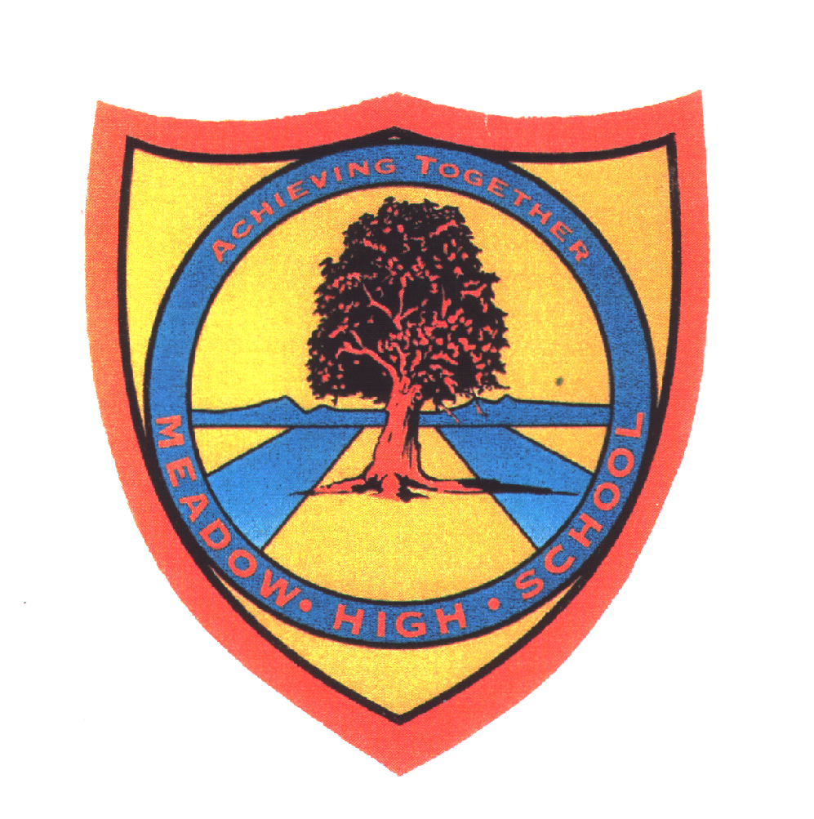 | Pathway 1 | Key Stage 3 Cycle 3 | Spring 1  Topic: States of Matter
Learning Intention: This unit develops an understanding of the different properties of solids, liquids and gases and the water cycle.
Key knowledge that should be learned during this SoW |  | All | Most | Some
Concept: |  | Pupils will learn about solids, liquids and gases. Pupils will learn about their properties and how this affects their state.
Knowledge: |  | To explore the states of matter | To recall the three states of matter | To recognise properties of solids, liquids and gases.  To identify the arrangement of particles and how compounds are formed.
Key Skills: |  | Observational and explorative skills.  Communication and teamwork. | Scientific experiments.  Listing and identifying. | Compare and contrast.
Language and/or communication skills: |  | Solid  Liquid  Gas | State  Matter  Changes | Same  Different
Curricular Links |  | Geography, PSHCE, speaking and listening.

