Meadow High School
Royal Lane, Hillingdon, Middlesex UB8 3QU

Telephone: (01895) 443310
Email: meadow@meadowhighschool.org
Website: www.meadowhighschool.org

Headteacher: Mrs Jenny Rigby
Deputy Headteacher: Ms Claire Caddell
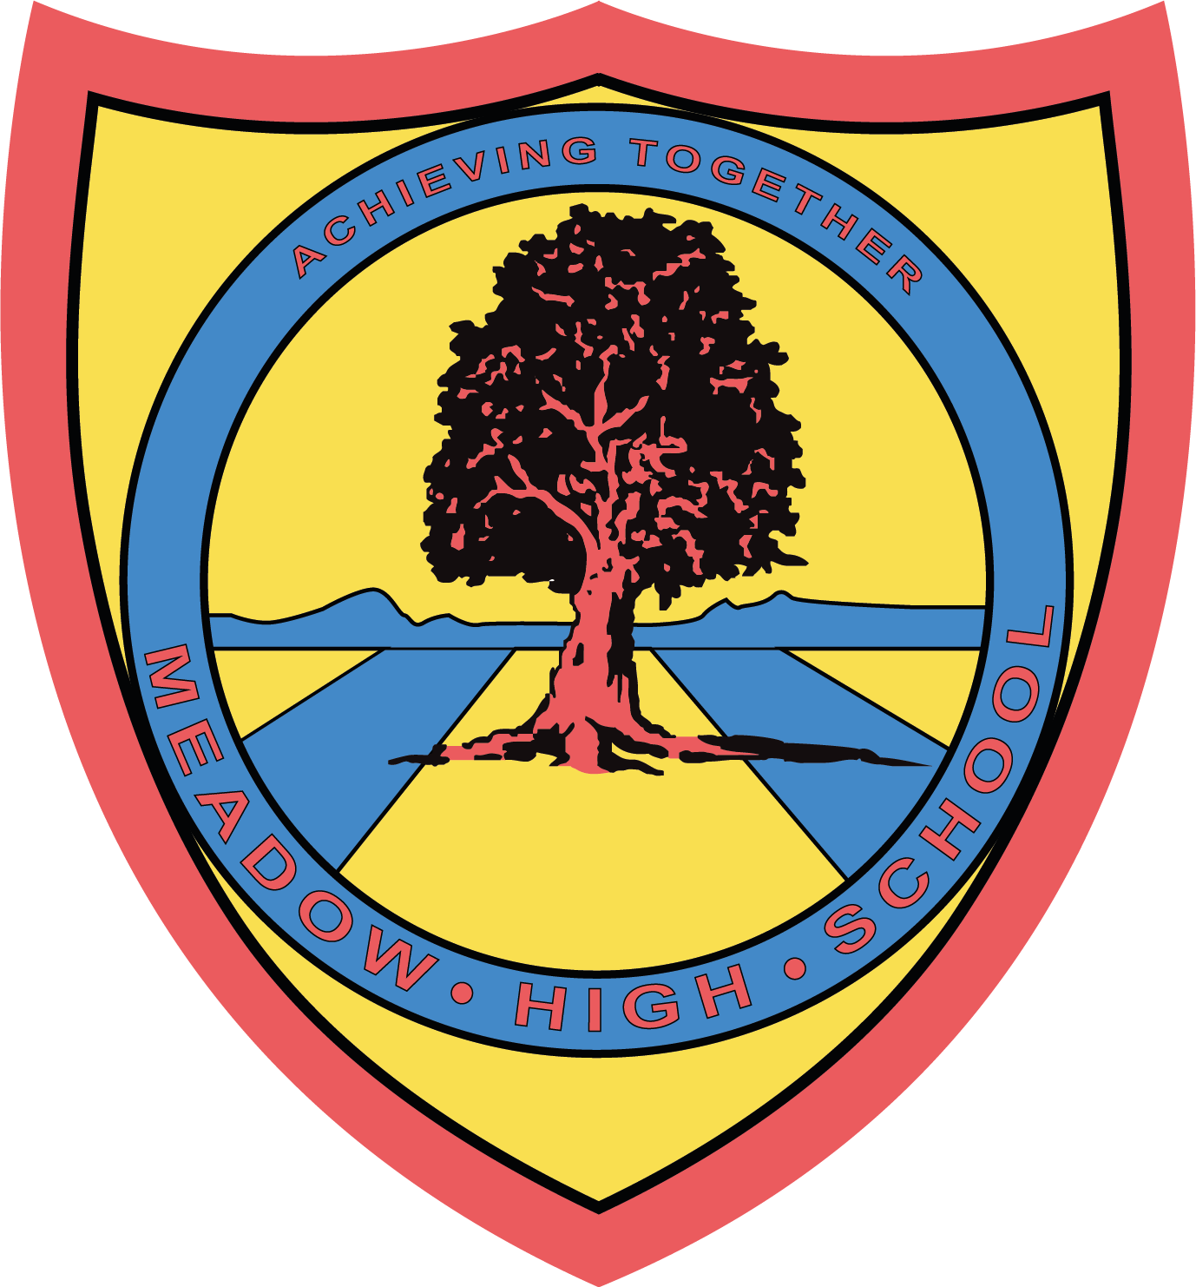

7th October 2022

Dear Parent/Carer,

Within our 6th form we have a purpose built Hairdressing department. We would like to encourage all our students (all year groups) to visit our salon as part of our hairdressing student learning programme on Fridays from 9.50am to 12.45pm. This enables our hairdressing students to learn the process of booking appointments, interacting with other students, shampoo and blow-drying students’ hair as part of their learning.

I manage the Hairdressing salon at all times and am a fully qualified Hairdresser; therefore, I would like to offer haircuts for our students for a minimum of £5.00. All profits from this venture will go towards the cost of running the salon.

We also offer a Hairdressing club on a Thursday during lunchtime, the students come and get involved in the daily running of the salon and a nail painting service is offered at no cost.

If you are interested in your child taking part in any of the above experiences, please return the attached reply-slip

Payment only if your child is having their haircut, this can be paid when the appointment is made or after they have their haircut!

Yours faithfully

D Lennon
Hairdressing Salon

REPLY SLIP: Hairdressing Salon – Please return to D Lennon

I give permission for my child to:

Have their hair washed
Have their haircut
Have their nails painted

Childs Name: _______________________________ Class: _______

Signed:_______________________________ Date: ___________

