Meadow High School
Royal Lane, Hillingdon, Middlesex UB8 3QU

Telephone: (01895) 443310
Email: meadow@meadowhighschool.org
Website: www.meadowhighschool.org

Headteacher: Mrs Jenny Rigby
Deputy Headteacher: Ms Claire Caddell
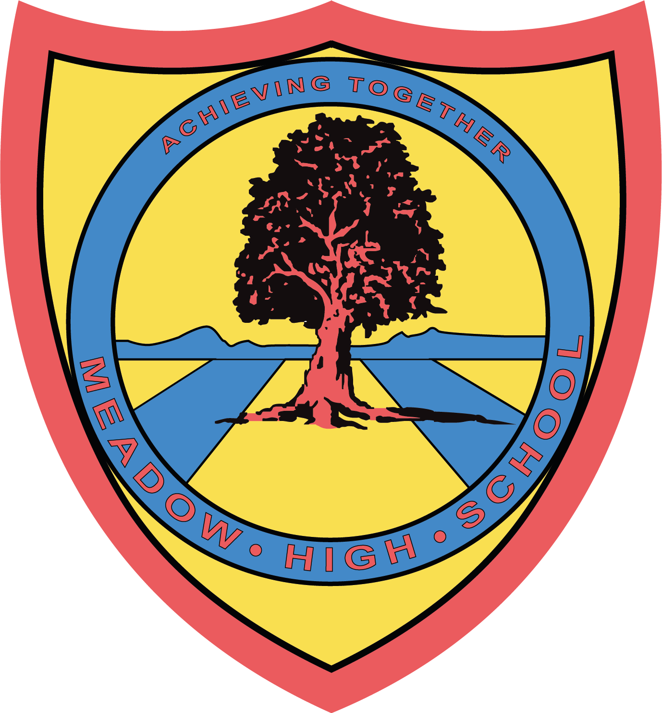

November 2022

Dear Parents/Carers,
Sixth Form Careers Fair
As a key stage group, we are going to the Career Fair at the Civic Centre in Uxbridge on Thursday 10th November 2022.
We will be travelling on public transport using tickets from Transport for London.
Students will be given the opportunity after the Careers Fair to go for lunch at McDonalds. However, if your child is entitled to a free school meal, a lunch can be provided, please indicate below and we will make sure they have a lunch to bring along from school.
Yours sincerely,

6th Form Tutors

----------------------------------------------------------------------------------------------------------------------------------------------------------------------------------------------

REPLY-SLIP - Careers fair – Please return to form tutors

Name: ………………………………………….. Class …………

- Is entitled to a free school lunch (tick appropriate box)
- Egg Sandwich
- Tuna Sandwich
- Cheese Sandwich
- Will bring in money for McDonalds (no more than £10)

Parent signature: ……………………………………………………

