Meadow High School
Royal Lane, Hillingdon, Middlesex UB8 3QU

Telephone: (01895) 443310
Email: meadow@meadowhighschool.org
Website: www.meadowhighschool.org

Headteacher: Mrs Jenny Rigby
Deputy Headteacher (Royal Lane): Miss Michelle Taylor
Deputy Headteacher (Northwood Road): Miss Amy Willis
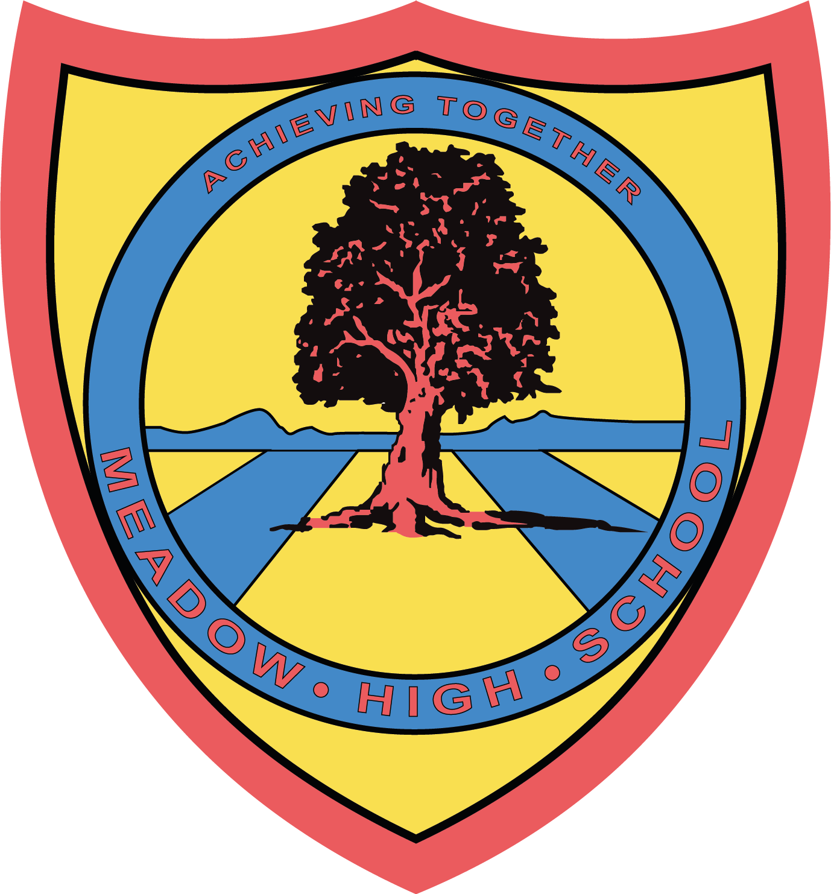

** correction to dates **

7 July 2025

Dear Parents and Carers,
We are writing to inform you that we have received permission from the Local Authority to implement a partial school closure on Thursday 4th and Friday 5th September 2025. This is for students in Pathway 2 for Years 9, 10 and 11 only.
Students will then return to school from their summer break on Monday 8th September 2025. They will have one day class based with their new or current form tutor before resuming usual lessons.
This decision has been made to allow staff time to prepare and set up classrooms in our new replacement block, which will be finally ready to open after numerous delays. The additional time is essential to ensure that learning environments are appropriately set up, health and safety standards are met, and that our pupils return to a well-prepared and welcoming space.
We understand that any disruption to the school routine can have a significant impact, especially within a SEND setting, and we sincerely apologise for any inconvenience this may cause. Please be assured that this decision was not taken lightly, and our priority remains the wellbeing and quality of education for all our pupils.
We thank you for your ongoing support and understanding as we take this exciting next step in improving our school facilities.
Kind regards,
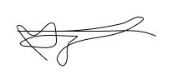
Michelle Taylor
Deputy Headteacher responsible for Pathway 2

Article 23:- 'A child with a disability has the right to live a full and decent life with dignity and independence, and to play an active part in the community.'



