Key stage 4 ICT Cycle 1 Spring 1
SOW E-safety

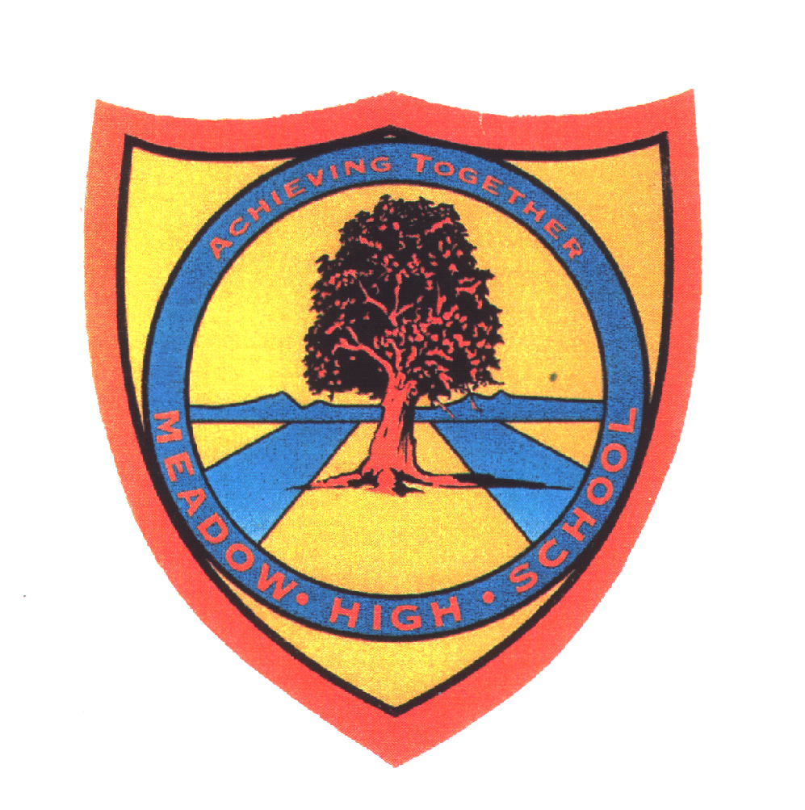 | Pathway 1 | Cycle 1  KS 4 (Pathways 1) | Term Spring
Learning Intention: This SOW aims to teach what personal information is, who is safe or unsafe to share this information with and the dangers of sharing this information with strangers. It also aims to teach the meaning of cyberbullying and online grooming. In the end, some pupils will be able to express their concerns to an adult if something does not seem right.
Key knowledge that should be learned during this SoW |  | All | Most | Some
Concept: |  | The pupils will learn what personal information is. | The pupils will learn the following concepts: personal information, social media and cyberbullying. | The pupils will learn the following concepts: personal information, social media, cyberbullying and online grooming.
Knowledge: |  | The pupils will understand that their birthday, address, name, gender and ethnicity are all part of their personal information. They will also learn who not to share it with online and the relevant dangers. | The pupils will understand that their birthday, address, name, gender and ethnicity are all part of their personal information. They will learn who not to share it with online and the relevant dangers. In the end, they will understand what cyberbullying is. | The pupils will understand that their birthday, address, name, gender and ethnicity are all part of their personal information. They will learn who not to share it with online and the relevant dangers. In the end, they will understand what cyberbullying and online grooming are.
Key Skills: |  | The pupils will be able to avoid sharing their personal information with strangers online. | In addition to the previous, the pupils will be able to avoid cyberbullying. | In addition to the previous, the pupils will be able to avoid online grooming.
Language and/or communication skills: |  | The pupils will develop the language skills and understanding that can ensure their online safety in the future. The pupils will learn the following keywords: personal information, birthday, gender, ethnicity, address, stranger, danger. | In addition to the previous, the pupils will develop language skills and understanding around social media and online surfing. Those skills will ensure the pupils’ online safety in the future. The pupils will learn the following keywords: personal information, birthday, gender, ethnicity, address, stranger, danger, cyberbullying. | The pupils will be able to surf online safety and also express their concerns to an adult if something does not seem right. The pupils will learn the following keywords: personal information, birthday, gender, ethnicity, address, stranger, danger, cyberbullying, online grooming.
Curricular Links |  | Links to other learning within the subject and spiral learning links: E-safety: personal information, social media, cyberbullying, online grooming.  Cross-curriculum links: PSHCE, English

