Meadow High School
Royal Lane, Hillingdon, Middlesex UB8 3QU

Telephone: (01895) 443310
Email: meadow@meadowhighschool.org
Website: www.meadowhighschool.org

Headteacher: Mrs Jenny Rigby
Deputy Headteacher PW2/3: Ms Claire Caddell
Deputy Headteacher PW1: Miss Amy Willis
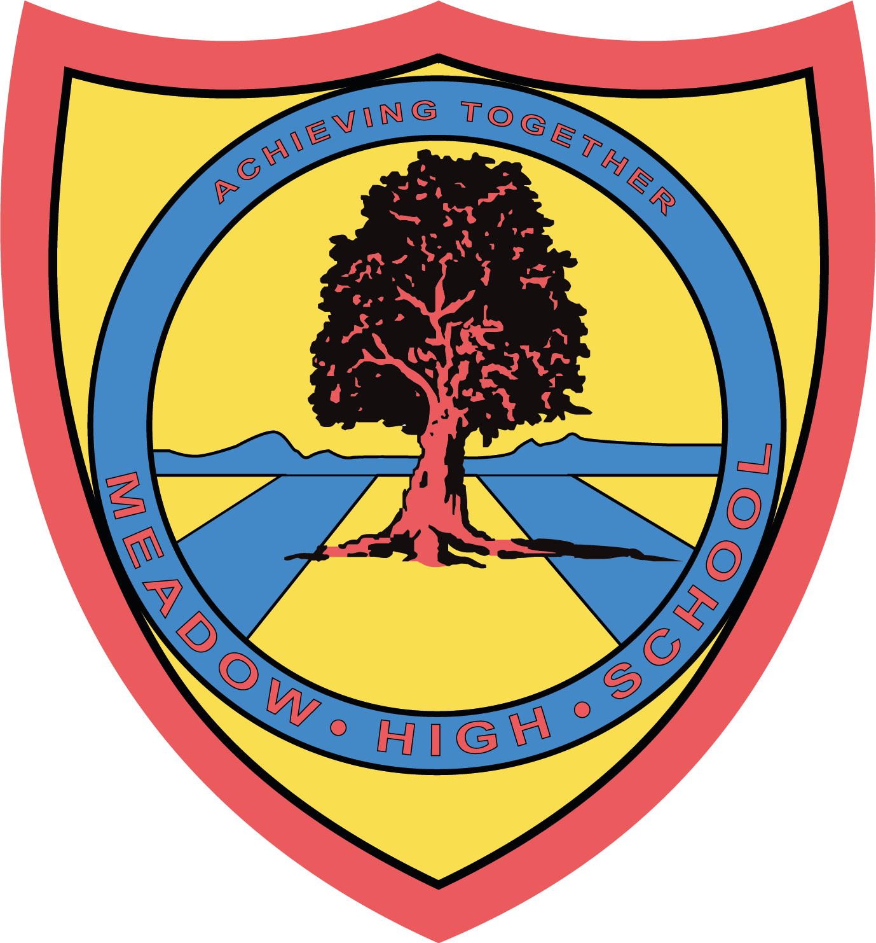

15th April 2024

Dear Parents/ Carers,

Your child has been chosen to attend the Under 13s and Under 16s Panathlon Higher Ability Football Competition at Goals, Gillette Corner on Friday 26th April 2024. The event will be taking place between 9:15 – 2:00. If there is any issue, you will be contacted. Travel arrangements will need to be made for your child to be picked up after school. Your child will return to school by 3.00 - 3.30 the latest.
Pupils will also need to bring a pack lunch and a water bottle and PE kit with shin pads, sports trainers or astro boots. Students should not have studded shoes, as students will not play.

If you have any questions or any issues, please do not hesitate to contact me.

Kind regards,

Mr Daniel McAlernon
Teacher of Physical Education and Year 11 Form Tutor

Article 23:- 'A child with a disability has the right to live a full and decent life with dignity and independence, and to play an active part in the community.'


