Meadow High School
Royal Lane, Hillingdon, Middlesex UB8 3QU

Telephone: (01895) 443310
Email: meadow@meadowhighschool.org
Website: www.meadowhighschool.org

Headteacher: Mrs Jenny Rigby
Deputy Headteacher (Royal Lane): Miss Michelle Taylor
Deputy Headteacher (Northwood Road): Miss Amy Willis
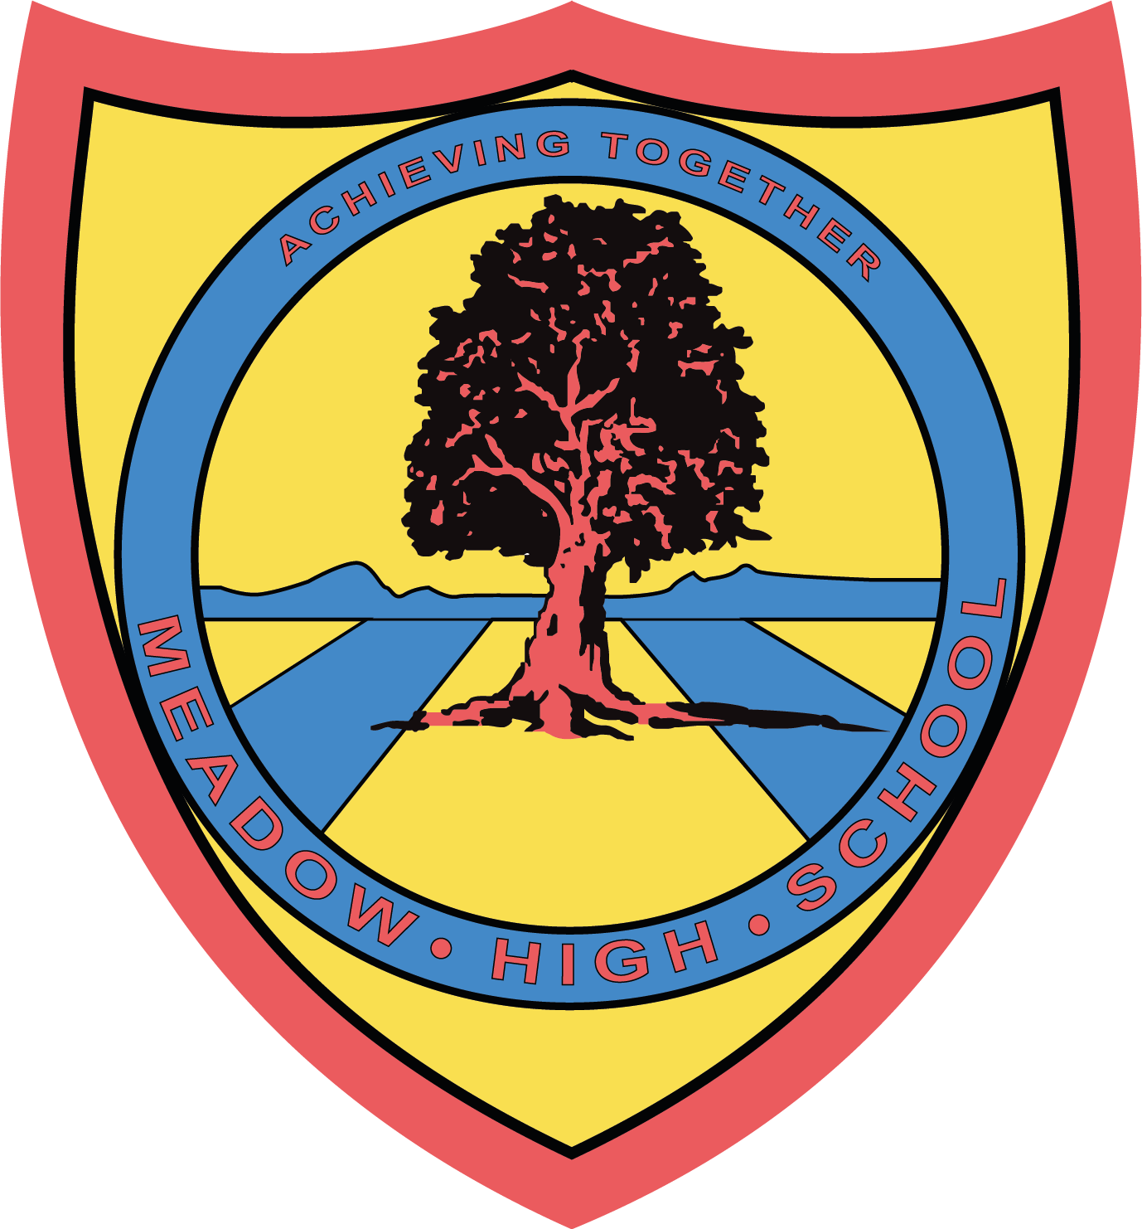

14 July 2025

Dear Parents and Carers,
We are excited to let you know that we will be holding a special celebration afternoon to mark the retirement of our beloved Headteacher, Mrs. Rigby after 28 years. This will be a joyful event to thank her for her incredible service and to give students and staff the chance to celebrate together.
Celebration Day Details:
- Date: Friday,18th July
- Time: 12pm - 3pm
- Location: School Site
On the day, students will arrive and sit in their form groups on the field (students may bring labelled picnic blankets if available). A delicious vegetarian picnic lunch will be prepared by our catering staff and served as a platter per class. Class staff will help manage this within each group.
There will be lots of fun activities, including a Bollywood dance session, a silent disco, exciting stalls including stocks for Mrs Rigby and of course… ice cream and ice lollies!
At the end of the celebration, students will return to their form classes for dismissal as usual.
We look forward to a wonderful day of celebration in honour of Mrs. Rigby’s amazing leadership!
Kind regards,

Michelle Taylor & Amy Willis
Deputy Head Teachers

Article 23:- 'A child with a disability has the right to live a full and decent life with dignity and independence, and to play an active part in the community.'



