Meadow High School
Royal Lane, Hillingdon, Middlesex UB8 3QU

Telephone: (01895) 443310
Email: meadow@meadowhighschool.org
Website: www.meadowhighschool.org

Headteacher: Mrs Jenny Rigby
Deputy Headteacher (Royal Lane): Miss Michelle Taylor
Deputy Headteacher (Northwood Road): Miss Amy Willis
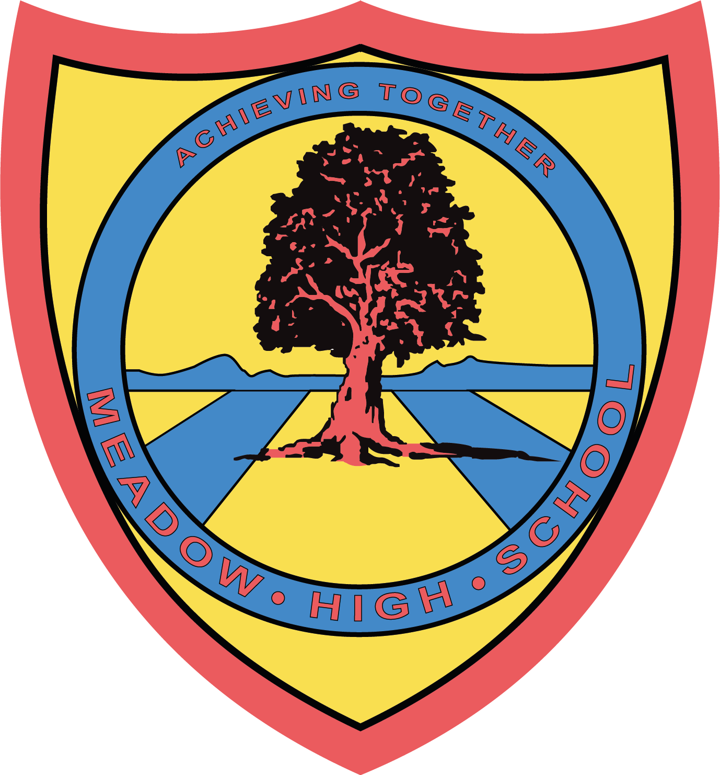

April 2025

Dear Parents / Carers

As you are aware, the Year 14 students and other leavers will be finishing their school year on 27th June 2025.

You are invited to attend this year's Leavers' Assembly, where students will be presented with their Records of Achievement.

Before this, on 24th June 2025, we will be organising a Year 14 trip, allowing students to spend time with their peers and enjoy a memorable send-off.

Additionally, all leavers are invited to the school Prom, which will be held on 10th July 2025.

Further details regarding these events, including timings and any additional information, will be shared in due course.

Kind Regards,

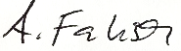

Mrs A Fabisch
Head of 6th Form
afabisch@meadowhighschool.org

01895443310 ext 241

Article 23:- 'A child with a disability has the right to live a full and decent life with dignity and independence, and to play an active part in the community.'



