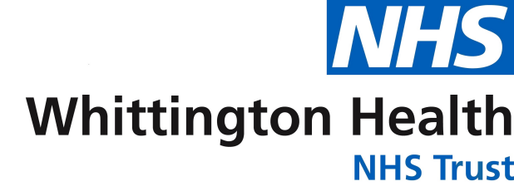
National Smile Month
Design A Poster Competition
As part of National Smile Month we would like you and your family to design a poster about keeping your teeth healthy.
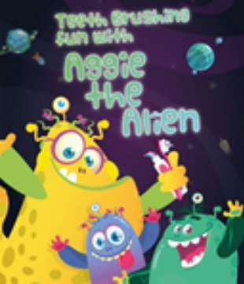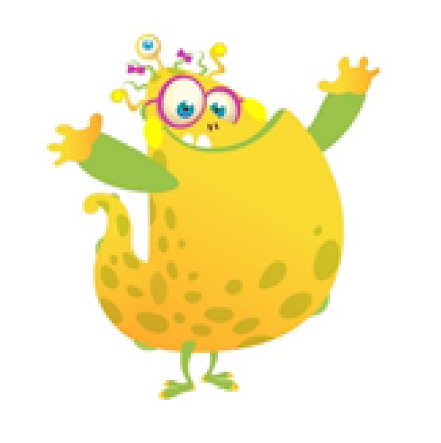
We run a programme in Hillingdon where children can brush their teeth at school, but we need a name for it? Can you think of one? The programme will then be named from the winning entry.
How to enter:
Put your name, age and nursery/school on the competition entry below
Then design your poster on the sheet below
Ask an adult to email a photo or a scan of your entry Closing date is Thursday 16 June.
This competition is run by the Hillingdon Oral Health Promotion Team. Contact sallymcgregor1@nhs.net for more information.
Entry form
Please email your entry to:
sallymcgregor1@nhs.net
Can you help Aggie the Alien teach children how to keep their teeth healthy by designing a poster
What should we call our programme in Hillingdon where children can brush their teeth at school?
......................................................................................................................Name:
Age:
Nursery/school:

