Meadow High School
Royal Lane, Hillingdon, Middlesex UB8 3QU

Telephone: (01895) 443310
Email: meadow@meadowhighschool.org
Website: www.meadowhighschool.org

Headteacher: Mrs Jenny Rigby
Deputy Headteacher PW2/3: Ms Claire Caddell
Deputy Headteacher PW1: Miss Amy Willis
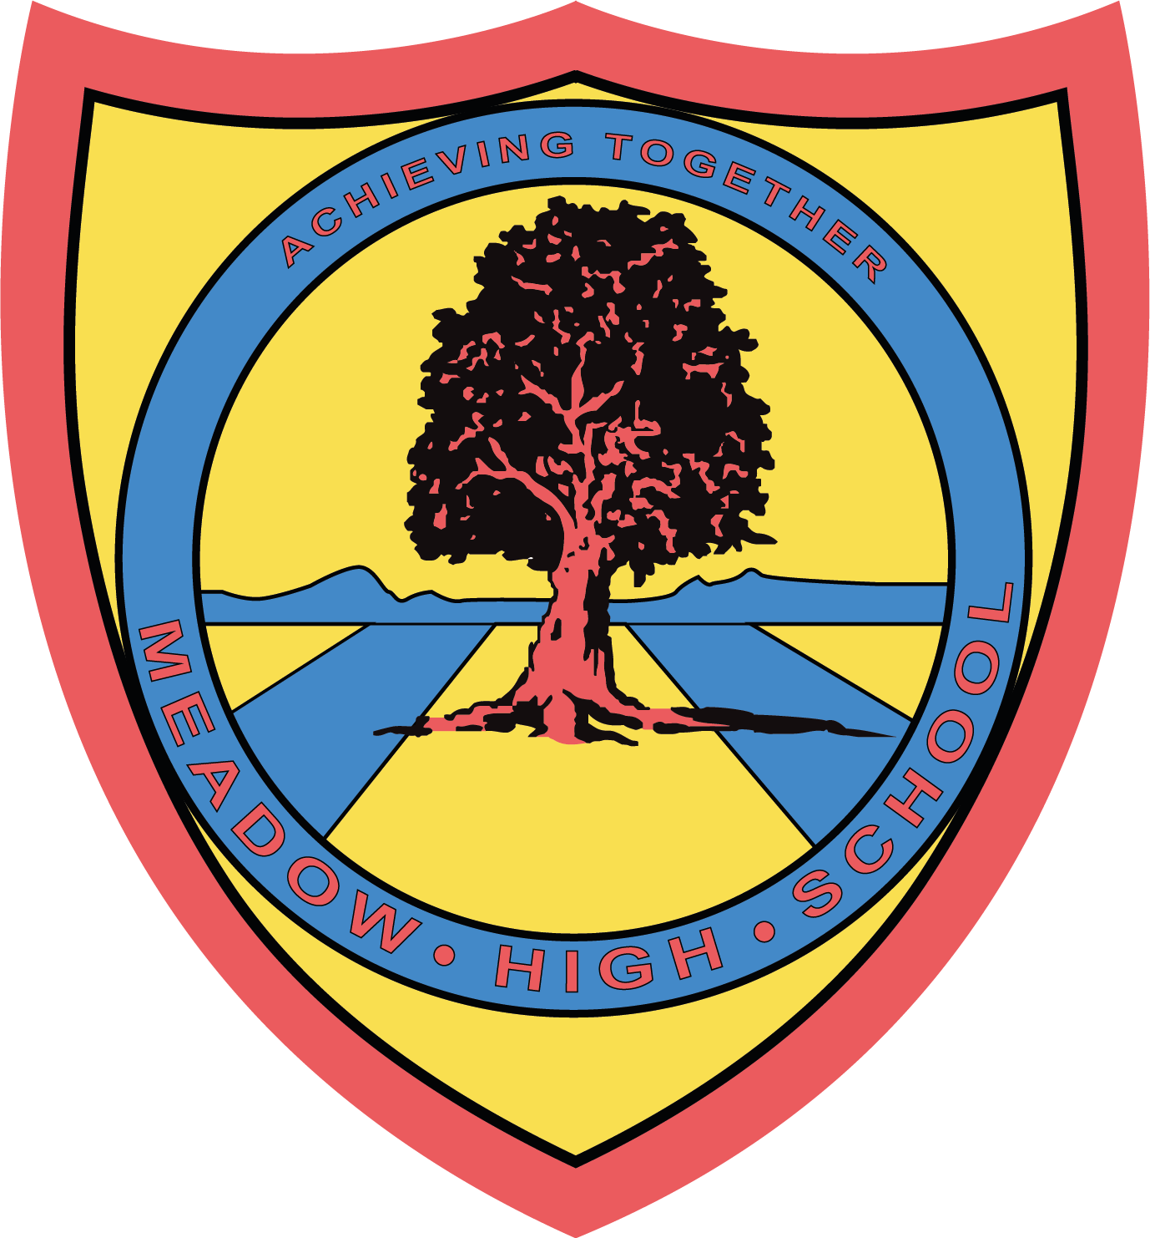

26 June 2024
Dear Parents/Carers,
As part of our learning Personal development, we are taking part in an eating out experience at Pizza Hut on Thursday 18th July 2024. This experience is to build upon the skills they have learnt in Out in the Community lessons and Themed Learning.
This will also support our work within PSHE looking at developing our social skills.
We will be leaving school at 11:30am and will return to school at 2:30pm in time for normal transport home. We will be travelling by school minibus and first aiders will accompany us.
Your child will not require a packed lunch on this day.
If you have any enquiries, please feel free to contact me mparker@meadowhighschool.org.
Yours sincerely,

Mr M Parker
Form Tutor
Article 23:- 'A child with a disability has the right to live a full and decent life with dignity and independence, and to play an active part in the community.'


