Meadow High School
Royal Lane, Hillingdon, Middlesex UB8 3QU

Telephone: (01895) 443310
Email: meadow@meadowhighschool.org
Website: www.meadowhighschool.org

Headteacher: Mrs Jenny Rigby
Deputy Headteacher: Ms Claire Caddell
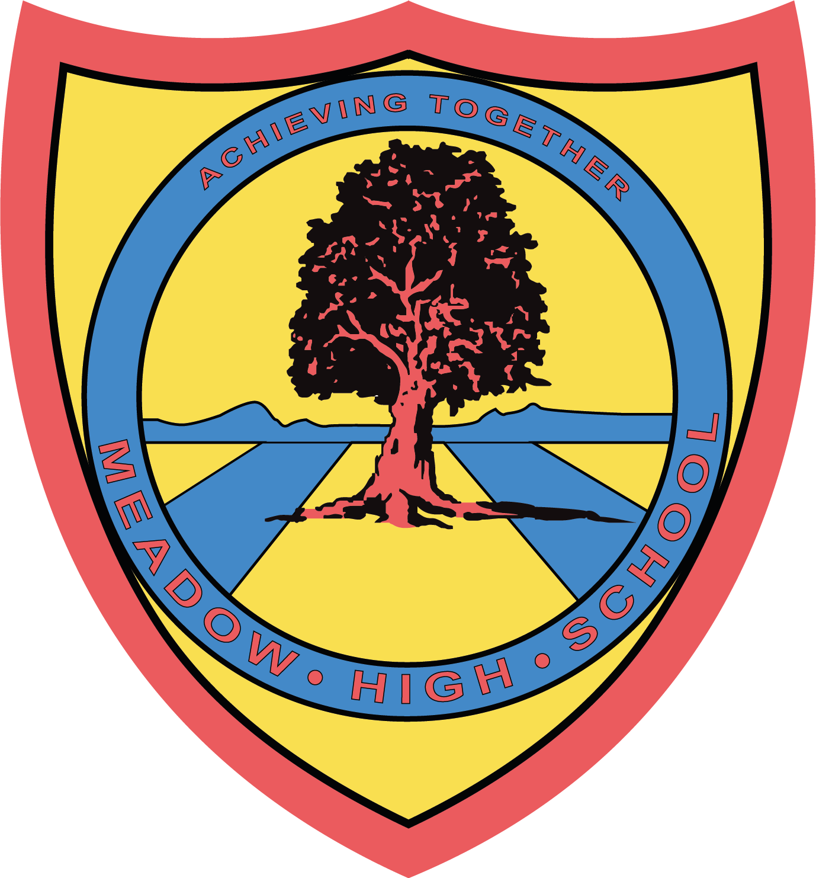


Children in Need Day
Friday 18th November2022

14 November 2022
Dear Parents/Carers,
We will be having a non-uniform day on Friday 18th November to raise awareness for Children in Need. Students can dress up in pyjamas or other spotty clothes if they want to take part. .
We will be having a cake sale at breaktime, please do send in donations of cakes if you wish to. Pupils will also be able to purchase cakes at breaktime, so can bring in small amounts of change as well.
For a bit of fun, students will be invited to a “dance off” at lunchtime. Everyone can join in and it is a fun and free activity!
During the last period of the day, students will be invited to a whole school assembly where they will learn about Children in Need. Our Team Leaders, Mr Haines, Mr Rogers, Mrs Newman and Ms Carter will be taking part in a ‘I’m A Celebrity inspired, BushTucker Trial' where they will try to win for their Key Stage / Pathway!
Donations will be welcomed and will be split between Children in Need and this year’s school charity, Steel Bones. To donate to these causes, either send your child in with donations of money, or use Parent Pay to give electronically.
If donating online, please use ParentPay.
Thank you for your support.
Yours sincerely,
Michelle Taylor
Meadow High School

