Meadow High School
Royal Lane, Hillingdon, Middlesex UB8 3QU

Telephone: (01895) 443310
Email: meadow@meadowhighschool.org
Website: www.meadowhighschool.org

Headteacher: Mrs Jenny Rigby
Deputy Headteacher: Ms Claire Caddell
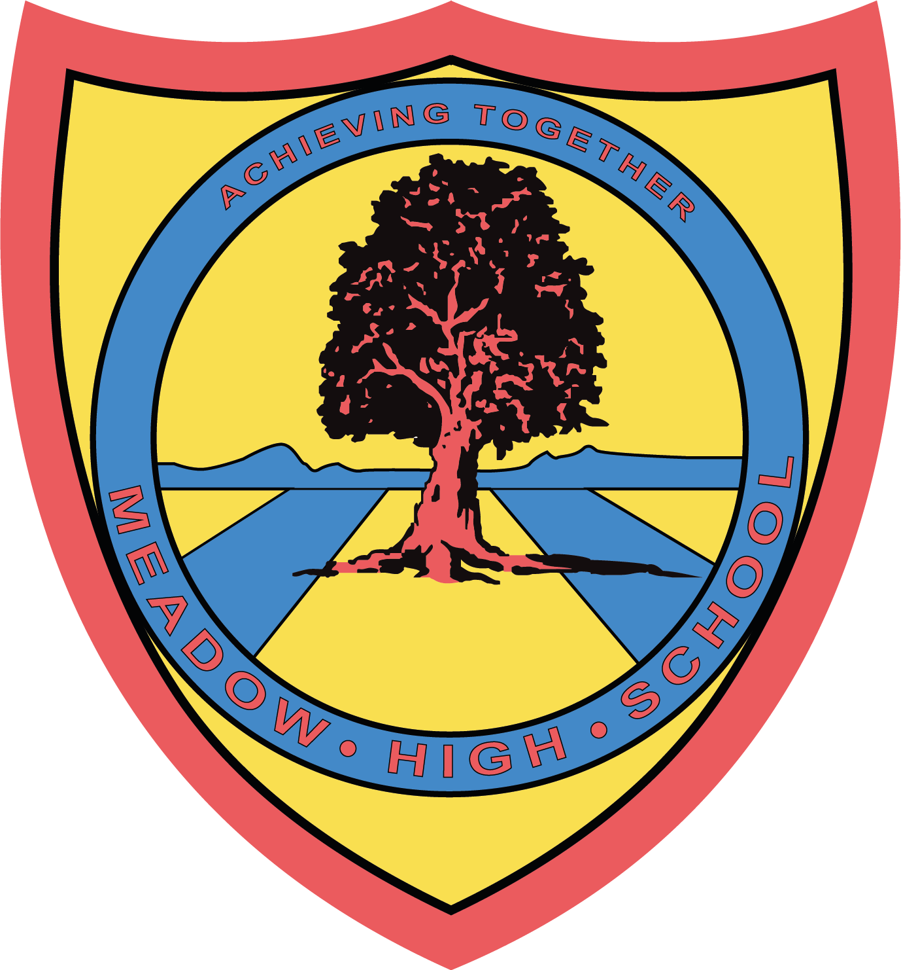

30th October 2023

Dear Parents/Carers of 6th form students,

Coffee Morning – Tuesday 7th November 2023: 9:00am – 11:00am

On Tuesday, 7th November between 9am and 11.30am we will be hosting a coffee morning for parents/carers to come and talk to different local providers.

This will be an informal event, where staff from the providers will be available to answer any questions you may have.

Providers who will be present are:
- Uxbridge College
- Green Corridor
- Berkshire college of Agriculture
- Build (Construction)
- Orchard Hill
- Job Centre Plus
Our allocated SEN caseworker, Sehrish Hussain, will also be present, to answer any questions that you may have concerning ‘moving on’.

Regards,

Sue Stock
01895 443310 (ext 244)
07841021772

