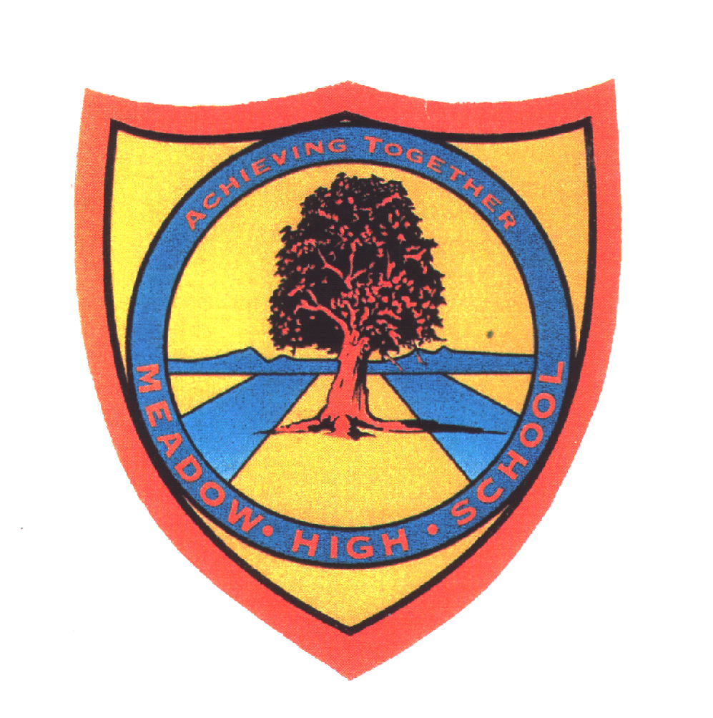 | Pathway ‘2-3’ | Year 9 Music | Autumn Term 1 up to Spring half Term of Term 2
Learning Intention: Music from different cultures
This unit explores music from around the world in more detail. The purpose of this Scheme of work is to provide Students with the opportunity to build on the knowledge they learnt about ‘Music and Songs‘ from Different Countries in year 8 by developing their ability to play music using a range of appropriate instruments including Djembe drums and Keyboard. Pupils learn about West African Drumming from the Malian Empire, Chinese music and Indian Raga music.
Key knowledge that should be learned during this SoW |  | All (Pathway 2) | Most (Pathway 3) | Some (Pathway 4)
Concept: |  | To encourage and support pupils to:  - To develop an understanding of music from different countries.  - To develop an understanding of how tradition plays a part in music from different cultures. | To encourage greater independence and decisions making through guidance in:  - To develop an understanding of music from different countries and be able to express their favourite one.  - To develop an understanding of how tradition plays a part in music from different cultures. Students will be able to give an example of one. | To develop independent thinking, decision making, basic leadership skills and problem solving in group work by:  - To develop an understanding of music from different countries and be able to express their favourite one, saying why they have made that choice.  - To develop an understanding of how tradition plays a part in music from different cultures. Students will be able to give an example of two.
Knowledge: |  | Develop a basic understanding of the following Core Knowledge:  - To be aware that songs from around the world can sound different.  - Students will understand that songs are used to portray feelings and emotions. | Develop a competent understanding of the following Core Knowledge:  - To be aware that music from around the world can sound different and that music can follow a tradition.  - Students will understand that songs are used to portray feelings and emotions. Students will be able to give an example of a song and its meaning. | Develop a confident understanding of the following Core Knowledge:  - To be aware that music from different countries is different from Western music because of factors such as culture, instruments and beliefs.  - Students will understand that songs are used to portray feelings and emotions. Students will be able to explain the message of the song by exploring the lyrics.
Key Skills: |  | what will they actually be able to do as a result of this learning  -To be able to play a song or piece of music from a different country with some support.  - Students will be able to use more than one instrument to play music from different countries, e.g. drum, keyboard.  -Students will be able to compose their own song for their own country with regular support | what will they actually be able to do as a result of this learning  -To be able to play 1- 2 songs / pieces of music from different countries with some support.  - Students will be able to use more than one instrument to play music from different countries, e.g. drum, keyboard and say which one they prefer.  -Students will be able to compose their own song for their own country with some support | what will they actually be able to do as a result of this learning  -To be able to play 2 songs/ pieces of music from different countries with minimal support.  - Students will be able to select an appropriate instrument to accurately represent music from a particular culture.  -Students will be able to compose their own song for their own country mostly independently
Language and/or communication skills: |  | To develop confidence in subject related language and begin to use a range from the following keywords independently and mostly accurately sharing ideas verbally when prompted.  - Culture  - Scale  - Drumming  - Africa  - Country  - Africa  - America  - Call and response | To improve use of subject related language and appropriate application of the below keywords and to share a range of new descriptions and their own keywords with the class:  - Culture  - Traditions  - Raga  - Djembe drum  - Indian  - Chinese  - West African  - Bass  - Tone  - Jasmine flower | To explore use of subject related language using broad and appropriate application for the most of the below keywords and regularly sharing own additional language  - Culture  - Traditions  - Raga  - Scales  - Malian Empire
Curricular Links |  | Spiral Learning  Links to learning about African culture in Art and Design- year 10 Tinga Tinga,  Links to learning about Asian Culture in Art and design Year 11 Japanese Art  8.1 Music & Songs from different countries  SMSC/PSHCE - A practical based project with a cross curricular developing knowledge of cultures, developing understanding of societies and history of music and how different music is based on different traditions celebrating diversity in culture.  Literacy-word games, word frames, vocabulary quiz  Numeracy is encouraged through counts of beats, Timings  Dance- linking with the Dance Curriculum in year 9

Talking points

- Students can discuss music from their own culture; discussing things like instruments and traditions. Students can present, using images or video, music from their culture, explaining what it’s about.
Implementation
- Core Focus:
- African Music
- Chinese Music
- Indian Music

Discussions about music from their country.
Appraising Music: Pupils are introduced to a range music from different cultures (Africa,China, and America) including how and why music was created in certain countries.

Performing: Students have got to perform the music they learned from the different countries that we ‘visited’. Performing consistently will build up students’ musicality and confidence.

Creating: When learning about African music, students will have the opportunity to compose / improvise Djembe music using authentic techniques.

There are opportunities for students to build up their body coordination during this unit. There are musical starters that require students to move around following the pace of the music. Also, this unit includes singing a sign song, where students need to multitask - singing and signing at the same time. Students with dyspraxia will get extra support from the teacher and TA’s, including 1-1 tutorial and extra rehearsal time. They will also receive more support when doing drumming. Also, they will be encouraged to make up their pattern as it provides them with extra confidence.

Assessment- Ongoing assessment of pupils performing practical tasks and teacher verbal feedback. Written Assessment theory question and a student self assessment of their performance.

Impact
Core Outcomes
Outcomes: 4 main outcomes
1.Students will show understanding or Djembe drumming through performance skills.
2.Students will show their knowledge of Music from different countries through written assessment
3. Students will show their creativity through creating an idea for their own country and compose their own music for that country
4. Students complete a self Assessment of their performance and the skills they developed

Wider Impact
Performances during school culturefest.
Career Links- Developing awareness of others, sharing experiences and celebrating culture. Developing understanding that there are cultural influences on music styles and professional Musicians use those music styles to influence their own ideas
Life Skills-Learn to appreciate music from a variety of cultures and different instruments like Djembe drums which can be played with others in social situations.

