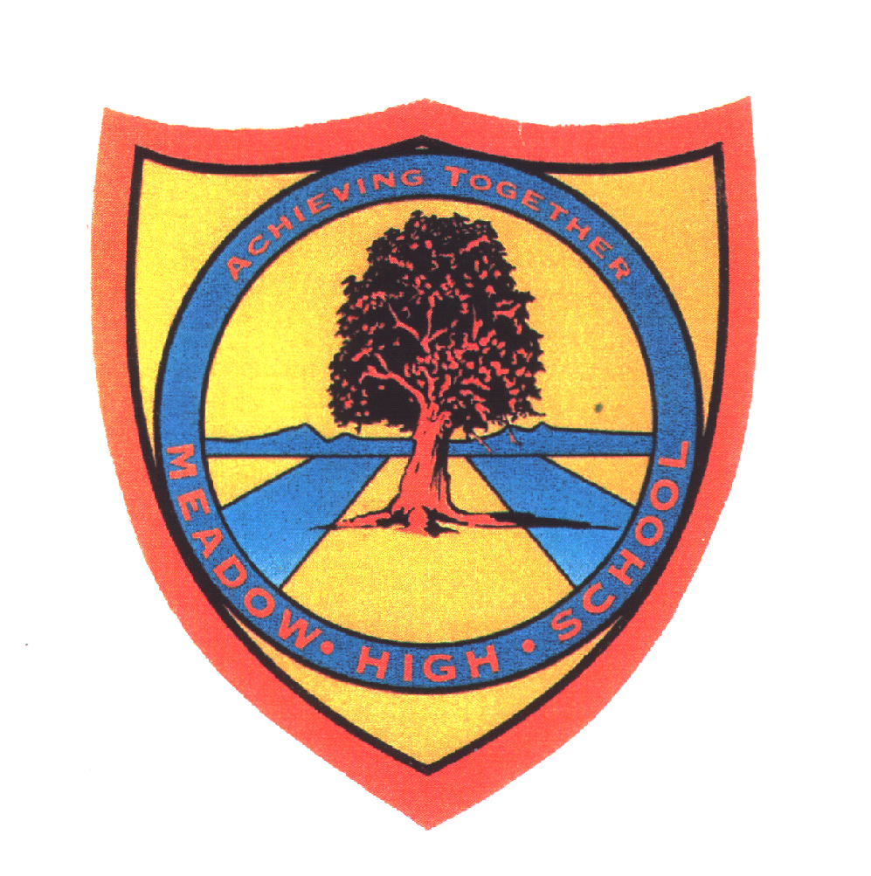 | Pathway 1 | Key Stage 3 Cycle 3 | Autumn 2  Topic: Sound
Learning Intention: This topic introduces students to the concept of sound and the way sound is made through vibrations travelling as wavelengths. Pitch and volume is also explored as well how sound vibrations travel into the human ear.
Key knowledge that should be learned during this SoW |  | All | Most | Some
Concept: |  | Students will have the opportunity to learn about the physics of sound. They will learn about what makes sounds and how the human ear works
Knowledge: |  | The ear; how we hear sounds; muffling sounds; pitch and volume  Experimenting with sounds and instruments; animal ears and how animals hear | To know that sounds are made by vibrations  To understand that sounds become fainter when they are further away | To know elements of how the human ear works  To experiment on muffling sound  To understand how we hear sounds
Key Skills: |  | Observational skills. Communication skills.  Teamwork.
Language and/or communication skills: |  | Sound  Listen  Ears  Vibration  Experiment  Same  Different | Sound  Pitch  Volume  Vibrations  Ear  materials | Human Ear  Muffling  Transmission
Curricular Links |  | PSHCE, PE, technology, English,

