Meadow High School
Royal Lane, Hillingdon, Middlesex UB8 3QU

Telephone: (01895) 443310
Email: meadow@meadowhighschool.org
Website: www.meadowhighschool.org

Headteacher: Mrs Jenny Rigby
Deputy Headteacher PW2/3: Ms Claire Caddell
Deputy Headteacher PW1: Miss Amy Willis
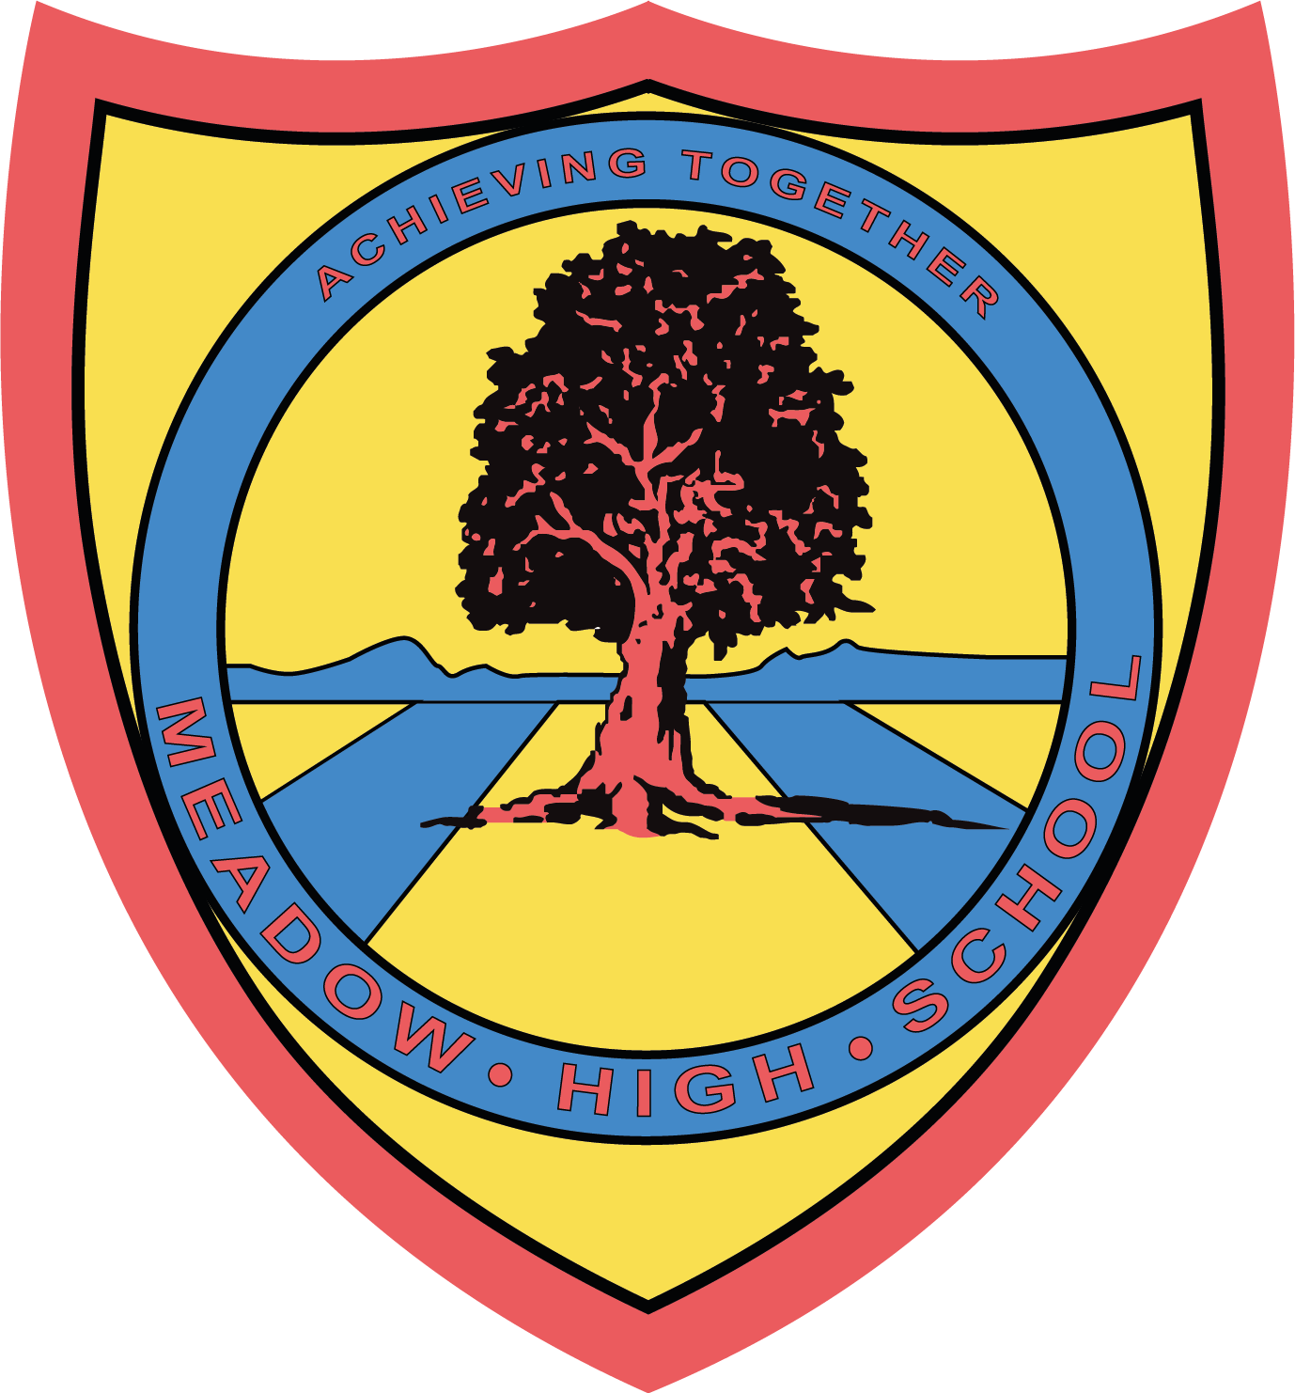

24th January 2024

Dear

The Jack Petchey Achievement Awards Presentation Evening will take place at The Beck Theatre, Hayes on Tuesday 30th April 7.30pm – 9.30pm.

This is a prestigious borough wide event, where all the Award Achievers from the last 12 months, along with their families and members of school staff, are commended for their contributions and efforts for which they received this award. Award winners will be called onto the stage to receive a boxed medallion and have their photo taken with the rest of the achievers from Meadow High School.

Entry to the event is strictly ticket only and you will be asked to provide tickets at the door of the venue. Please indicate below whether you can attend and how many tickets you require (award winner, plus max 2 guests).

If you have any questions please do not hesitate to contact me at school.

Yours sincerely

Maxine Newman
Jack Petchey Co-ordinator

Article 23:- 'A child with a disability has the right to live a full and decent life with dignity and independence, and to play an active part in the community.'

……………………………………………………………………………………………………………………………………….………………………

Reply Slip: Jack Petchey Foundation Presentation Evening – please return to Maxine Newman

Award winner:

We are unable to attend

Yes, we are able to attend

We require ………… Tickets (max 2 guests to attend plus the Award winner)

Signed (Parent/Carer): ______________________________________

