Meadow High School
Royal Lane, Hillingdon, Middlesex UB8 3QU

Telephone: (01895) 443310
Email: meadow@meadowhighschool.org
Website: www.meadowhighschool.org

Headteacher: Mrs Jenny Rigby
Deputy Headteacher: Ms Claire CaddellDear Parent / Carers,

Dear Parents and Careers,

A case of scabies was discovered today in school.

Check if it's scabies
The symptoms of scabies are:
- intense itching, especially at night
- a raised rash or spots
The spots may look red. They are more difficult to see on dark skin, but you should be able to feel them.
The scabies rash usually spreads across the whole body, apart from the head.
However, older people, young children and those with a weakened immune system may develop a rash on their head and neck.

A pharmacist can help with scabies
Scabies is not usually a serious condition, but it does need to be treated.
Please Visit the NHS website for more information

https://www.nhs.uk/conditions/Scabies/

If you would like any further advice, please feel free to contact me at school.
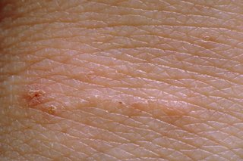
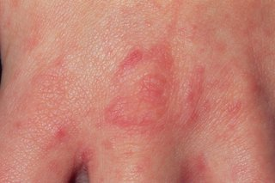
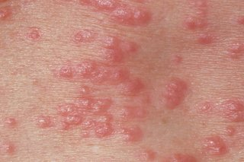

Yours Sincerely

Kathleen Bentley

Welfare Lead

