Meadow High School
Royal Lane, Hillingdon, Middlesex UB8 3QU

Telephone: (01895) 443310
Email: meadow@meadowhighschool.org
Website: www.meadowhighschool.org

Headteacher: Mrs Jenny Rigby
Deputy Headteacher PW2/3: Ms Claire Caddell
Deputy Headteacher PW1: Miss Amy Willis
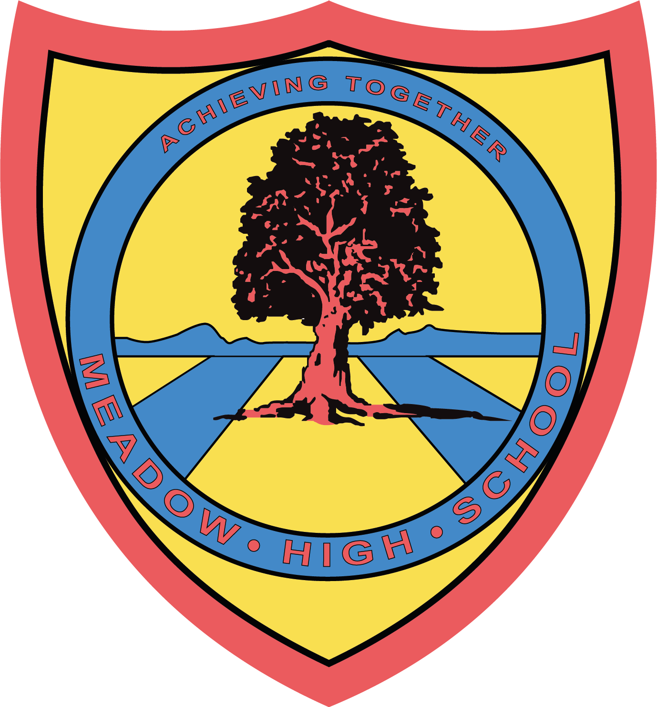

21st November 2023

Dear Parent/Carer,

Our brand new Scholastic Book Club is now up and running!

Scholastic Book Club is a fantastic way for all of us to promote a love of reading for our students, and to support our school!

For every £1 you spend on our Book Club, our school will earn 20p in Scholastic Rewards. We can then use these rewards to get brand new books and resources for our students!

Please go to https://schools.scholastic.co.uk/meadow-ub8/digital-book-club to browse the latest books and order online.

Please place your order online by 21st December 2023.

If you have any questions, please contact our Librarian, Miss S Gaafar, at sgaafar@meadowhighschool.org.

Kind Regards,

Miss S Gaafar
Librarian (Supporting and Delivering Learning)

Article 23:- 'A child with a disability has the right to live a full and decent life with dignity and independence, and to play an active part in the community.'


