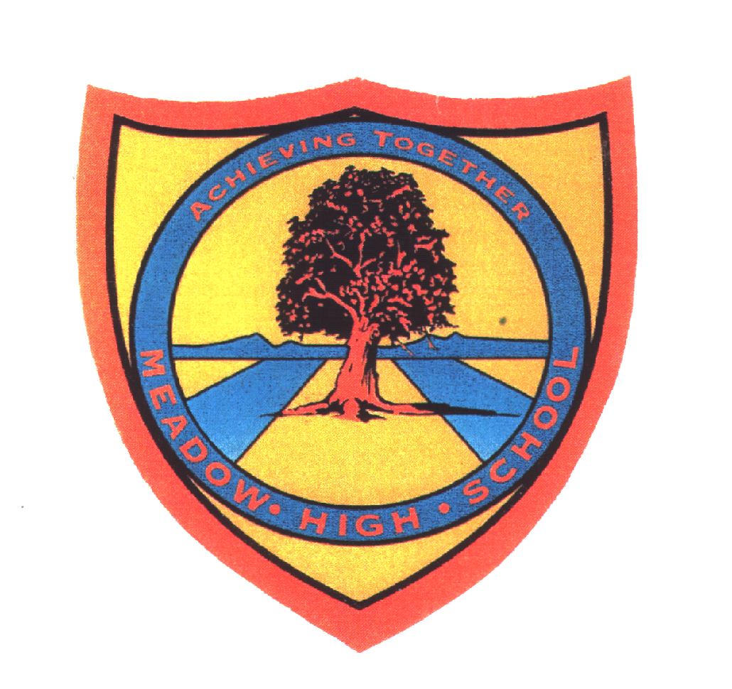
Meadow High School
Royal Lane, Hillingdon, Middlesex UB8 3QU

Telephone: (01895) 443310
Email: meadow@meadowhighschool.org
Website: www.meadowhighschool.org

Headteacher: Mrs Jenny Rigby
Deputy Headteacher: Ms Claire Caddell

Key Stage 5 Duke of Edinburgh Residential Trip to
Paccar Scout Camp
Wednesday 19th April - Friday 21st April 2023

Dear Parents/Carers,

Here a kit list of what each student will need to bring on the Duke of Edinburgh Expedition. We will be outside and things will get muddy/wet etc so please do not pack your best clothes or bring anything valuable. Reminder: there are to be no devices of any kind brought on the expedition.

- 1 pillow in pillowcase
- 1 single fitted sheet
- Waterproof coat
- Wellington boots or walking boots
- Trainers
- 3 old t shirts (long or short sleeve depending on weather forecast)
- 3 vests
- 2 old jumpers or fleece style jumpers jackets
- 3 old pairs of trousers
- 4 sets of underwear
- 4 pairs of socks
- Nightwear
- Gloves, hat, scarf (weather dependent)
- Sunscreen and hat (weather dependent)
- Toothbrush
- Toothpaste
- Hairbrush
- Shower gel
- Deodorant and personal hygiene items
- Optional £10 in sealed envelope clearly named (onsite shop)

Many thanks,

Faye Bonnar
Pathway 1 Faculty Lead

