KS4 Computing Summer 1
Finding information on the Internet

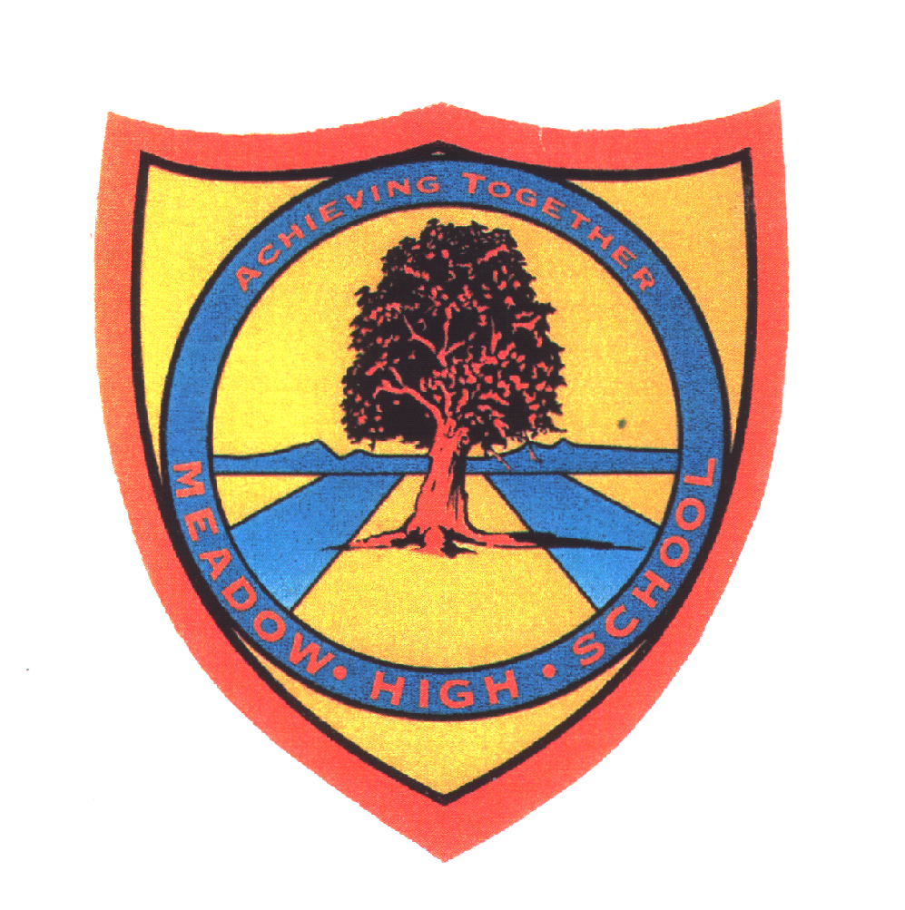 | Pathway 1 | Cycle 1  KS 4 (Pathways 1) | Term Summer
Learning Intention: This SOW aims to teach how to search for information on the Internet, how to use Google maps and how to access online shopping websites.
Key knowledge that should be learned during this SoW |  | All | Most | Some
Concept: |  | The pupils will understand the concept of searching for information on the Internet. | In addition to the previous, the pupils will understand relevant to Google maps concepts like directions, maps, distance, route. | In addition to the previous, the pupils will understand the meaning of online shopping and translation.
Knowledge: |  | The pupils will understand that the Internet is used for searching for information online and for entertainment. | In addition to the previous, the pupils will understand other uses of the Internet like using Google maps to find places nearby and compare means of transport and routes. | In addition to the previous, the pupils will understand other uses of the Internet, like online shopping and translation.
Key Skills: |  | The pupils will be able to search for information on the Internet. They will be able to find what the weather will look like, search for answers to questions, search for pictures and games. | In addition to the previous, the pupils will be able to use Google maps to search for places nearby, routes, distances and means of transport. | In addition to the previous, the pupils will be able to find where and what they want to shop online. They will also be able to compare the climate in different countries and find information about them. In the end, they will understand how to use Google translate.
Language and/or communication skills: |  | The pupils will develop language skills, so they can independently search for information on the Internet. This skill will reinforce their ability to type, read and decode information on the computer screen. The pupils will learn the following keywords: Internet, information, pictures, entertainment, search, Google maps, Amazon, Youtube, Google translate. | In addition to the previous, the pupils will develop language skills, so they can independently use Google maps and plan their journeys. The pupils will learn the following keywords: Internet, information, pictures, entertainment, search, Google maps, directions, map, route, compare, transport, Amazon, Youtube, video, song, Google translate. | In addition to the previous, some pupils will become independent travellers. They will also be able to understand how online shopping works and possibly be able to use it in the future. The pupils will learn the following keywords: Internet, information, pictures, entertainment, search, Google map, directions, map, route, compare, country, transport, Amazon, online shopping, Youtube, video, song, Google translate.
Curricular Links |  | Links to other learning within the subject and spiral learning links: Accessing websites, use of the Internet, use of Google maps, entertainment online, finding pictures online, finding information online.  Cross-curriculum links: English: speaking, listening, reading, writing, typing, pictures., Geography.

