Meadow High School
Royal Lane, Hillingdon, Middlesex UB8 3QU

Telephone: (01895) 443310
Email: meadow@meadowhighschool.org
Website: www.meadowhighschool.org

Headteacher: Mrs Jenny Rigby
Deputy Headteacher (Royal Lane): Miss Michelle Taylor
Deputy Headteacher (Northwood Road): Miss Amy Willis
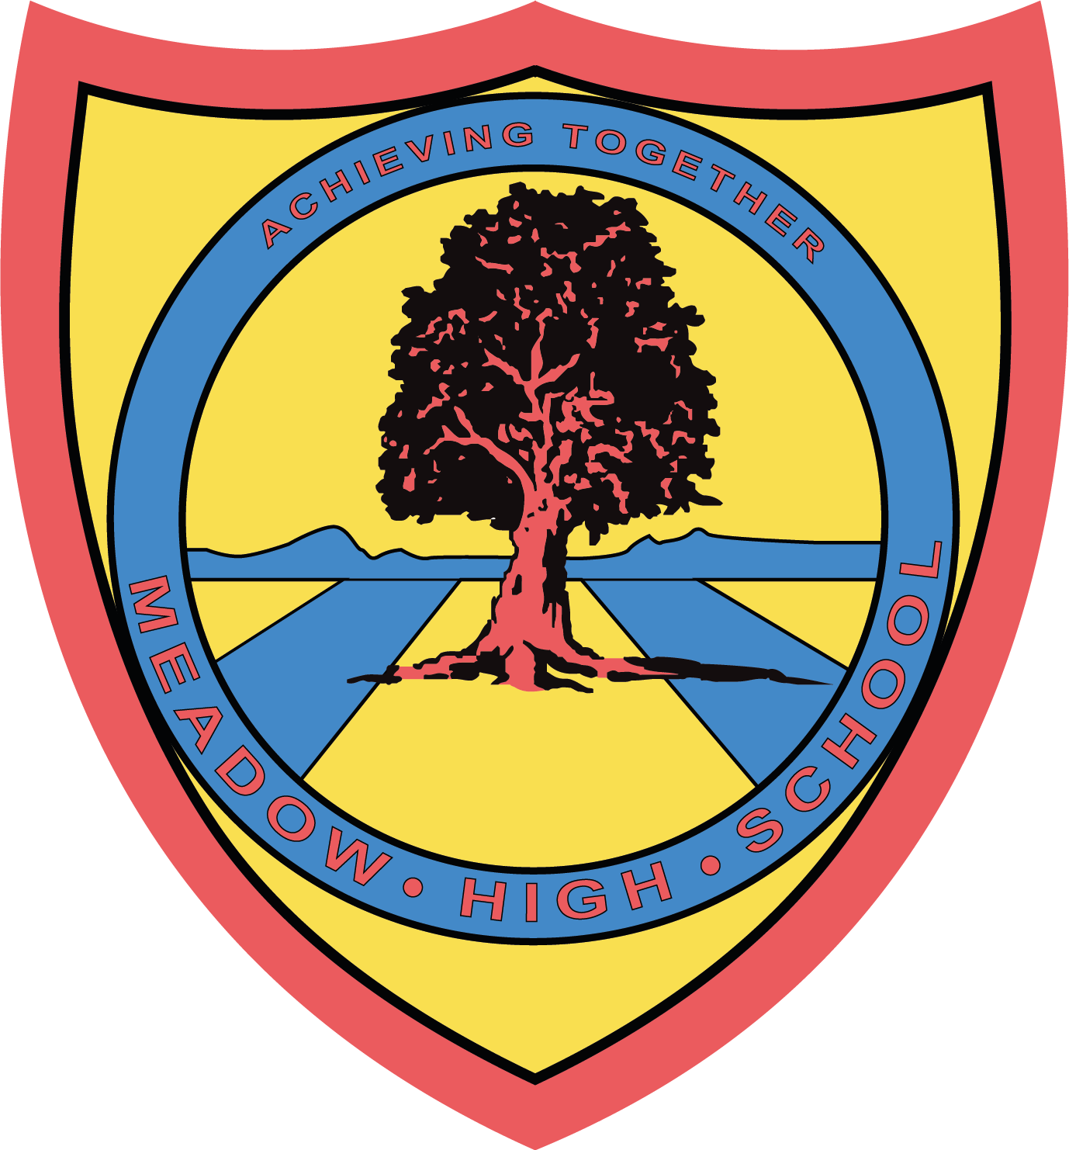

1st May 2025

Dear Parents/ Carers,

Year 11 Sports Leaders; Festival

To support your child’s Sports Leaders course, your child has volunteered to lead an event for a Primary school festival on Tuesday 6th May. The event will be taking place between 09:00 – 14:30 so no extra travel arrangements need to be made.

Pupils will need to bring their own packed lunch for this event. If your child is entitled to a free school meal then a packed lunch will be provided; please indicate which sandwich on the reply slip.

On the day your child should come into school in their PE kit and ‘Sports Leader’ jumper (weather dependent; including a sun hat and sunscreen if needed). Your child will also need to bring a bottle of water with them.

If you have any questions just let me know.

Kind regards,
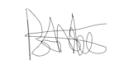
Mr. Anstee
PE Faculty Lead

Article 23:- 'A child with a disability has the right to live a full and decent life with dignity and independence, and to play an active part in the community.'


___________________ for the reply slip, turn over ___________________

REPLY SLIP: Year 11 Sports Leaders; Festival – please return to Mr Anstee

I am aware that my child ……………………………………….…………………………..…….… medical needs/ medication has changed since the last time I notified the school

My child is bringing their own packed lunch

My child has free school meals and would like a: tuna / cheese / egg sandwich (please circle)

I have attached medical documentation to help the school update their Risk Assessment

Or

I acknowledge that there are NO updates to report for my child ……………………………..…………………………….

My emergency contact details are ______________________________________

Signed: _______________________________ Print Name: _____________________________

