Meadow High School
Royal Lane, Hillingdon, Middlesex UB8 3QU

Telephone: (01895) 443310
Email: meadow@meadowhighschool.org
Website: www.meadowhighschool.org

Headteacher: Mrs Jenny Rigby
Deputy Headteacher: Ms Claire Caddell
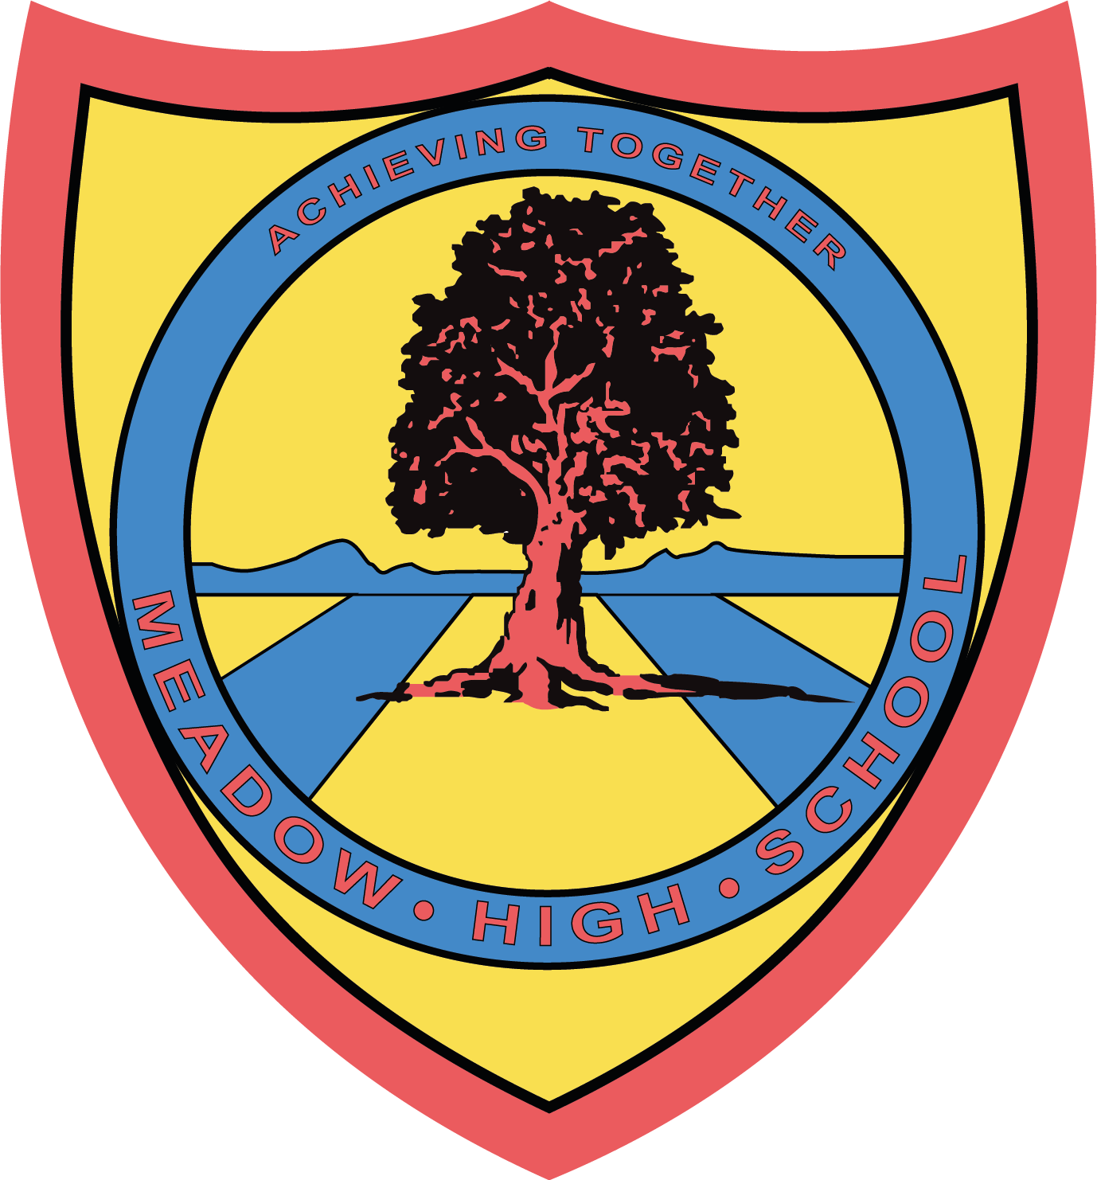

18th July 2023
Dear Parents/Carers,
Vocational Pathways
Meadow High school offers a wide range of Vocational Pathways to Sixth form pupils so that they can learn and develop essential employability skills. Most of these skills are transferable in supporting a pupil's increased independence. Every student will receive a detailed induction programme to enable them to perform each pathway safely and ensure they fully understand their role and responsibilities. All these pathways run under close supervision and guidance of our experienced staff. Year 12-14 students participate in various Vocational Pathways one day per week and some of these pathways are off-site (out in the community).
Current Year 11 students attended the Vocational Pathways assembly at school highlighting the aim and benefits of this programme and how it is delivered. Your child also had an opportunity to experience some of these pathways as per their choices on 11/07/2023. From September 2023, students will be participating in these pathways and will be rotated every term. Where possible students who are independent travellers (or parents/carers who can support travel arrangements) and are confident with completing work experience outside of school, will be placed in the community and we encourage and support them to do so.
Please read the brief description of these pathways:
On-site Pathways:
Tuck Shop: Students run a school tuck shop at break time and serve hot food/drinks.
Tasks involved: - Setting up, cleaning and sanitising the tables, setting up equipment for the shop such as food warmer, toastie maker, induction hob and smoothie maker. Preparing hot dogs (halal and normal) and cheese toasties. Displaying items such as water, juice, hot drink cups, tissues and so on ready for sale. Counting the cash tin, selling food to the students and staff and maintaining overall good standards of hygiene.
School Charity shop: Students gain work experience in the school charity shop to build great customer service skills. (Please note the charity shop is currently closed until further notice due to new construction starting in the Summer holidays 2023).
Tasks involved: Sorting out donated items, setting up the charity shop in a presentable manner, learning customer services skills such as meet and greet, assisting them and selling items, pricing and tagging items, counting money in the till, money management and other admin jobs such as creating advert leaflets, laminating and distribution.
Site-team: Students are also great at supporting our school site team by doing different jobs within school.
Tasks involved: Distributing resources such as printing paper, paper towels, anti-bacterial wipes, blue tissue roll, facial tissues around the school. Provide support with various cleaning tasks such as window cleaning, litter picking etc. Support with site inspections, assisting the site team with deliveries and any other tasks as requested/directed by the site team.
Crunchy-Munchy: Students prepare fresh food for the school staff as part of their Catering Assistant pathway.
Tasks involved: Buying ingredients from the local supermarket and preparing and serving the meal as per the recipe. Time management - Prepare the meal by the given time, packing the cooked meal into containers and ready for collection, delivering food to the designated staffroom, tidying up the kitchen and maintaining high levels of food hygiene standards. P.T.O.
Office/Administrative/Receptionist:
Tasks involved: Archiving, managing school display boards, creating posters, any others resources requested by school staff such as information for school charity events, budgeting - calculating expenses and sales from the shopping and sales receipts, creating spreadsheets, learning to do emails including attachments, CC, BCC and general office/admin tasks such as laminating, printing, scanning, distributing letters to the classes.
Enterprise: Students produce quality items during these sessions, which can be sold in the school Charity shop or at event sales within the school such as Christmas, Mother’s day, Valentine ’s Day and so on.
Hairdressing: Students support to run a hair salon for the school staff and students.
Tasks involved:- Setting up the salon for customers, making appointments, meet and greet customers, money handling, assisting the hairdresser instructor (Teacher), tidying up the hair salon and equipment and following health and safety rules at all times.
Vehicle Cleaning: Students carry out general cleaning of the school vehicles (mini-buses and 7/9-seater cars) from inside with the staff full support delivering good standards of service.
Car Wash: Students will learn how to wash a car professionally using various tools/equipment such as the jet wash, hoover and hosepipe. Students will also build knowledge on effective and efficient use of various cleaning products such as car shampoo, shining sprays, T-cut, wheel cleaners and so on.
General cleaning (House kitchen/staffroom/student common room):- Students will carry out general cleaning tasks in various areas, to build their practical skills and independence.
Off-site Pathways
Iver Environment centre (IEC) in Uxbridge and Rural Activities Garden Centre (RAGC) in Stockley: Students volunteer on a weekly basis at these local community centres. They complete various tasks delegated to them and they work as part of a team with other members of staff.
Tasks involved: General maintenance of grounds and site, sowing seeds according to the weather, maintaining and watering the plants, following health and safety rules and learning to use different gardening tools.
Heathrow Special Needs Farm, West Drayton: On a weekly basis, our students support farm staff in general maintenance of their site, collecting fresh eggs, cleaning/preparing animals cages and preparing (cutting/chopping) food for animals and following health and safety rules at all times.
The Burroughs (Care Home in West Drayton): Students volunteer at the local care home and carry out general tasks as given by the care home staff, such as; setting up/clearing tables, making beds, supporting the site team with various tasks. Students also plan and organise visits for residents at school and serve them tea and food. Residents also have the opportunity to pamper themselves in our school salon.
Shopping Assistant - Students learn to shop in the local supermarkets focusing on essential skills such as money management, buying fresh food, bagging items correctly, following the shop layout effectively to pick items, buying items that are value for money, asking for help from the shop staff and so on.
Work Experience: Students who are confident to work in the local community and are able to make independent travel arrangements, can complete work experience on individual work placements such as local garden centres, cafes, shops and so on. These placements will be term-time only and with a minimum of 4 hours per week (one day as per school timetable).
Please feel free to discuss this with your child so that they understand the purpose of these pathways and benefits they will gain by participating.
Kind regards,

Vocational Team

