Meadow High School
Royal Lane, Hillingdon, Middlesex UB8 3QU

Telephone: (01895) 443310
Email: meadow@meadowhighschool.org
Website: www.meadowhighschool.org

Headteacher: Mrs Jenny Rigby
Deputy Headteacher: Ms Claire Caddell
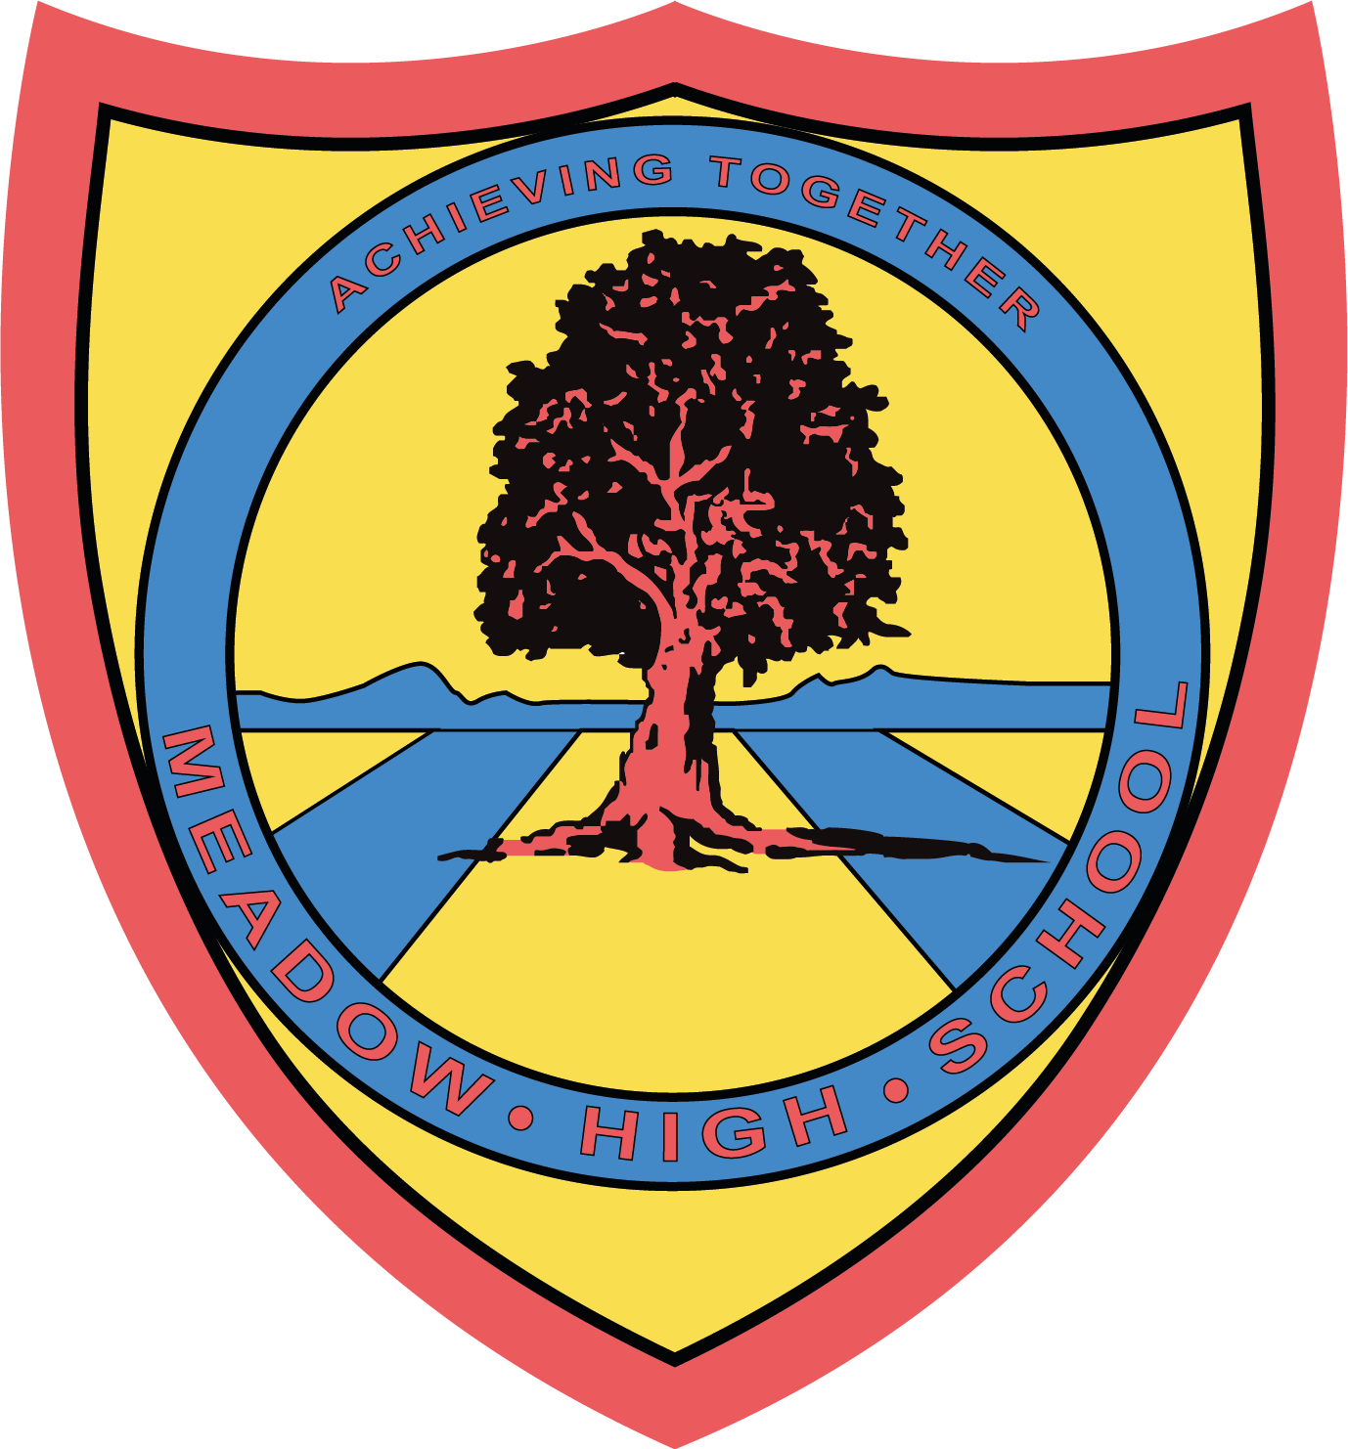

January 2023

Dear Parent/Carer,

For their Unit Award in Food Technology, pupils will be focusing on 4-6 units of work, with a range of different cooked products. Pupils will be taking part in some theory lessons to further their understanding of Health and Safety in the kitchen and practical lessons where they will be building up their confidence towards everyday cooking.

Pupils will also take part in sensory evaluations of various foods. If you wish your child to take home the products that they prepare, the amount required for the practical and taste-testing lessons will be £10.00 for each Term.

If you are unable to make this payment in full, please contact the school office.

Thank you in advance.

Mrs Shukla
Food Technology Department

PLEASE MAKE ALL PAYMENTS VIA PARENTPAY. IF YOU REQUIRE LOGIN DETAILS OR ASSISTANCE, PLEASE CONTACT RECEPTION.

