Meadow High School
Royal Lane, Hillingdon, Middlesex UB8 3QU

Telephone: (01895) 443310
Email: meadow@meadowhighschool.org
Website: www.meadowhighschool.org

Headteacher: Mrs Jenny Rigby
Deputy Headteacher PW2/3: Ms Claire Caddell
Deputy Headteacher PW1: Miss Amy Willis
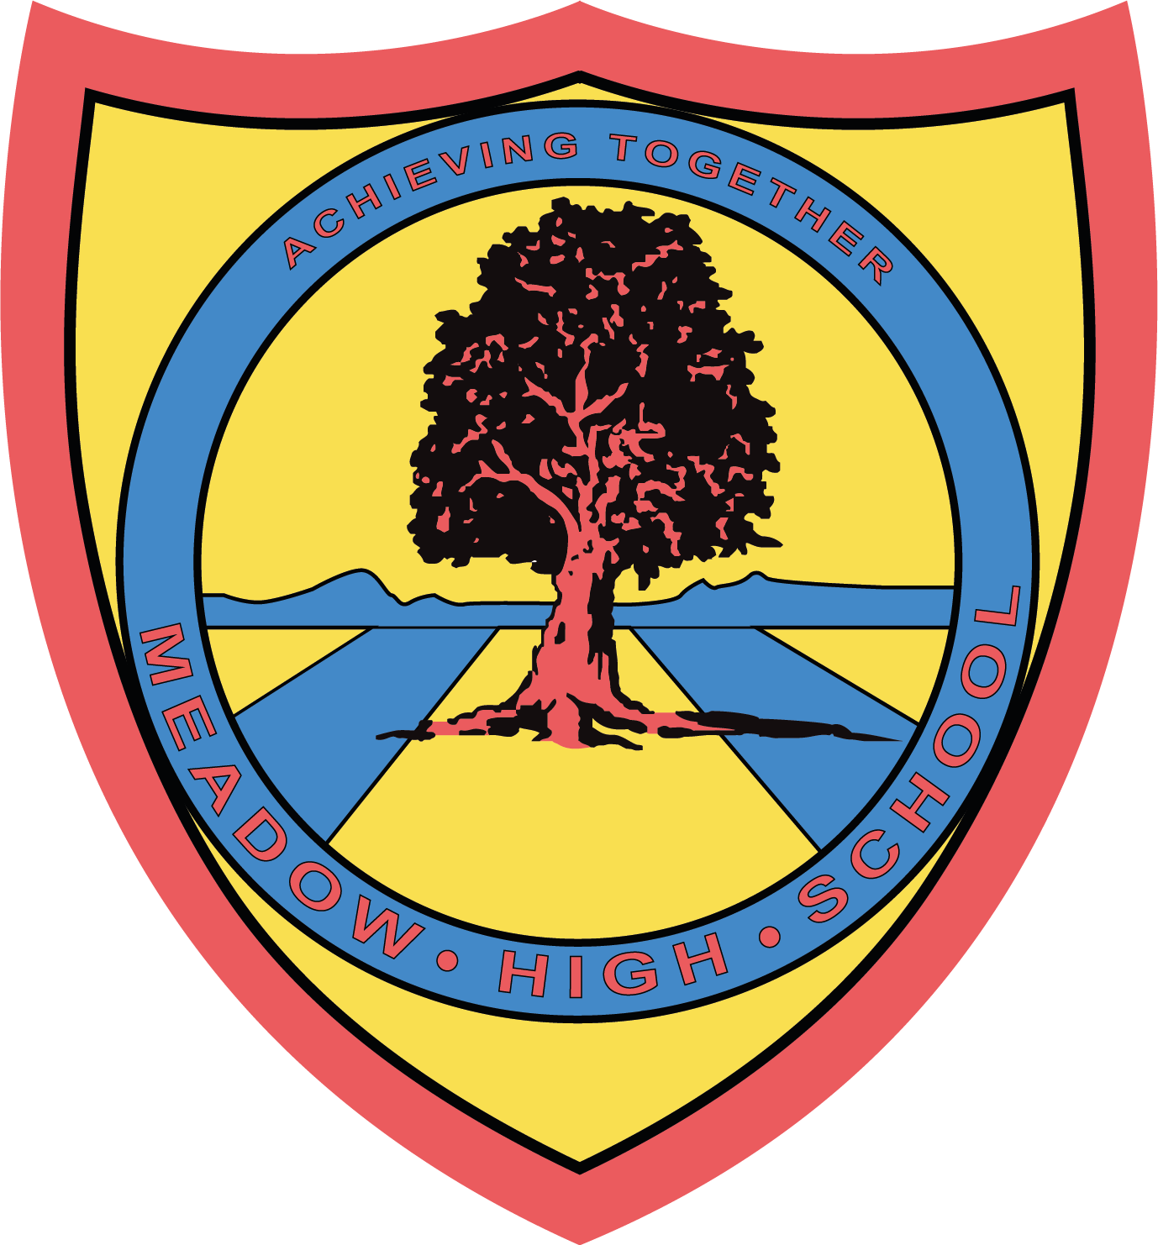

Monday 11th December 2023

Dear Parent/Carer,

As Christmas approaches, we kindly ask that you please bring back all library books your child may have borrowed from the school Library before the end of the school term.

Please return all library books back to school by Thursday 21st December.

Once your child has returned all of their library books, they will have the option to choose one book to take home over the Christmas break.

Please note that if book(s) are not returned, are lost or are damaged beyond repair, a letter will be sent home asking for payment towards a replacement. We will discuss this with your child’s form tutor first to consider any extenuating circumstances before sending out any requests for replacement costs.

If you are unsure which books your child may have borrowed, please contact our Librarian, Miss S Gaafar, at sgaafar@meadowhighschool.org, who will be happy to help you.

Kind Regards,

Miss S Gaafar
Librarian (Supporting and Delivering Learning)

Article 23:- 'A child with a disability has the right to live a full and decent life with dignity and independence, and to play an active part in the community.'



