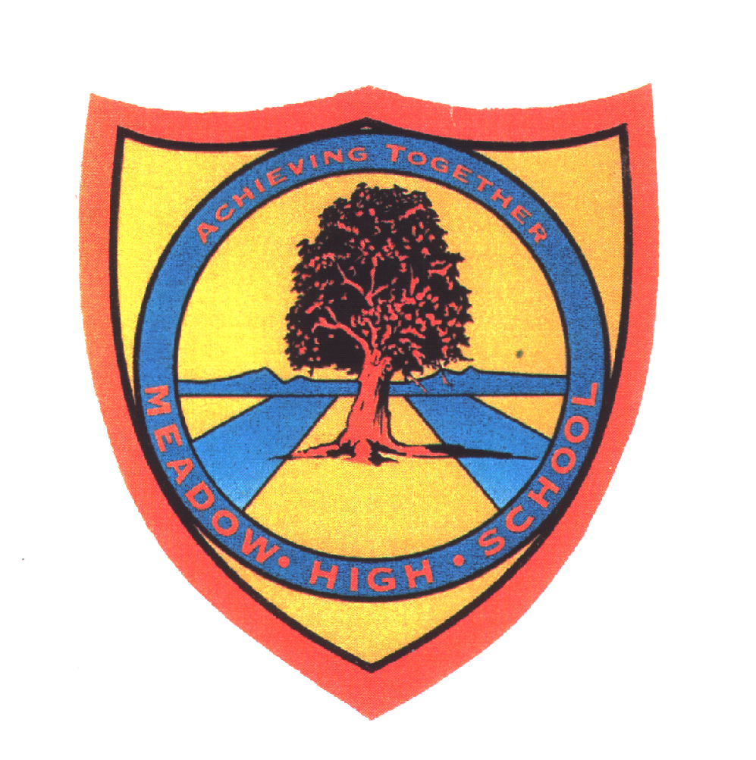 | Pathway 1 | KS4  Performing Arts  Cycle 2 | Spring Term 2  Castles
Learning Intention: Drama based unit. By the end of this unit pupils will have explored stories about knights and dragons, explored the ideas of heroes and villains in stories, and worked as a group to develop their own hero and villain story.
Key knowledge that should be learned during this SoW |  | All | Most | Some
Concept: |  | Character and setting | Heroes and villains. Creating characters and settings. | Story structure and character motive
Knowledge: |  | Know what the terms character and setting mean, including that not all characters in stories are human | Know that some stories have heroes and villains in them. Know that it is important to warm up before physical activities. How to warm up safely | To know that stories have a beginning, middle and end.  How to construct simple descriptive sentences. That characters in stories need to have a reason for their actions
Key Skills: |  | Be able to identify the characters and settings in familiar stories. Identify features of settings in familiar stories. Identify some characteristics of characters in familiar stories. Begin to create own characters identifying name and role (e.g. Anna the princess). Use own characters to act out actions. | How to warm up safely. Be able to identify heroes and villains in familiar stories. Begin to create own characters and settings with some consideration of features.  Begin to tell simple stories using their own or familiar characters. | Create stories with a clearly defined beginning, middle and end. Identify the motive behind the actions of familiar characters and characters they have created.
Language and/or communication skills: |  | character  setting  story  sequence  events  Use of signalong and widgit symbols to support access to and learning of new language | warm-up  hero  villain  plan  Use of ELKLAN sequencing diagrams to support creating/structuring story  Use of Mindmaps to explore theme of heroes and villains and creation of characters | compare  motive  Use of Colourful Semantics to support construction of sentences  Use of ELKLAN colourful stories grid to support creating/structuring story
Curricular Links |  | En1/1a listen and respond appropriately to adults and their peers  En1/1b ask relevant questions to extend their understanding and knowledge  En1/1c use relevant strategies to build their vocabulary  En1/1i participate in discussions, presentations, performances, roleplay/improvisations and debates  En1/1k consider and evaluate different viewpoints, attending to and building on the contributions of others  Ar1/1.2 to use drawing, painting and sculpture to develop and share their ideas, experiences and imagination  Ge1/1.3b use basic geographical vocabulary to refer to:  - key physical features, including: beach, cliff, coast, forest, hill, mountain, sea, ocean, river, soil, valley, vegetation, season and weather  - key human features, including: city, town, village, factory, farm, house, office, port, harbour and shop  PE1/1.1a master basic movements including running, jumping, throwing and catching, as well as developing balance, agility and co-ordination, and begin to apply these in a range of activities

