Meadow High School
Royal Lane, Hillingdon, Middlesex UB8 3QU

Telephone: (01895) 443310
Email: meadow@meadowhighschool.org
Website: www.meadowhighschool.org

Headteacher: Mrs Jenny Rigby
Deputy Headteacher: Ms Claire Caddell

Dear Parent/Carer,

On Tuesday 13th December 2022-Thursday 15th December inclusive, we are planning a Pathway One department trip to the Beck Theatre to watch a pantomime version of ‘Cinderella’. Tickets are £14.00 each and we are seeking voluntary contributions from families to support the cost of the trip. This includes an ice cream. This can be paid via Parentpay.

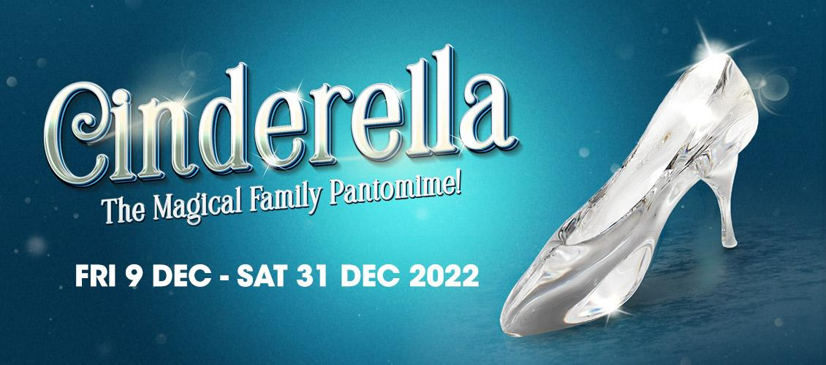

We will visit during normal school hours. Pupils should be wearing school uniforms. We will be traveling by school minibus, which will be driven by MIDAS (qualified) trained drivers.

Please see below for the date your child's class will be visiting.

Tuesday 13th December- Classes JE and SM
Wednesday 14th December- Classes IM an MP
Thursday 15th December- Classes SS, YA and JR.

Pupils will require a healthy packed lunch on the day, however, if your child is entitled to a free school meal we can provide a packed lunch for them if you wish (please indicate a sandwich choice on slip below). Please also indicate an ice cream flavour preference.

Please complete the permission slip below. If you have any questions, please do not hesitate to contact your child’s form tutor or myself.

Yours faithfully,

Miss Willis
Assistant Head Teacher- Pathway 1

-------------------------------------------------------------------------------------------------------------------------------
REPLY-SLIP: Pathway 1 Pantomime Trip
please return to Miss Willis

Name of Child: ……………………………………………………………….

( ) I would like my child to attend.

( ) I will pay the voluntary donation of £14.00 to cover my child's ticket and ice cream. (paid via Parent Pay)

( ) I will be providing my son/daughter with a healthy packed lunch

( ) My son/daughter is entitled to a free school lunch, please provide one for him/her
Please specify the sandwich filling below
( ) Egg Mayonnaise ( ) Tuna Mayonnaise ( ) Cheese

( ) My child would like the following ice-cream flavor: (please mark one)
( ) Blackcurrants in clotted cream ( ) Chocoholic Heaven ( ) Heavenly Honeycomb
( ) Mint Choc Chip ( ) Salted Caramel ( ) Strawberries in Clotted Cream
( ) Vanilla Clotted Cream ( ) Lemon sorbet ( ) Plant based Salted Caramel

Signed………………………………………. Date…………….

