Meadow High School
Royal Lane, Hillingdon, Middlesex UB8 3QU

Telephone: (01895) 443310
Email: meadow@meadowhighschool.org
Website: www.meadowhighschool.org

Headteacher: Mrs Jenny Rigby
Deputy Headteacher (Royal Lane): Miss Michelle Taylor
Deputy Headteacher (Northwood Road): Miss Amy Willis
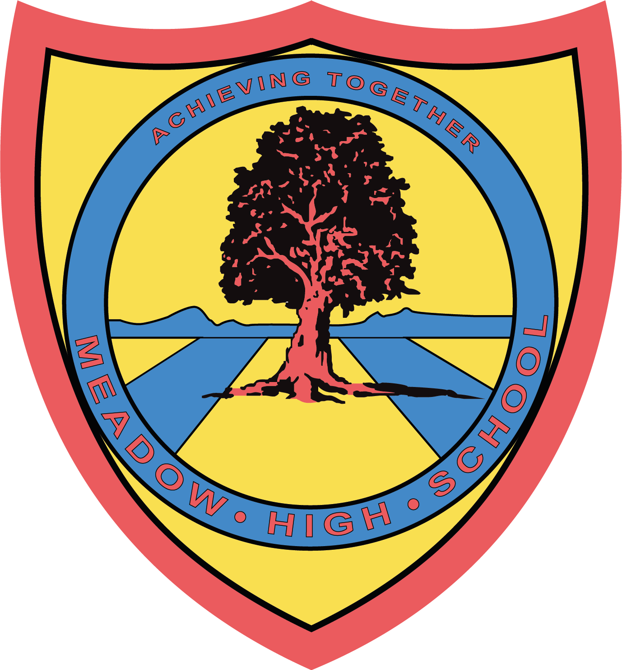

16th June 2025

Dear Parents/Carers,

To support your child with their learning, we have arranged an educational visit to Pizza Hut, Hayes on Monday, 23rd June 2025 as part of their studies in Maths.

We will be leaving school at 1.15pm and returning to school at 2.45pm. We will be travelling by school
Minibus, First Aiders will also accompany us. Students will view the Menu and will be ordering and paying for their meal as part of their learning.

Students can bring £10.00 towards the Meal, for which they will be responsible.

We hope that your child will be able to take part in this trip, as it is designed to support the learning that takes places in the lesson.

Please complete the attached slip and return as soon as possible. If you have any enquiries please feel free to contact me.

Yours sincerely,

Mrs Porter
Form Tutor

Article 23:- 'A child with a disability has the right to live a full and decent life with dignity and independence, and to play an active part in the community.'


…….……………………………………………………………………………………………………………….
REPLY-SLIP: Pizza Hut Trip: Monday, 23rd June 2025, please return to Mrs Porter

I give my permission for ………………………………………….…to take part in the above trip.

Signed (Parent/Carer): …………………………………………………….. Date: ………..………….
Emergency contact number: ………………………………………………………

