Meadow High School
Royal Lane, Hillingdon, Middlesex UB8 3QU

Telephone: (01895) 443310
Email: meadow@meadowhighschool.org
Website: www.meadowhighschool.org

Headteacher: Mrs Jenny Rigby
Deputy Headteacher: Ms Claire Caddell
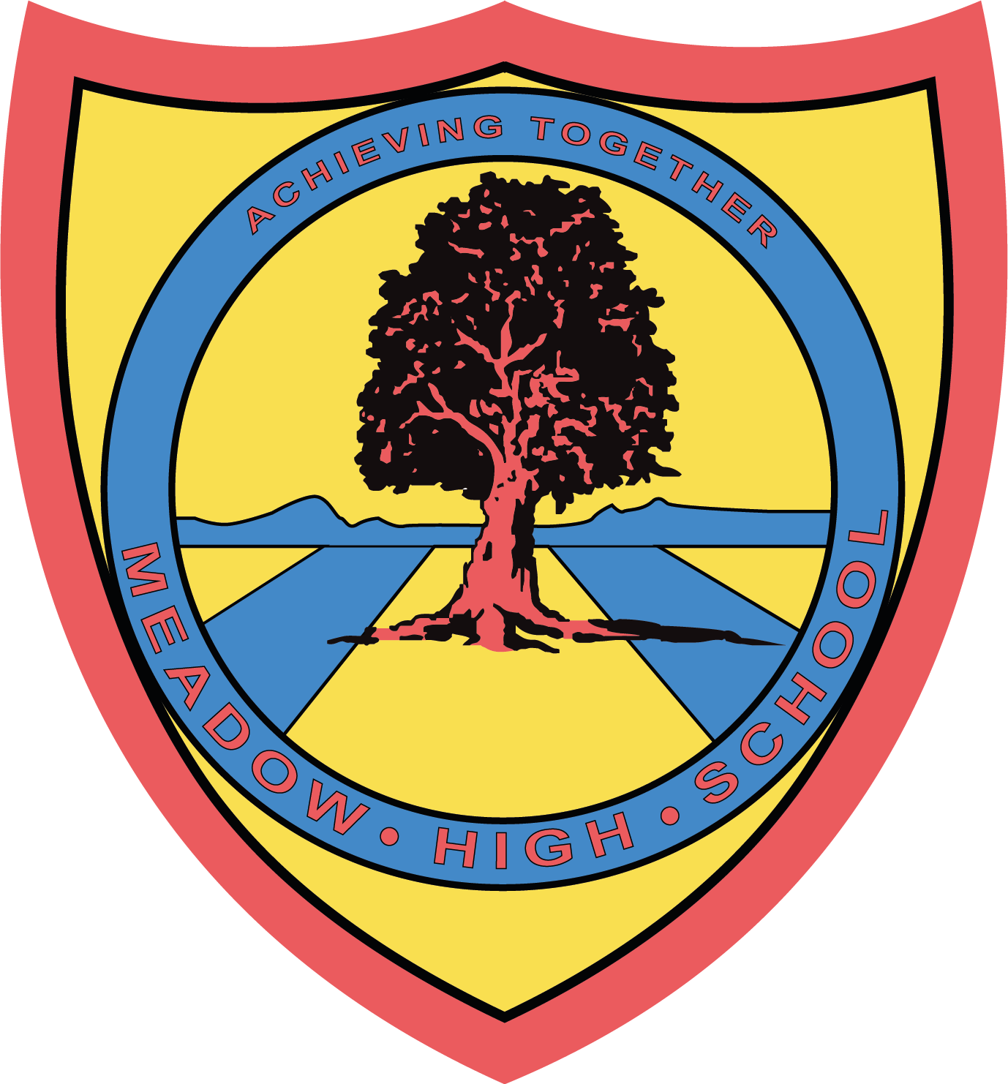

17th March 2023
Dear Parents / Carers,

Year 8 PSHE Teambuilding Trip – Airport Bowl – Monday 27th March 2023

As part of their PSHE topic about building relationships and teambuilding, 8HA students have chosen to go to the Airport Bowl. In order for the trip to take place, we ask for a voluntary contribution of £6 to be paid via ParentPay.

On the day, if pupils would like, they can bring with them £5 for McDonalds. If your child would prefer packed lunch, please provide that. If your child is entitled to a free school meal, we can provide a packed lunch. Please indicate below, along with sandwich choice.

If you are happy for your child to visit the arcade, please provide spending money of £5 maximum.

The event will be taking place on Monday 27th March during school hours. We will leave school at 10:00 and return at 14:00.

Please complete and return the reply slip as soon as possible. If there are any problems or questions then please contact me at school.

Kind Regards,

Mrs H Ali
Form Tutor
@MeadowPE

Article 23:- 'A child with a disability has the right to live a full and decent life with dignity and independence, and to play an active part in the community.'


___________________________________________________________________________
REPLY SLIP: 8HA – Airport Bowl - please return to Mrs Ali

My child will be having McDonalds.

My child will be provided with a healthy packed lunch.

My child is entitled to a free school meal and would like a lunch provided

Tuna ( ) Cheese ( ) Egg Mayo ( ) please tick sandwich choice

I have paid £6 contribution via ParentPay.

Signed: ___________________________________

