Meadow High School
Royal Lane, Hillingdon, Middlesex UB8 3QU

Telephone: (01895) 443310
Email: meadow@meadowhighschool.org
Website: www.meadowhighschool.org

Headteacher: Mrs Jenny Rigby
Deputy Headteacher: Ms Claire Caddell
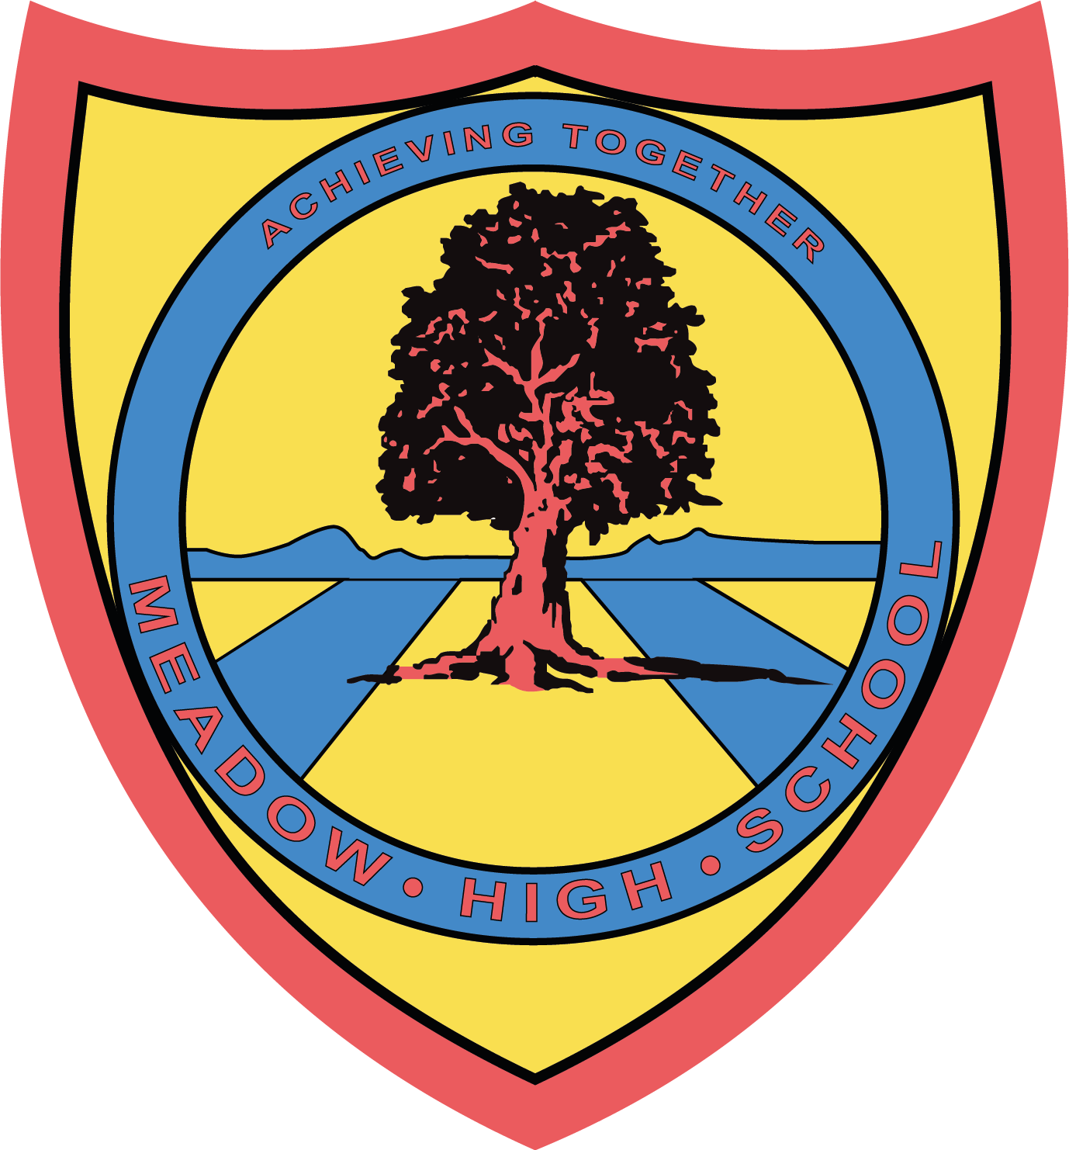

3 May 2023

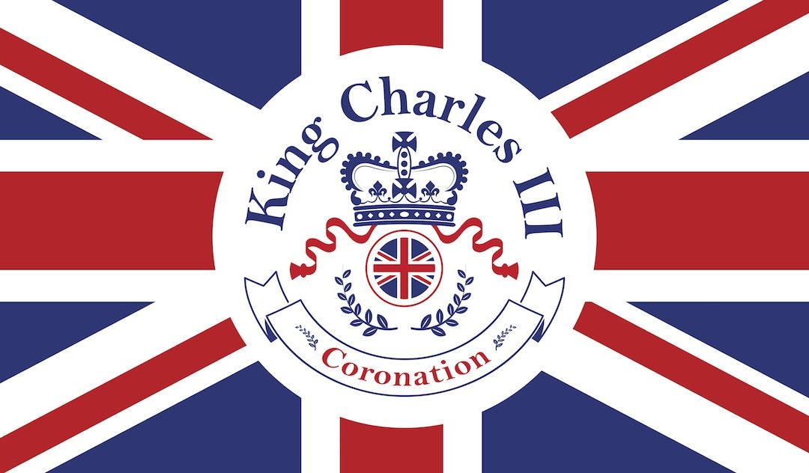

King's Coronation Celebration Day
Friday 5th May

We have a very exciting day planned to celebrate King Charles' Coronation on Friday 5th May!

Students will begin the day in their form classes making their very own crowns and learning about the Royal Family.

The lunch menu will be different, as students will be making their own lunch to have at our extra special picnic! If you would prefer for your child to bring their own packed lunch, please feel free to do so.

We will end the day with a disco and a Coronation Crown parade!

Students are welcome to dress in non-uniform with red, white and blue colours

Kind Regards,

Sarah Gaafar
Librarian (Supporting and Delivering Learning)
School Events Coordinator

