Meadow High School
Royal Lane, Hillingdon, Middlesex UB8 3QU

Telephone: (01895) 443310
Email: meadow@meadowhighschool.org
Website: www.meadowhighschool.org

Headteacher: Mrs Jenny Rigby
Deputy Headteacher PW2/3: Ms Claire Caddell
Deputy Headteacher PW1: Miss Amy Willis
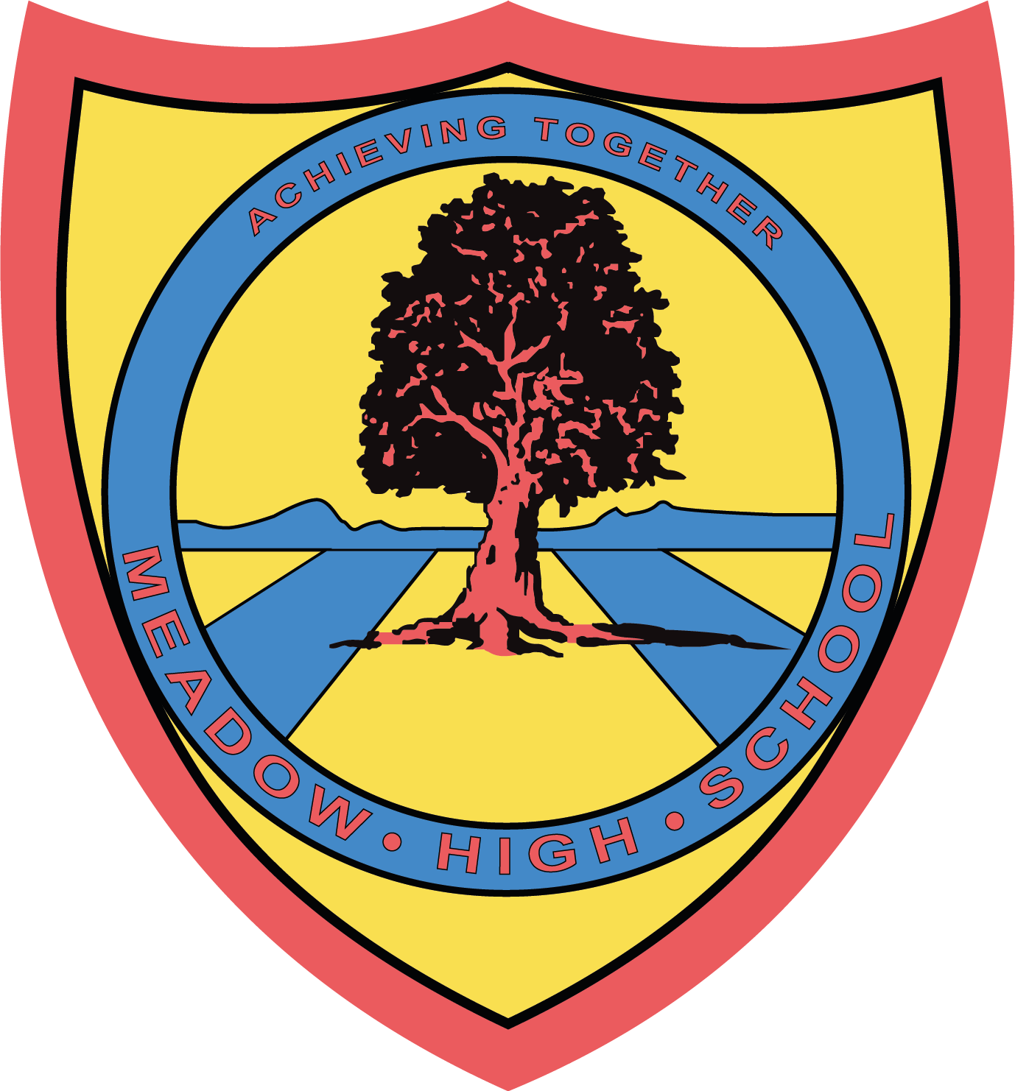

Wednesday 12th June 2024



Dear Parent/Carer,

With the invaluable support from our families, our students and our Governors here at Meadow, we now have our brand new library, which opened its shiny new doors in June 2023. Our library is a warm, welcoming and vibrant space that is the new hub of our school.

The library is always bustling with students, whether it is during a weekly class visit or at break and lunchtimes and we have already had some fantastic events take place in our library, including our Scholastic Book Fair and our Harry Potter Day celebration!

We are now entering our third year of establishing our new library space, and we have been invited to take part in a competition to win extra funding to put towards even more amazing new resources for our students and our library.

National Book Tokens are giving schools across the UK the chance to win £1,000 in National Book Tokens and a year’s free membership to the School Library Association, PLUS one overall winner will also receive £500!

We are asking for your much-needed support to help us continue our development of a fun and welcoming library space for all by nominating Meadow High School for the National Book Tokens prize. All you need to do is visit https://www.nationalbooktokens.com/schools-prize and enter your email address, contact details and "Meadow High School" as your chosen school.

The closing date for nominations is Wednesday 31st July 2024.

Kind Regards,

Miss S Gaafar
Librarian (Supporting and Delivering Learning)

Article 23:- 'A child with a disability has the right to live a full and decent life with dignity and independence, and to play an active part in the community.'


