Meadow High School
Royal Lane, Hillingdon, Middlesex UB8 3QU

Telephone: (01895) 443310
Email: meadow@meadowhighschool.org
Website: www.meadowhighschool.org

Headteacher: Mrs Jenny Rigby
Deputy Headteacher (Royal Lane): Miss Michelle Taylor
Deputy Headteacher (Northwood Road): Miss Amy Willis
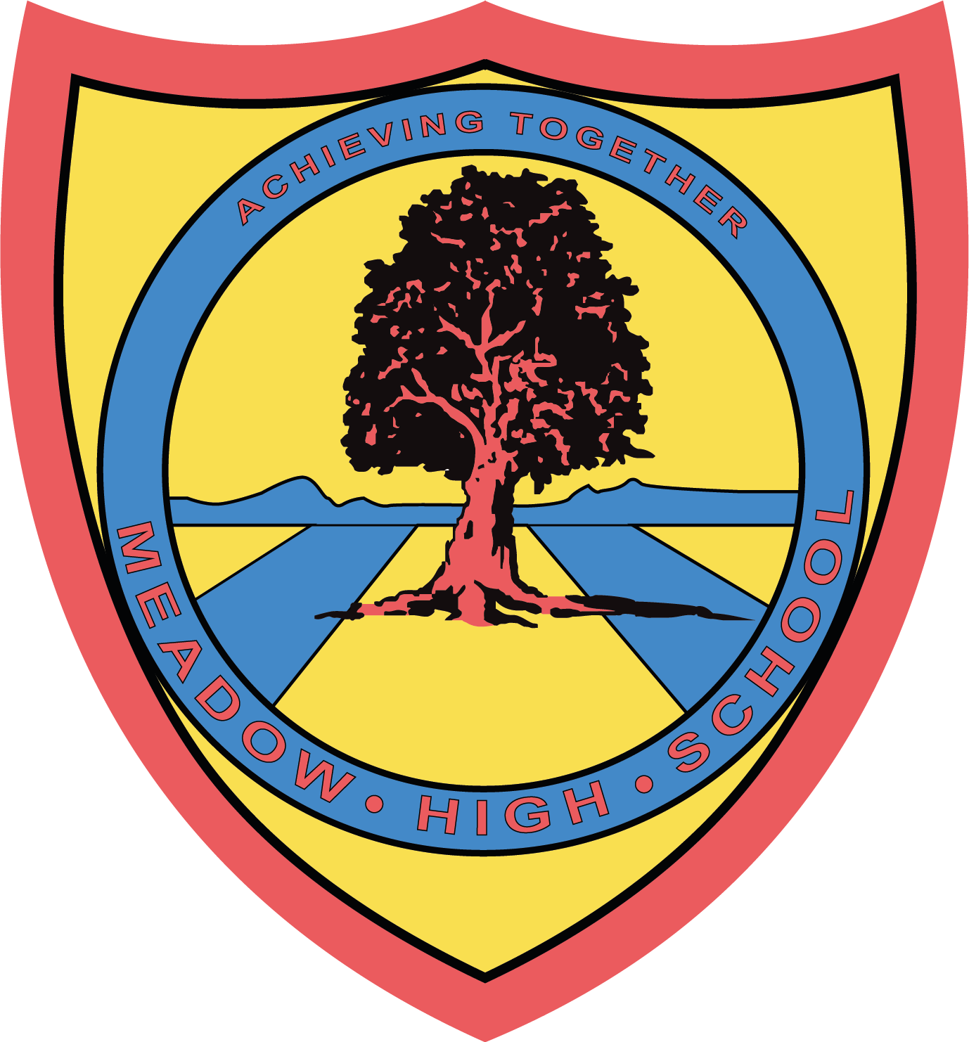

21st July 2025

Dear Parents/ Carers,

6th Form Sports Leaders; Level 2

Your child has picked ‘Sports Leaders Level 2’ for next academic year - we look forward to teaching them.

Just a gentle reminder, for this course your pupil will be required to ‘Lead a minimum of five hours sport/physical activity sessions in the community’. These could include:
• at an extra-curricular setting
• at a sports club
• at a youth club
• any other community setting where there is a responsible adult supervising.

If you/ your child already know of a venue please could this be arranged as soon as possible. However, the pupils would not need to lead a session until later in the year.

If your child may not be able to ‘Lead a minimum of five hours’ then they will not be able to achieve Level 2. We will, however, still teach the skills required to give all pupils the opportunity to utilise these ‘Life After Meadow’.

If you have any questions just let me know.

Kind regards,

Mr. Anstee
PE Faculty Lead

Article 23:- 'A child with a disability has the right to live a full and decent life with dignity and independence, and to play an active part in the community.'


