Meadow High School
Royal Lane, Hillingdon, Middlesex UB8 3QU

Telephone: (01895) 443310
Email: meadow@meadowhighschool.org
Website: www.meadowhighschool.org

Headteacher: Mrs Jenny Rigby
Deputy Headteacher: Ms Claire Caddell
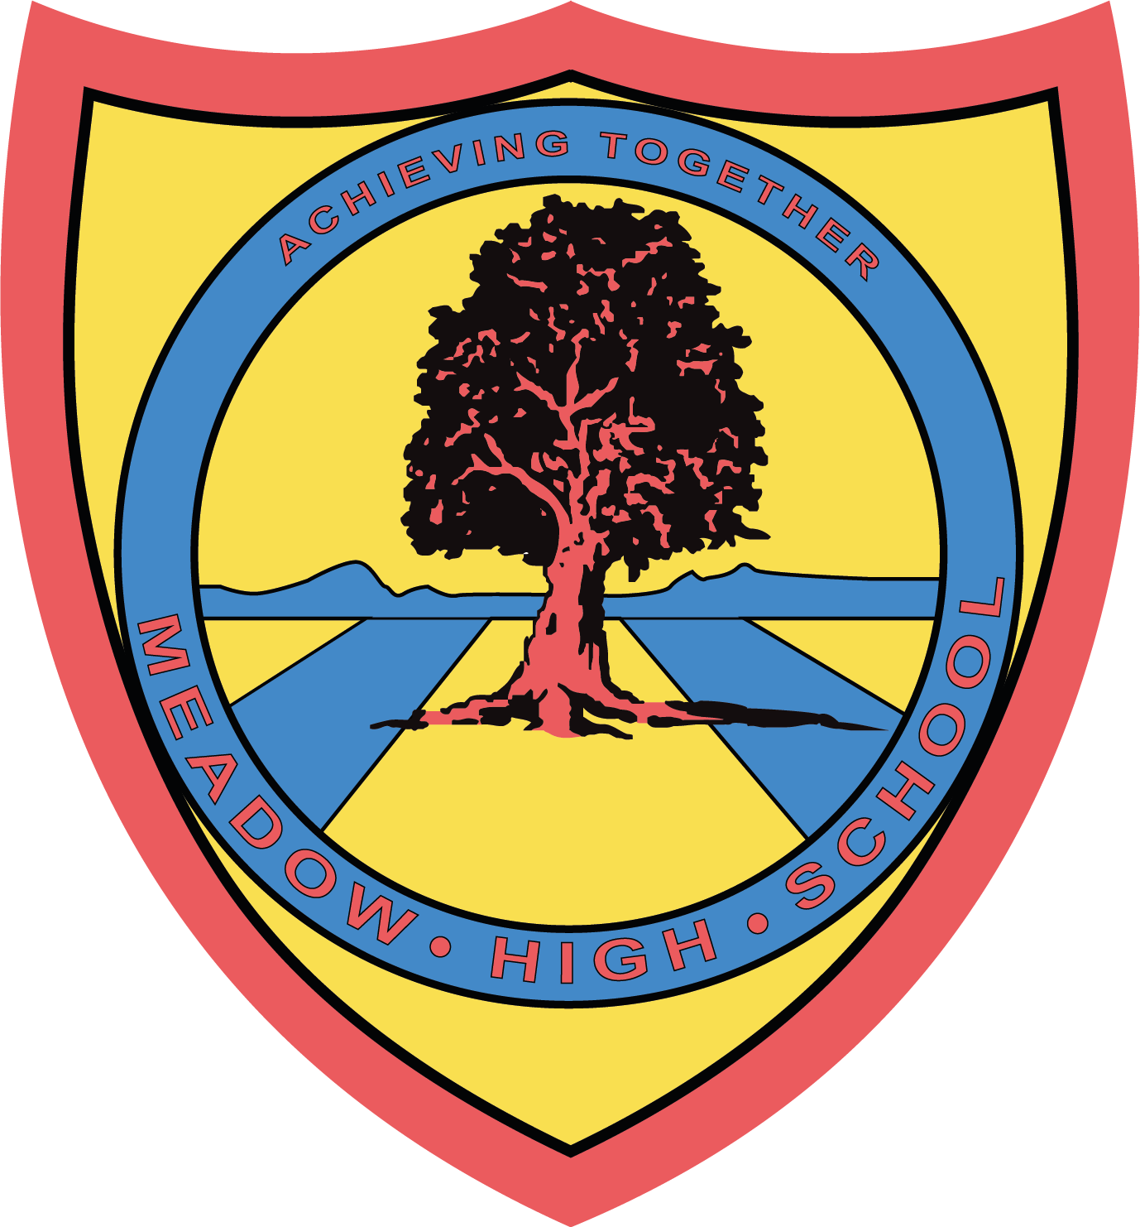

27 June 2023

Dear Parents/Carers,

To support your child with their learning in English, we have arranged an educational visit to Warner Bros. Studio Tour London in Watford on Monday 17th July.

We will be leaving school at 9.15am and returning to school at 2:45pm in time for normal transport home. We will be travelling by minibus, which will be driven by MIDAS (qualified) trained drivers, first aiders will also accompany us.

To cover the cost of the trip, we request a voluntary contribution of £23.00. Should we not receive sufficient funds to run this trip, the trip may not be able to go ahead and donations will be refunded. Please can you make your payment via Parent Pay.

Students will need to bring their own healthy packed lunch and wear sensible footwear. If your child is entitled to a Free School Meal, a lunch can be provided, please indicate below. Students will also be allowed to bring some spending money to spend in the gift shop, a maximum of £10, for which they will be responsible for.

We hope that your child will be able to take part in this trip, as it is designed to support the learning that takes place in the classroom. Please complete the attached slip and return it as soon as possible. If you have any enquiries please feel free to contact Mrs Ali.

Thank you in advance for your help and support.

Yours faithfully,

Mrs H Ali
Year 8 Form Tutor

Article 23:- 'A child with a disability has the right to live a full and decent life with dignity and independence, and to play an active part in the community.'

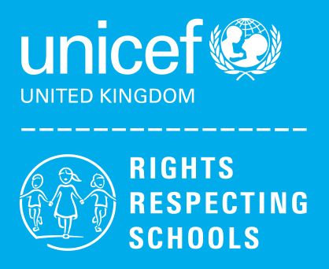
✂-----------------------------------------------------------------------------------------------------------------------------------------
Reply-Slip: Trip to Warner Bros. Studio Tour – Monday 17th July - please return to Mrs Ali.

I am aware that my child………………………………………………………………………….has a trip to Warner Bros. Studio Tour.

( ) I will pay £23.00 via ParentPay

( ) I will be providing my child with a healthy packed lunch

( ) My child is entitled to a free school meal and would like a lunch provided.
Please specify the sandwich filling Egg mayonnaise ( ) Tuna mayonnaise ( ) Cheese ( )

Signed (Parent/Carer): ………………………………………………... Date: ………………

