Meadow High School
Royal Lane, Hillingdon, Middlesex UB8 3QU

Telephone: (01895) 443310
Email: meadow@meadowhighschool.org
Website: www.meadowhighschool.org

Headteacher: Mrs Jenny Rigby
Deputy Headteacher (Royal Lane): Miss Michelle Taylor
Deputy Headteacher (Northwood Road): Miss Amy Willis
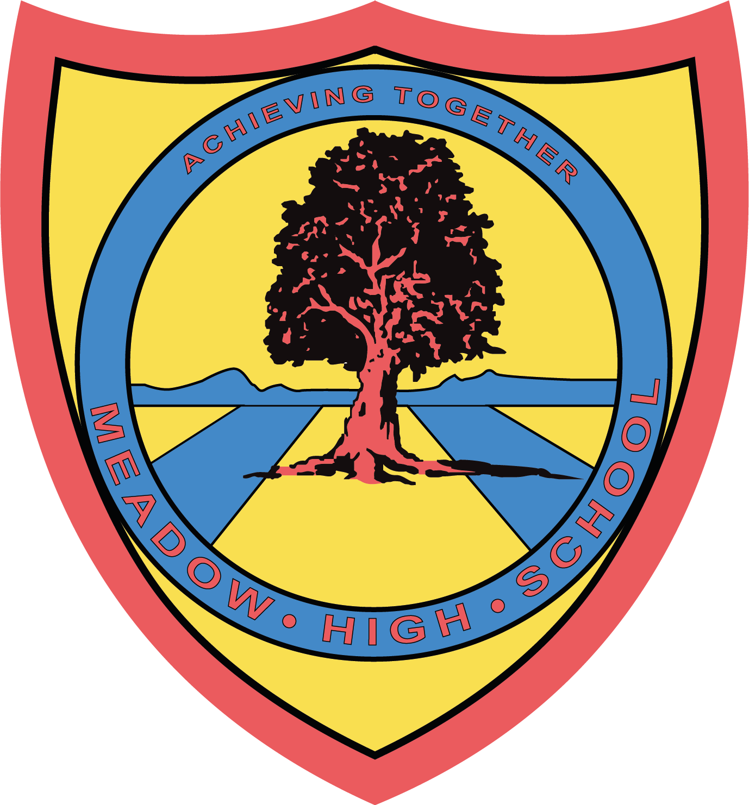



Dear Parent,

During the week of the 3rd February 2025, all students and staff will receive an email invite to take part in an anonymous 'Race In The School Community' questionnaire, run by an external company called FLAIR.

The questions will provide an opportunity for students and staff to reflect on their views and experiences related to race while at school. The responses will give us a better idea of student and staff experiences and help us to understand in which areas we can improve. The findings from this research will also help guide our policy decisions.

The questionnaire is anonymous and names are not attached to the responses, so we have no way of knowing who completed it. To guarantee that participants remain anonymous, a confidentiality threshold of 5 has been set. It is very important to us that our students and staff are completely honest.

The questionnaire only takes 10 minutes to complete and will be done in school time, with the support of your child’s teachers and teaching assistants.

What happens next?
In the next few days, students and staff will receive an email link to complete the questionnaire.

Once results are in, we will share key findings so you can see how we are doing. Action planning will then begin shortly after. At each stage, we will share our progress with you.

Thank you for playing your part in our efforts to continually improve our culture. If you have any questions, please get in touch.

Many thanks,

Claire Sojka Maxine Newman
csojka@meadowhighschool.org mnewman@meadowhighschool.org
EDI Lead EDI Lead

