Meadow High School
Royal Lane, Hillingdon, Middlesex UB8 3QU

Telephone: (01895) 443310
Email: meadow@meadowhighschool.org
Website: www.meadowhighschool.org

Headteacher: Mrs Jenny Rigby
Deputy Headteacher (Royal Lane): Miss Michelle Taylor
Deputy Headteacher (Northwood Road): Miss Amy Willis
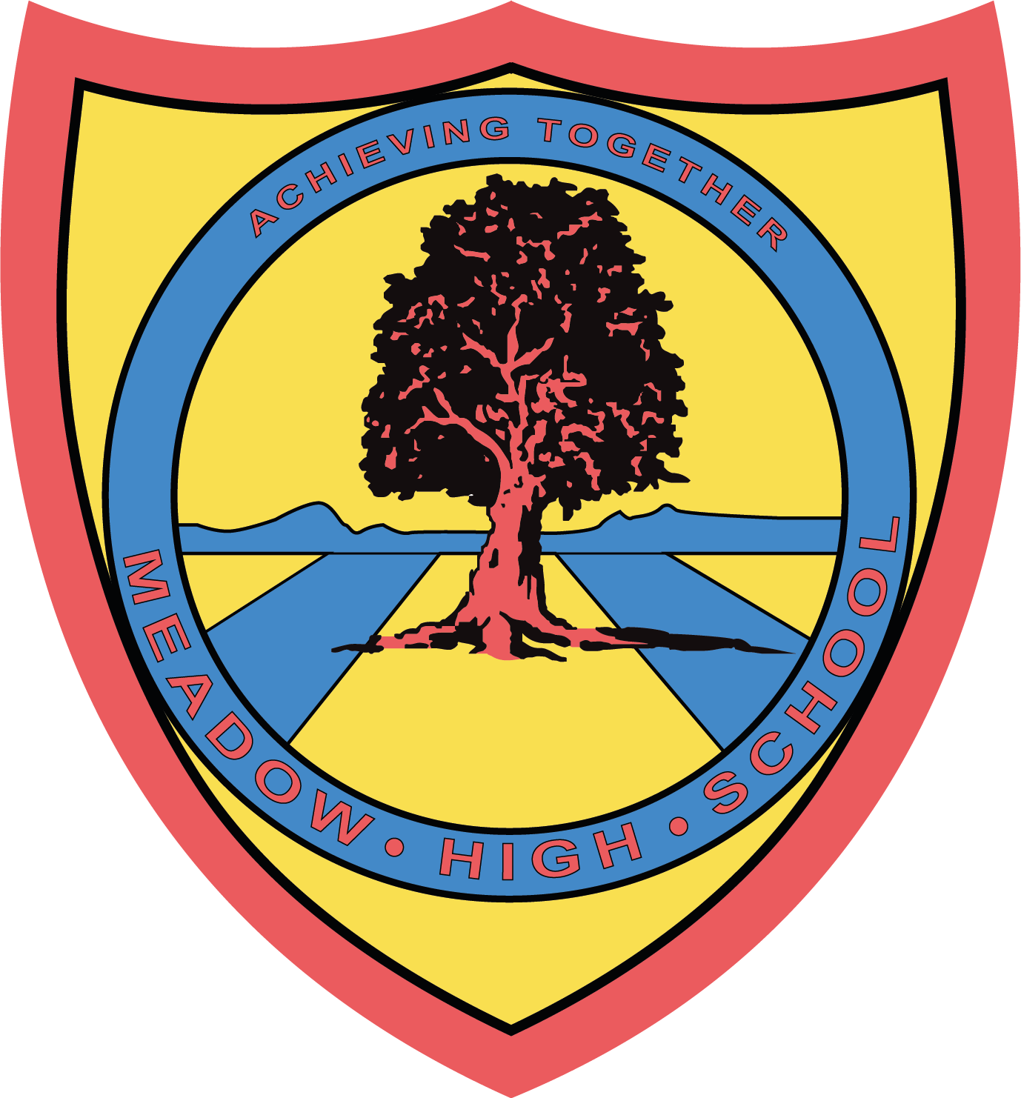

Wednesday 7th May 2025

Dear Parents / Carers,
Re: Swimming Lessons for Year 8 students
Starting on Thursday 15th May, your child will be having their swimming lessons on a Thursday period 4 and 5, instead of PE. They will not need their PE kit, but will need their swimming kit. These lessons are conducted off site and students will be transported there via school mini bus. These lessons will run until the end of the school year.
They will need to bring:
- Swimming trunks / costume (no bikinis)
- A towel
- Goggles if required
If you have any queries please do not hesitate to contact me at school.
Yours Sincerely,

Miss C Sojka
Swim Teacher

Article 23:- 'A child with a disability has the right to live a full and decent life with dignity and independence, and to play an active part in the community.'



