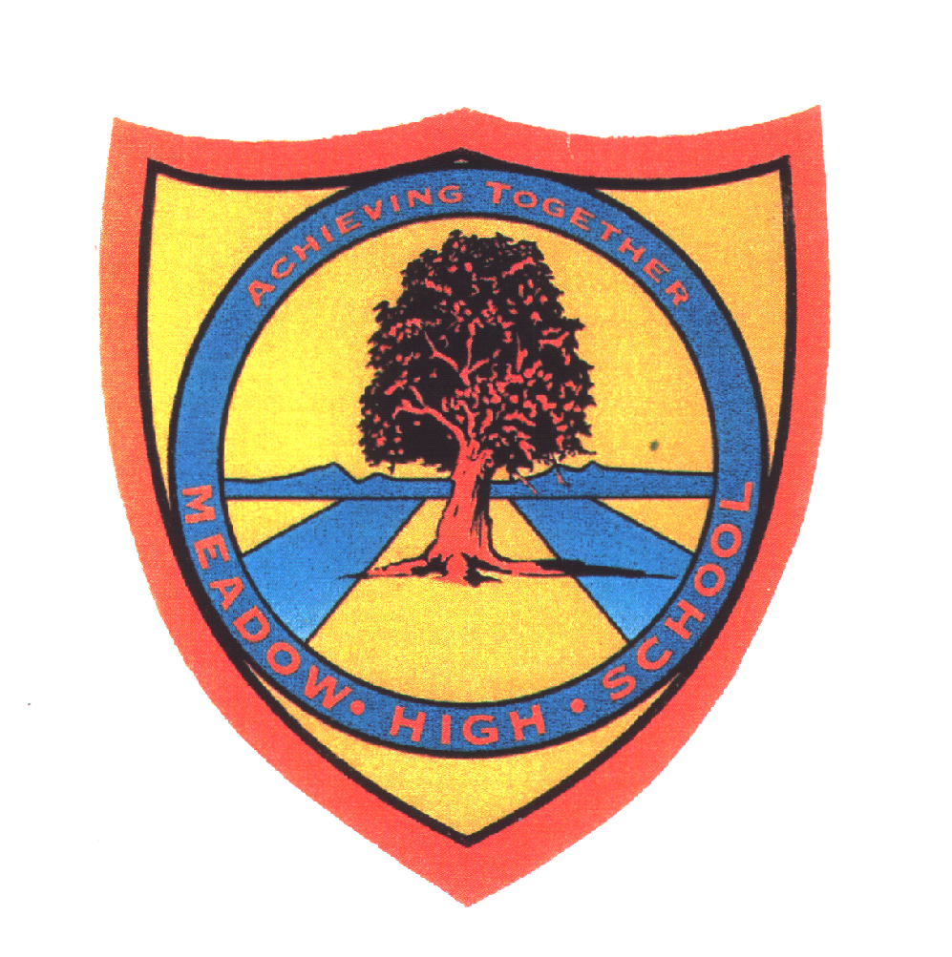 | Pathway 1 | Key Stage 3 Cycle 3 | Summer 2  Topic: Plants
Learning Intention: Pupils will learn about the characteristics of living things. Including that cells are the fundamental building blocks of living things. Pupils will be reminded of the basic parts of a plant, including seeds. They will have the opportunity to plant their own seeds and to make observations of how they grow over time.
Key knowledge that should be learned during this SoW |  | All | Most | Some
Concept: |  | Pupils will leant about plant needs, development, care and importance.
Knowledge: |  | To recognise the seven life processes | To understand the seven life processes | To understand what the happens if plants do not have what is need to live.
Key Skills: |  | Sort and name plants  Observations, sometimes using equipment. | Identity and describe plants  Identify similarities and differences | Compare and classify plants.  Asking simple scientific questions
Language and/or communication skills: |  | Live  Grow  Feed  Water  Light  Healthy  need | Movement  Reproduction  Sensitivity  Nutrition  Excretion  Respiration  growth | Compare  Classify  Explain  Adapt
Curricular Links |  | Geog, PSHCE

