
Meadow High School
Royal Lane, Hillingdon, Middlesex UB8 3QU

Telephone: (01895) 443310
Email: meadow@meadowhighschool.org
Website: www.meadowhighschool.org

Headteacher: Mrs Jenny Rigby
Deputy Headteacher: Ms Claire Caddell
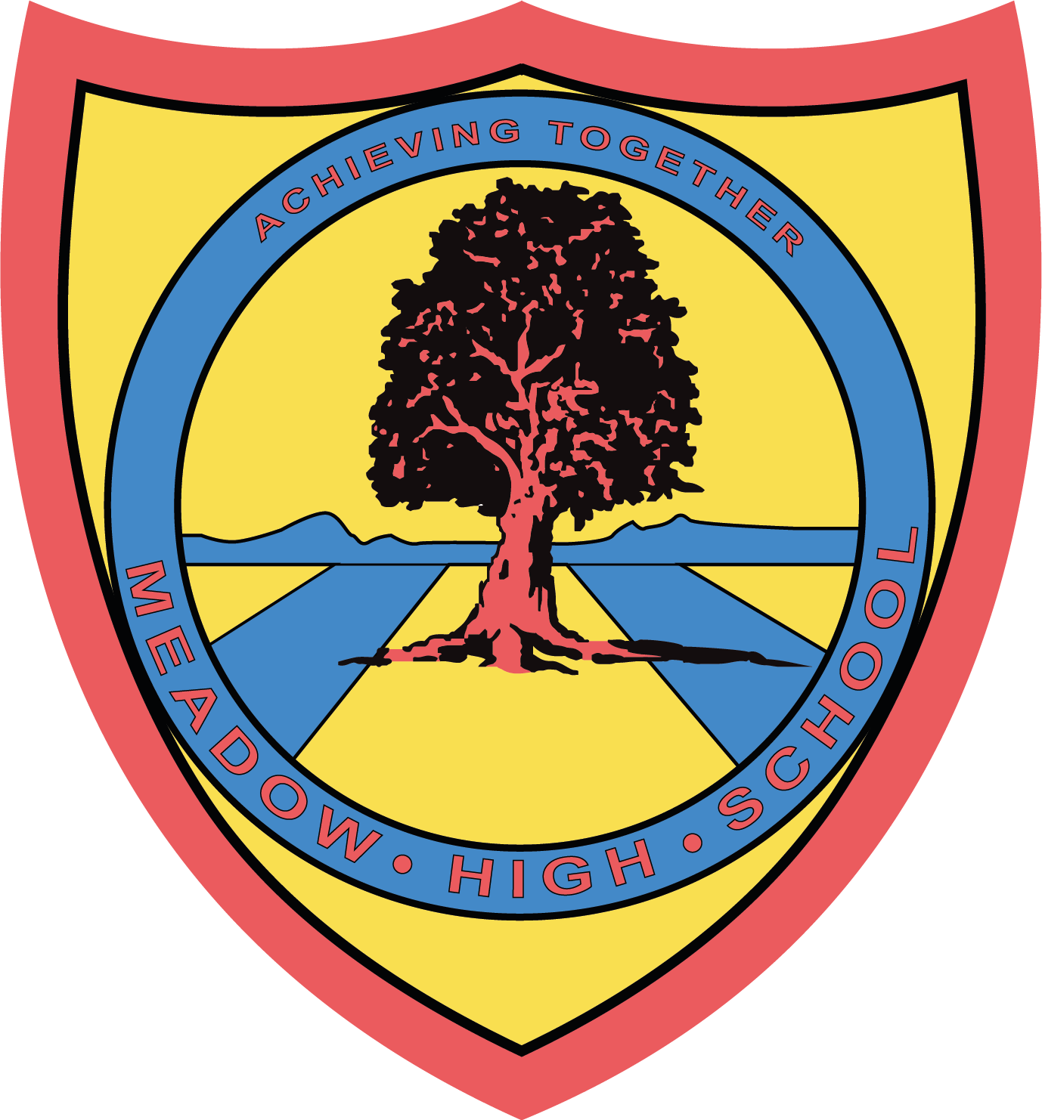

Dear Parents/Carers, 26th June 2023
Year 11 & 6th Form PromFest – Thursday 13th July 2023
To celebrate the achievements of our Year 11 and 6th Form students, we will be holding our school Prom on Thursday 13th July 2023 between 7:00pm and 10:00pm in the school hall.
We have to do things a little bit differently this year, as part of the site is being packed up, ready for the next phase of the school’s build project. Hhowever, we didn’t want our students to miss out! So…. the theme is ‘PromFest’ and the dress code is smart/casual/festival fun! Due to the kind support of staff and Friends of Meadow, we are able to keep the costs down and the tickets are a bargain at £8.00 per student. The ticket price includes a live band, disco, our favourite festival food trucks and another little surprise too! There will be plenty of opportunities to take photos on the night. We will respect parent choices about use of photos on our website, if you do not want your child to be in any photographs with friends please contact your child’s Form Tutor.
Tickets are on sale NOW! If you would like your child to attend, please complete the slip below and return to us in room 26. Tickets must be bought in advance via Parent Pay to help us plan effectively.

Miss Lennon’s Salon will be open again this year, if your child would like support with hair and/or nails to help them feel fabulous on the night please tick the box on the slip below and we will contact you to arrange a suitable time – first come, first served.
We hope very much that all students will attend as the evening is a celebration of their shared experiences at Meadow High School and the journey they have all been on together.
Yours faithfully,
Anne Sugden & Jennie Tudor
On behalf of the Prom Committee
-------------------------------------------------------------------------------------------------------------------------------------------------------------------------------------------------------------
Reply Slip: Year 11, 12, 13 & 14 Summer Prom 2023 – Thursday 13th July 2023
I give my permission for my child …………………………………………………………………... to attend the above event.

( ) I confirm that I have paid for a ticket via ParentPay.
( ) My child will be collected at 10:00pm by …..…………………………….………….Tel. no………………..…………….....
( ) I give my permission for my child to make their own way home at the end of the night.
( ) My child would like an appointment at Miss Lennon’s salon hair / nails. (please circle)
* The food trucks are pizza and fish & chips. [G/F, veggie and vegan options will be available.]
Signed……………………………………………….……………... Date………………………………….. Class: ………..…….
PRINT NAME: …………………………………………………………………………………………

