Meadow High School
Royal Lane, Hillingdon, Middlesex UB8 3QU

Telephone: (01895) 443310
Email: meadow@meadowhighschool.org
Website: www.meadowhighschool.org

Headteacher: Mrs Jenny Rigby
Deputy Headteacher: Ms Claire Caddell
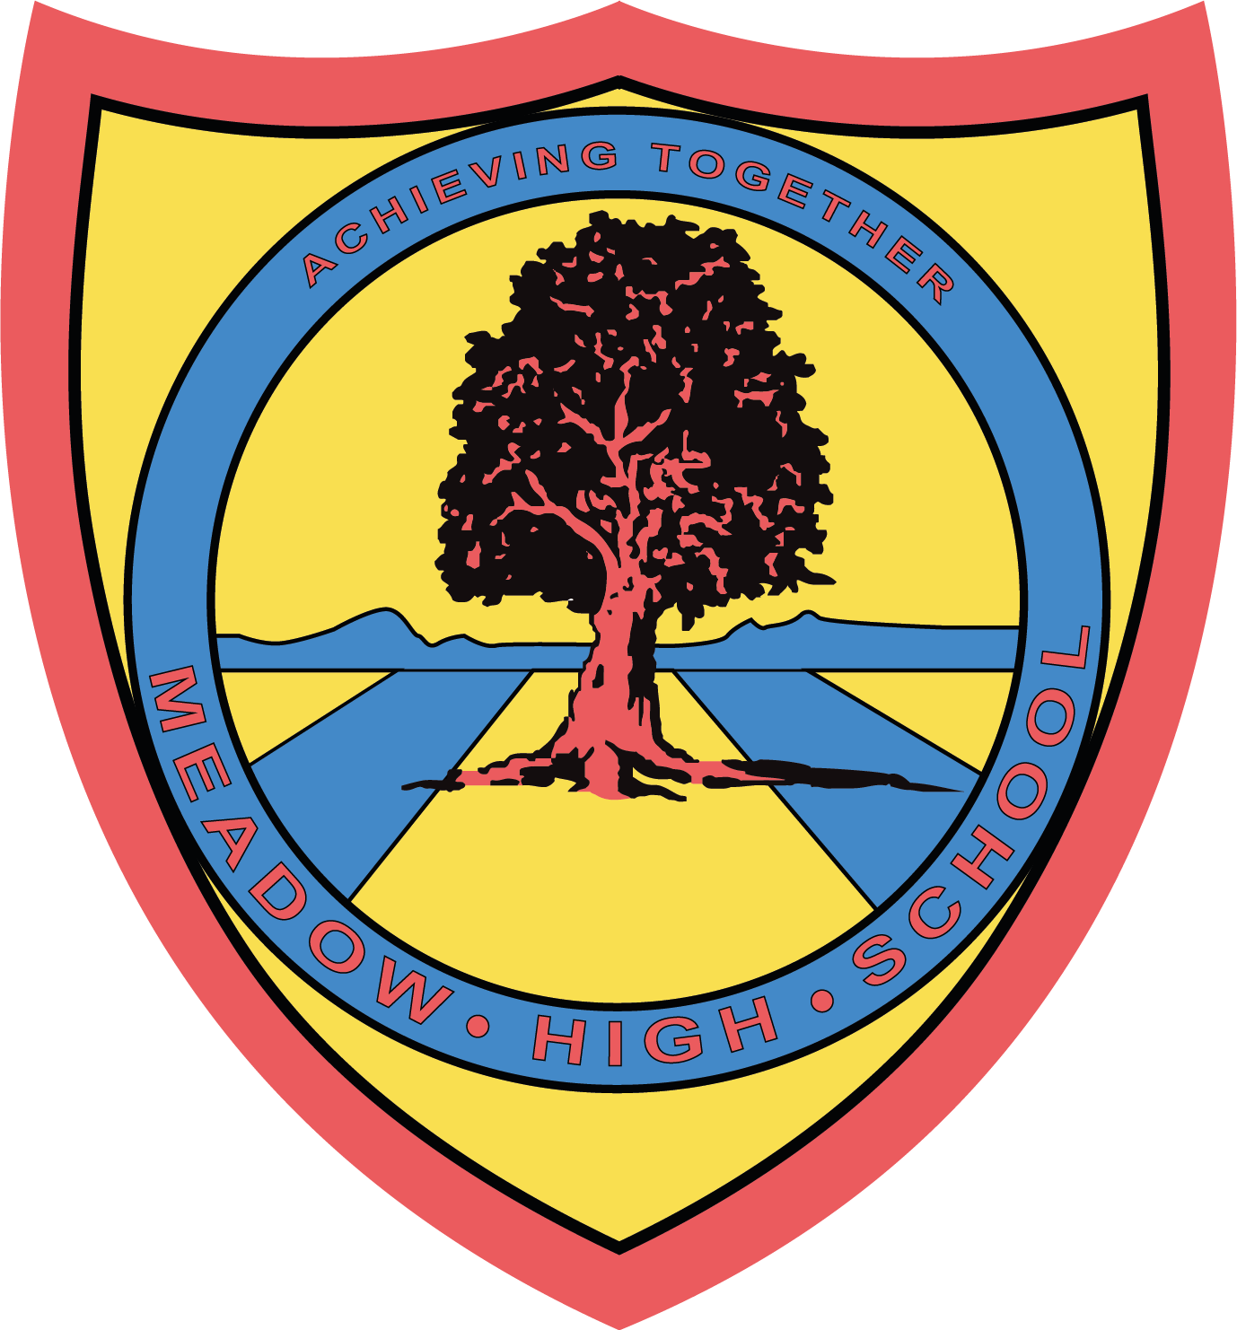

Thursday 25th May 2023

Dear Parent / Carer,

We will be visiting The Natural History Museum on Friday 16th of June. This trip is to provide pupils with the opportunity to explore topics we have been studying during our Science lessons, i.e. extinction and endangered species.

We will be travelling by coach, leaving soon after registration and we will be back at school for normal home time arrangements. All pupils are required to wear school uniform.

Please provide your child with a healthy packed lunch. If your child receives free school meals and you would like a lunch provided, please indicate this on the slip below. Please provide your child with a water bottle.

If you require any further information about this event, please contact us at school.

Yours sincerely,

Mr Szabo and Ms Kaminska
Science teachers

Article 23:- 'A child with a disability has the right to live a full and decent life with dignity and independence, and to play an active part in the community.'


-------------------------------------------------------------------------------------------------------------------------------------
Reply-Slip: National History Museum – 16th June 2023 - Please return to Ms Kaminska or Mr Szabo

Students name…………………………………………………………………………………………….………………
( ) I will be providing my child with a packed lunch on that day.
( ) My child is entitled to a free school meal and would like a packed lunch provided.
[ ] tuna mayo [ ] egg mayo [ ] cheese please tick choice of sandwich

Signed…………………………………………… Date ………………………………………..
(Parent / Carer)

