Meadow High School
Royal Lane, Hillingdon, Middlesex UB8 3QU

Telephone: (01895) 443310
Email: meadow@meadowhighschool.org
Website: www.meadowhighschool.org

Headteacher: Mrs Jenny Rigby
Deputy Headteacher (Royal Lane): Miss Michelle Taylor
Deputy Headteacher (Northwood Road): Miss Amy Willis
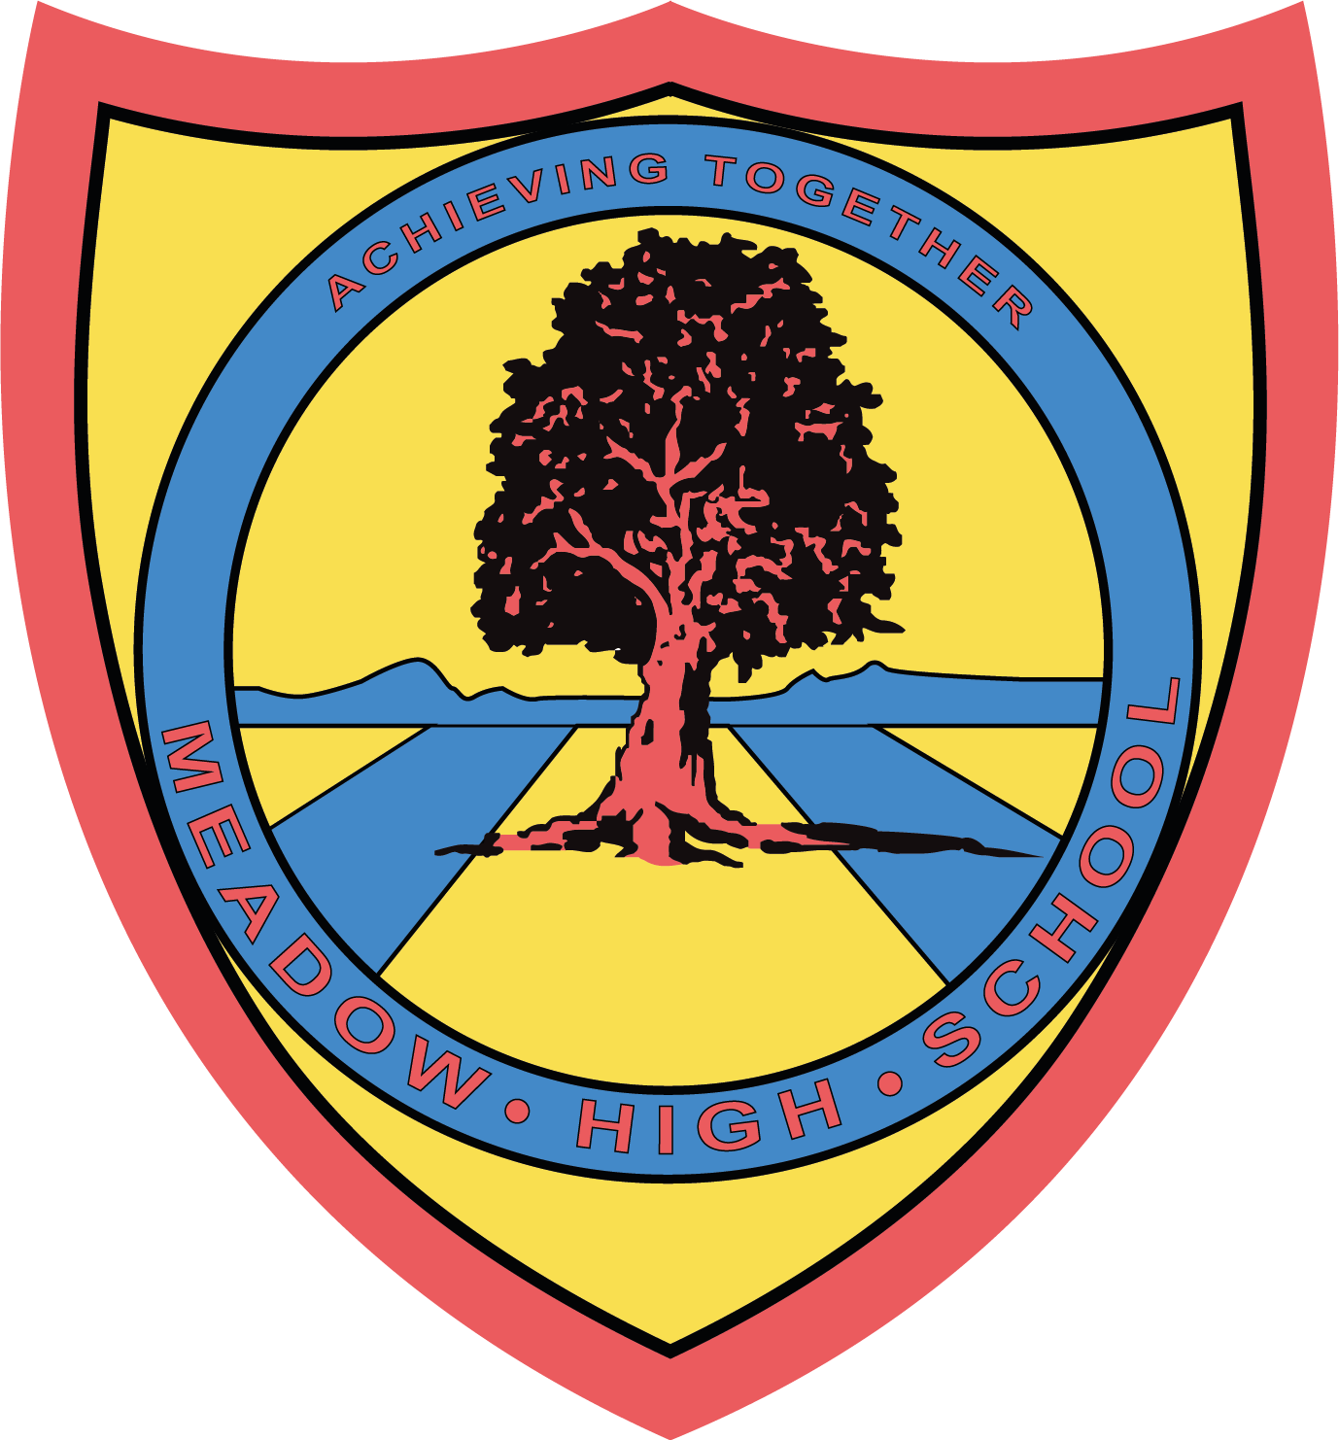

Wednesday 2nd July 2025

Dear Parent/Carer,

As we approach the end of our school year, we kindly ask that you check at home for any school library books your child may have taken home.

If you have any school library books at home, please send them back to school with your child so that they can be returned to Mrs Kennedy-Edwards, the school Librarian, by Friday 11th July

If books are not returned by Friday 11th July, we will assume they are lost, and you may be issued a fine to replace these books. Please note that any extenuating circumstances will be taken into consideration before payment is requested.

If you have any questions or concerns, please contact Mrs Kennedy-Edwards via email on skennedy@meadowhighschool.org.

Kind Regards,

Mrs Kennedy-Edwards
Librarian (Supporting and Delivering Learning)

Article 23:- 'A child with a disability has the right to live a full and decent life with dignity and independence, and to play an active part in the community.'



