Meadow High School

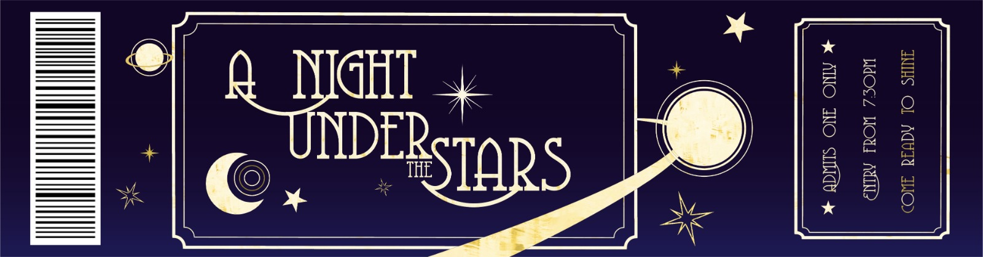
Royal Lane, Hillingdon, Middlesex UB8 3QU

Telephone: (01895) 443310
Email: meadow@meadowhighschool.org
Website: www.meadowhighschool.org

Headteacher: Mrs Jenny Rigby
Deputy Headteacher: Ms Claire Caddell

Dear Parents/Carers, 21st June 2022
Year 11 & 6th Form Prom – Thursday 14th July 2022
To celebrate the achievements of our Year 11 and 6th Form students, we will be holding our school Prom on Thursday 14th July 2022 between 7:30pm and 10:00pm in the school hall. We have spoken to the students and tried to include as many of their favourite things as we can!
The theme is ‘A Night Under the Stars’ and the dress code is smart/casual. Due to the kind support of staff, we have been able to keep the costs down and the tickets are a bargain at £8.00 per student. The ticket price will include a disco, a three course sit-down meal and few other little surprises too! There will be plenty of opportunities to take photos on the night. We will respect parent choices about use of photos on our website, if you do not want your child to be in any photographs with friends please contact your child’s Form Tutor.
Tickets are on sale NOW! If you would like your child to attend, please complete the slip below and return to us in room 26. Tickets must be bought in advance to help us plan and prepare.

Miss Lennon’s Salon will be open again this year, if your child would like support with hair and/or nails to help them feel fabulous on the night please tick the box on the slip below and we will contact you to arrange a suitable time – first come, first served. Thanks to the hard work of Mrs. Hamilton our Prom Shop is open and ready to help with some really fabulous dresses and suits to hire. The hire cost is £3.00 to cover laundry expenses, if your child would like to come and look please tick the box on the slip.
We hope very much that all students will attend as the evening is a celebration of their shared experiences at Meadow High School and the journey they have all been on together.
Yours faithfully,
Anne Sugden & Jennie Tudor
On behalf of the Prom Committee
-------------------------------------------------------------------------------------------------------------------------------------------------------------------------------------------------------------
Re: Year 11, 12, 13 & 14 Summer Prom 2022 – Thursday 14th July 2022
I give my permission for my child …………………………………………………………………... to attend the above event.

( ) I confirm that I have paid for a ticket using ParentPay.
( ) My child will be collected at 10:00pm by …..………………………….………….Tel. No………………..……………….....
( ) I give my permission for my child to make their own way home at the end of the night.
( ) My child would like an appointment at Miss Lennon’s salon hair / nails. (please circle)
( ) My child would like to visit Mrs. Hamilton’s Prom Hire Shop to look at the dresses/suits.
Signed……………………………………………….……………... Date………………………………….. Class: ………..…….
PRINT NAME: …………………………………………………………………………………………

