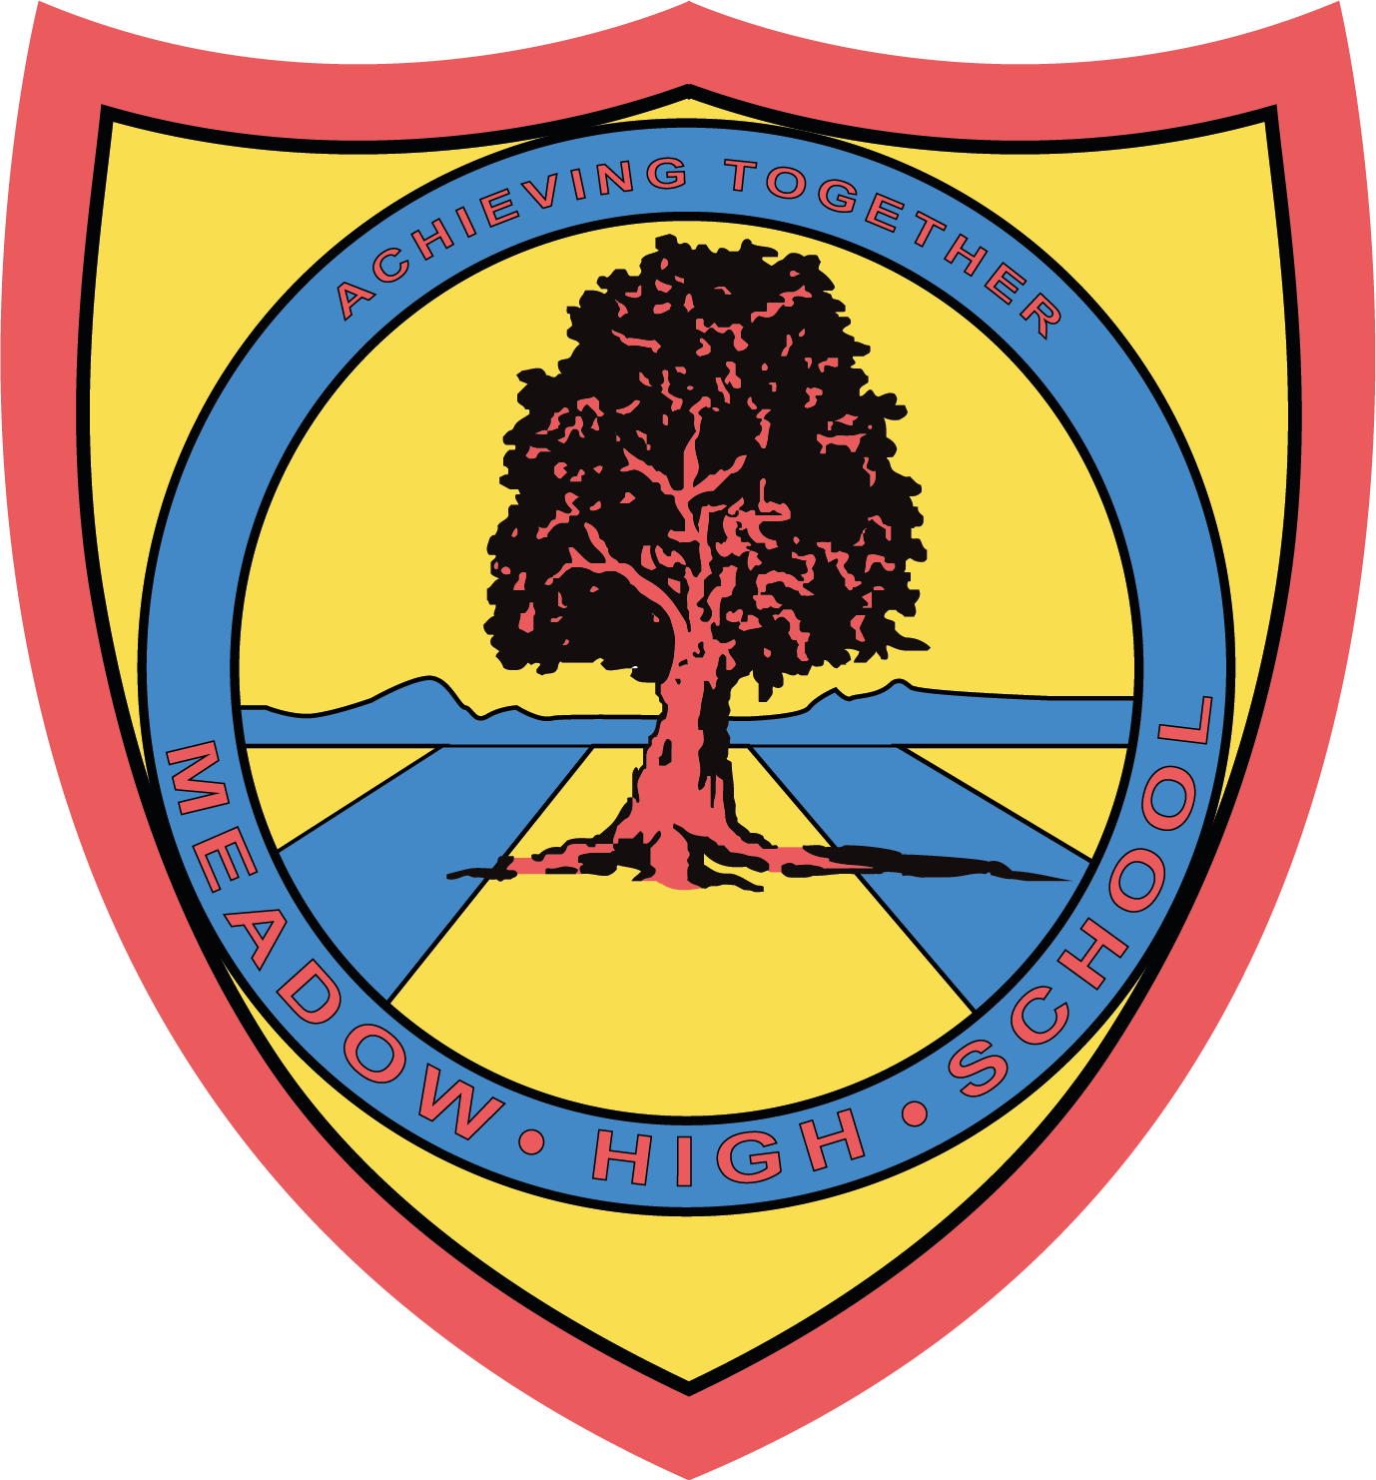
Meadow High School
Royal Lane, Hillingdon, Middlesex UB8 3QU

Telephone: (01895) 443310
Email: meadow@meadowhighschool.org
Website: www.meadowhighschool.org

Headteacher: Mr Graham Cunningham
Deputy Headteacher (Royal Lane): Miss Michelle Taylor
Deputy Headteacher (Northwood Road): Miss Amy Willis

Deputy Headteacher (Royal Lane): Miss Michelle Taylor
Deputy Headteacher (Northwood Road): Miss Amy Willis

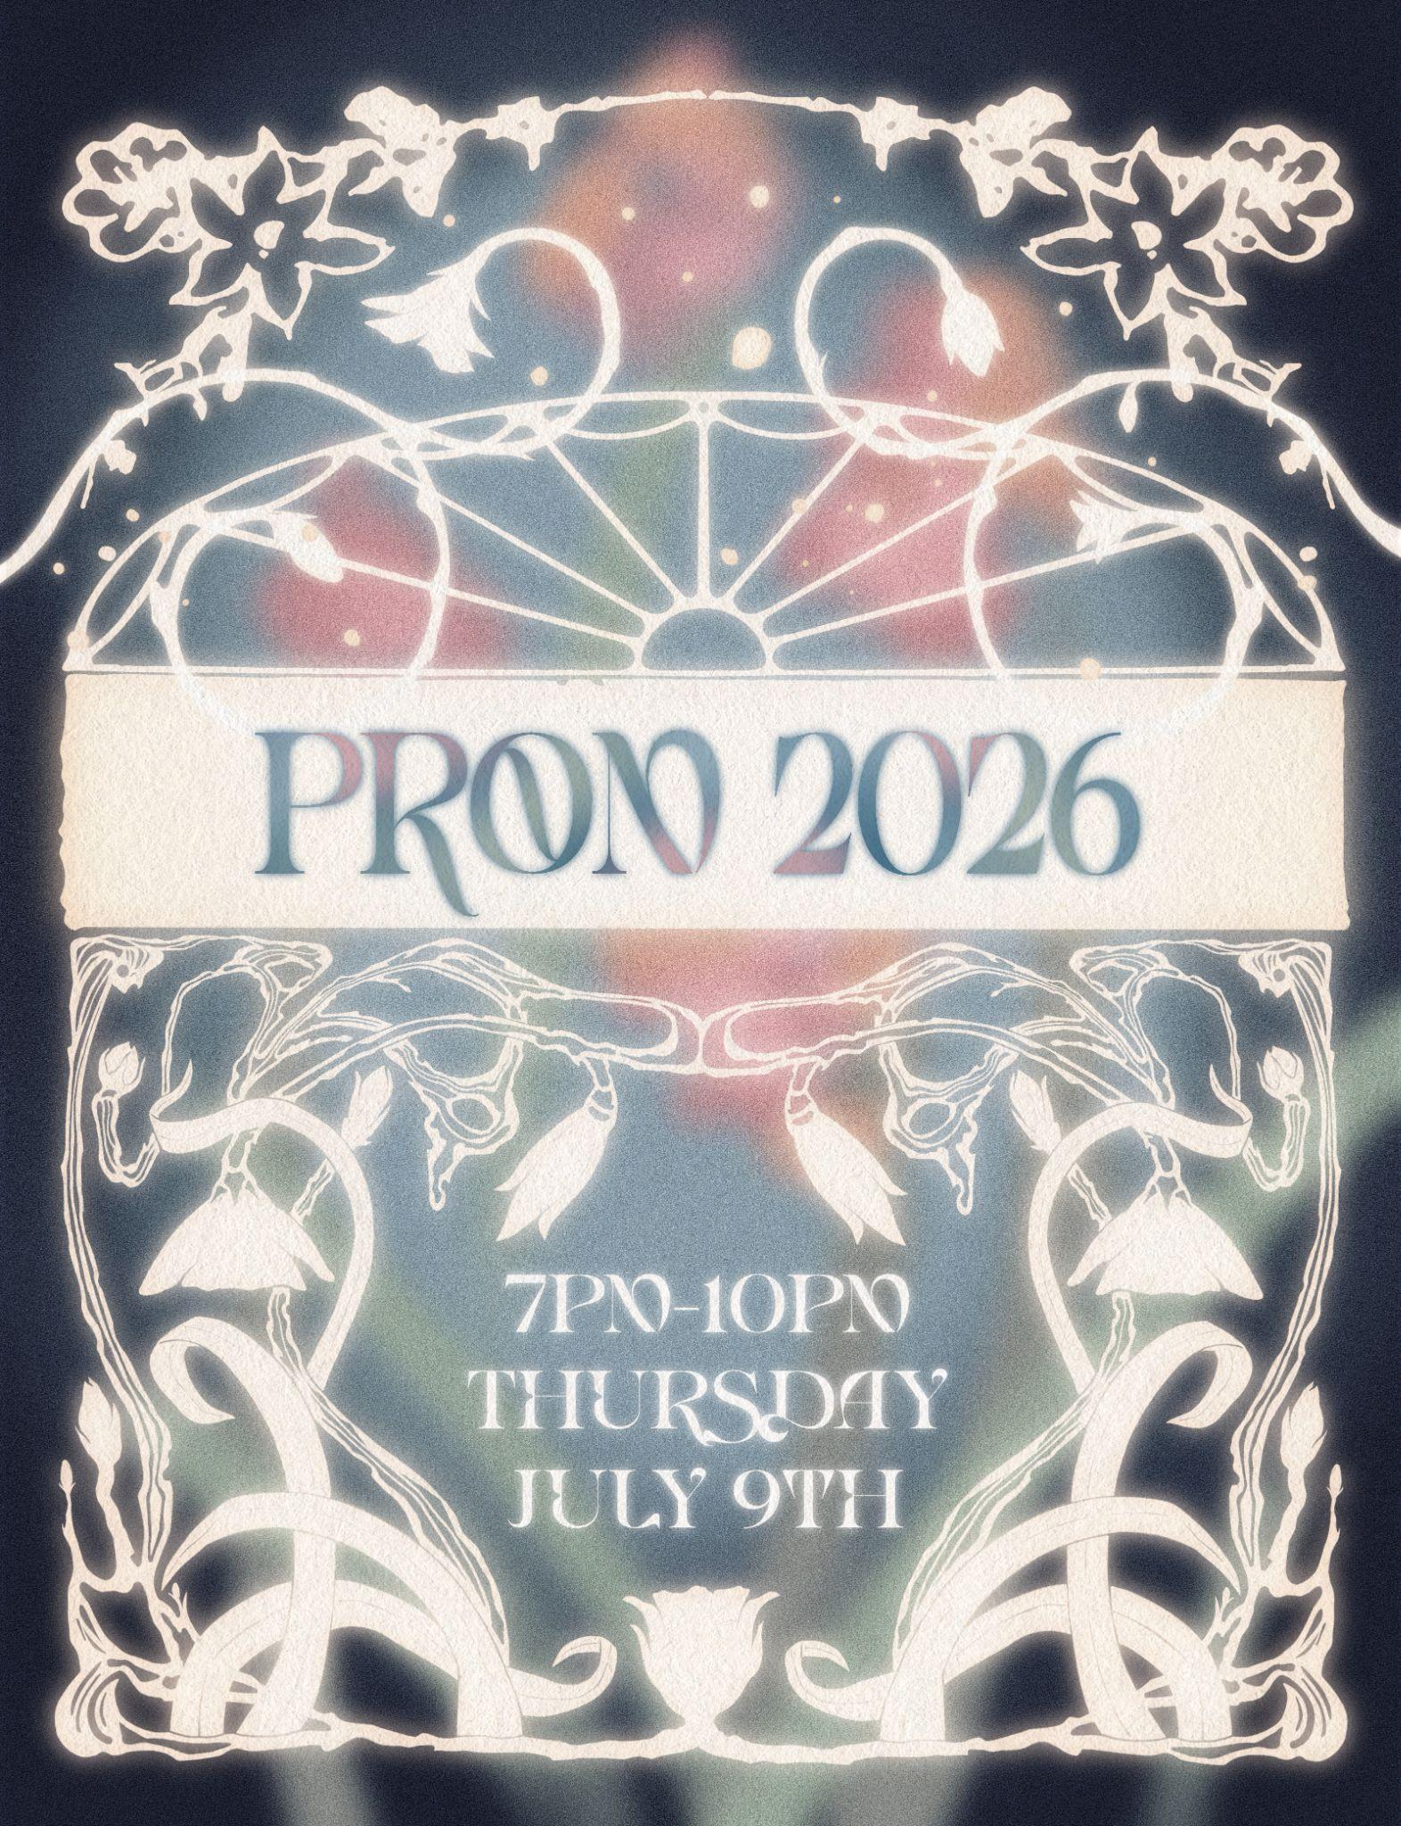

22 June 2026

Dear Parents/Carers,
Re: Year 11 & 6th Form Midsummer’s Night Dream PROM – Thursday 9th July 2026
To celebrate the achievements of our Year 11 and 6th Form students, we will be holding our school Prom on Thursday 9th July 2026 between 7:00pm and 10:00pm in the school hall. Ticket price £12.

The theme this year is A Midsummer’s Night Dream, we meet by moonlight for a magical evening celebrating our love of music, dancing, good food and good company. At Meadow High School we believe in celebrating our individuality - wear what makes you feel amazing!

Prom Shop: Stylist to the stars, Ms Hibbs will be happy to help anyone stuck for what to wear. Tick the slip below and she will then arrange a time for your child to come and have a look.
Dee’s Trims: Ms. Lee and her talented team are on standby. If your child would like support with hair and/or nails to help them feel fabulous on the night please tick the slip below and we will contact you to arrange a suitable time – first come, first served.

Prom tickets are on sale NOW until Thursday 2nd July
The ticket price includes a delicious three course meal (Head Chef - Mrs Fabisch), a visit to Ms Barratt’s famous mocktail bar and Mr. M. ‘spinning the discs’ with a special guest set from Luke. The evening is a chance to hang out with friends and dance the night away. This year you will have the chance to add a touch of glitter before striking a pose with friends in our photo booth. To join in the fun, all you need to do is fill in the slip below, make your menu choice and hand both to Ms Nayar in the Faculty Leader’s Office - thank you Miss Nayar!

Please note: There will be plenty of opportunities to capture memories by taking photos. If you do not want your child to be in any photographs with friends, or please contact your child’s Form Tutor.
We hope very much that all students will come and celebrate. It’s a chance for our 6th Form community to say hello to those joining in September and farewell to those ready for the next chapter of their lives.
Yours faithfully,
Anne Sugden & Jennie Tudor

Article 23:- 'A child with a disability has the right to live a full and decent life with dignity and independence, and to play an active part in the community.'


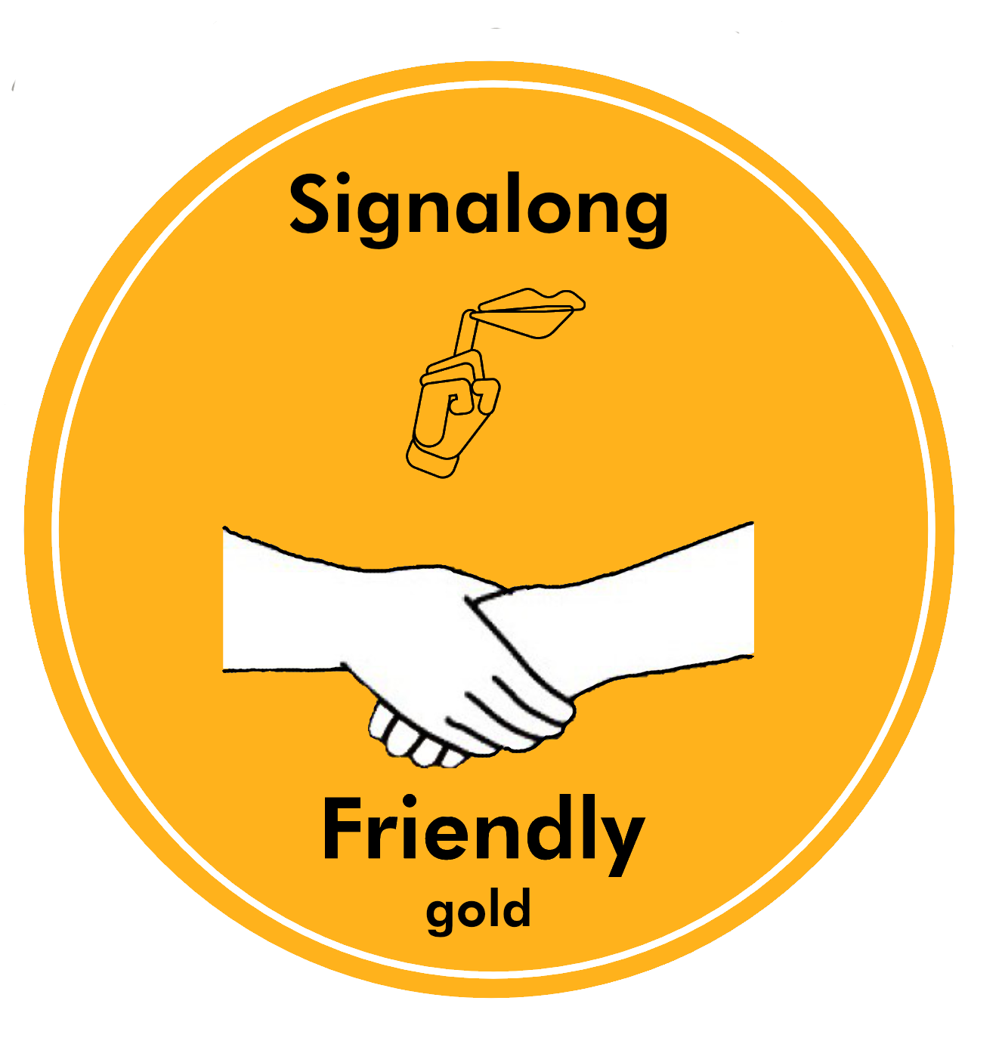
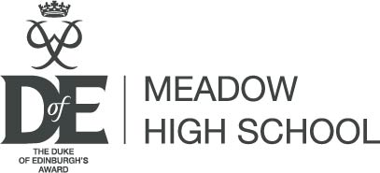


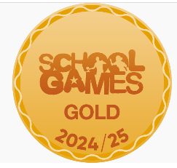

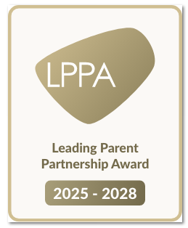
-------------------------------------------------------------------------------------------------------------------------------------------------------------------------------------------------------------
Reply Slip: 6th Form and Year 11 Summer Prom – Thursday 9th July 2026 [7:00pm – 10:00pm]
I give my permission for my child …………………………………………………………………... to attend the above event.

( ) I confirm that I have paid for a ticket using ParentPay.
( ) My child will be collected at 10:00pm by …..…………………………….………….Tel. no………………..…………….....
( ) I give permission for my child to make their own way home at the end of the night.
( ) My child would like an appointment at Dee's Trims for hair / nails. (please circle) ( ) My child would like to visit the Prom Shop.
Signed……………………………………………….……………... Date………………………………….. Class: ………..…….

Menu Choices: Our Head Chef, Mrs Fabisch, has been hard at work. Please have a look at the menu. Please have a look then choose ONE main course. Tick your choice. There will be a dessert trolley of delights available on the night for you to choose from including a special treat, thanks to Kaytlin and the Jack Petchey Foundation, a chocolate fountain!
PLEASE NOTE: Any specific dietary requirements, please speak to your Form Tutor by Wed. 2nd July 2026.

