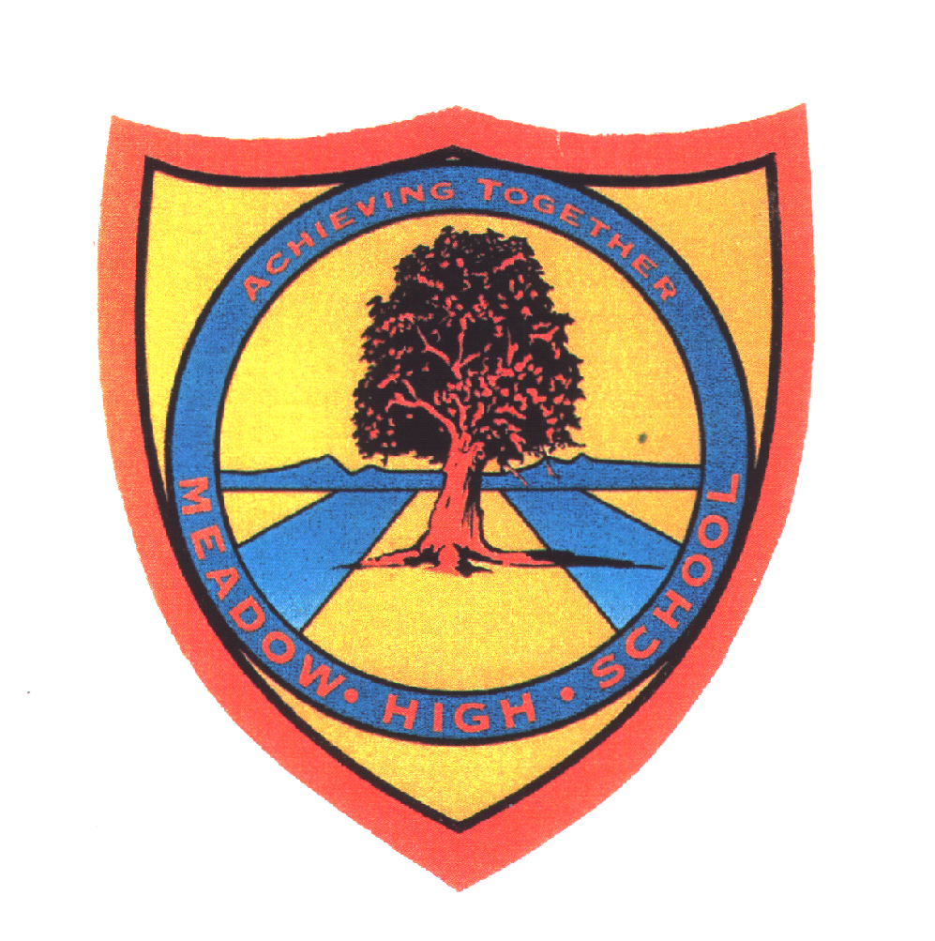 | Pathway 1 | Key Stage 3 Cycle 3 | Spring 2  Topic: Animal Diet and Food Chains
Learning Intention: Pupils will learn and extend their understanding of the characteristics of living things, how living things require energy and what this energy looks like in terms of food and food chains.
Key knowledge that should be learned during this SoW |  | All | Most | Some
Concept: |  | Food chains and to understand how energy moves in food chains
Knowledge: |  | Pupils are to match animals to the food they eat.  Pupils to be able to name some food groups and sort foods into categories.  Group animals according to the types of food they eat. | Pupils are to recognise that different animals eat different foods and that to do so they need to have different teeth and claws to do so.  To know how we need to care for our teeth  To begin to explore food chains | To recognise the seven life processes and what is required for these.  To begin to explore food webs.
Key Skills: |  | Label,  Identify  Sort | Group  Type | Research  Explore  Hypothesis
Language and/or communication skills: |  | Healthy  Food | Food chain  Links  Energy | Balanced  Food web
Curricular Links |  | PSHCE, life skills,

