Meadow High School
Royal Lane, Hillingdon, Middlesex UB8 3QU

Telephone: (01895) 443310
Email: meadow@meadowhighschool.org
Website: www.meadowhighschool.org

Headteacher: Mrs Jenny Rigby
Deputy Headteacher: Ms Claire Caddell
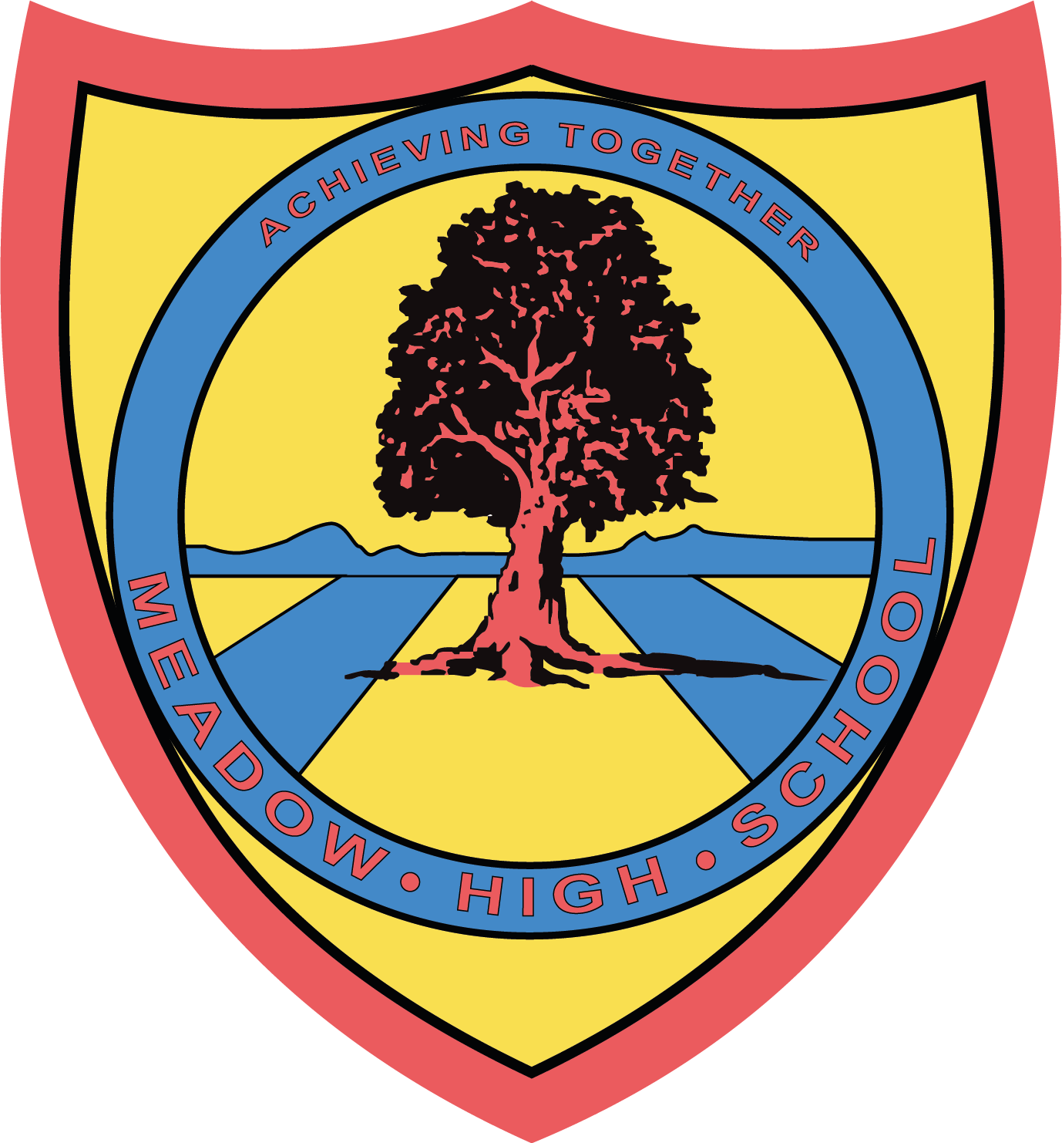

3rd October 2023
Dear Parent/Carer,

On Tuesday 12th December - Thursday 14th December inclusive, we are planning a Pathway One department trip to the Beck Theater to watch a pantomime version of ‘Beauty and the Beast’. Tickets are £14.00 each and we are seeking voluntary contributions from families to support the cost of the trip. This includes an ice cream. This must be paid via ParentPay.



We will visit during normal school hours. Pupils should be wearing school uniform. We will be traveling by school minibus, which will be driven by MIDAS (qualified) trained drivers.

Please see below for the date your child's class will be visiting.

Tuesday 12th December- Classes SS and AP
Wednesday 13th December- Classes YA, JR and JE
Thursday 14th December- Classes SM, IM and MP

Pupils will require a healthy packed lunch on the day, however, if your child is entitled to a free school meal we can provide a packed lunch for them if you wish (please indicate a sandwich choice on premission-slip).

Please complete and return the permission slip. If you have any questions, please do not hesitate to contact your child’s form tutor or myself.
Yours faithfully,

Miss Willis
Deputy Head Teacher Meadow High School- Northwood Road

Article 23:- 'A child with a disability has the right to live a full and decent life with dignity and independence, and to play an active part in the community.'
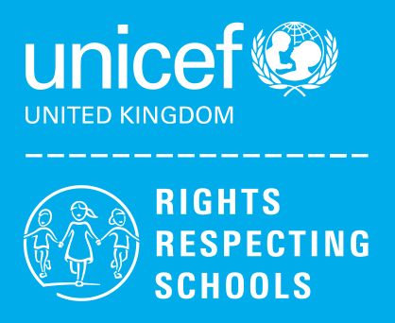
----------------------------------------------------------------------------------------------------------------------------------------------------------
REPLY-SLIP: Pathway 1 Pantomime Trip – December 2023 - please return to Miss Willis

Name of Child: ……………………………………………………………….

( ) I would like my child to attend.

( ) I will pay the voluntary donation of £14.00 to cover my child's ticket and ice cream. (paid via Parent Pay)

( ) I will be providing my son/daughter with a healthy packed lunch

( ) My son/daughter is entitled to a free school lunch, please provide one for him/her
Please specify the sandwich filling below
( ) Egg Mayonnaise ( ) Tuna Mayonnaise ( ) Cheese

( ) My child would like the included ice cream.

Signed………………………………..……………………. Date……………….…….

