Meadow High School
Royal Lane, Hillingdon, Middlesex UB8 3QU

Telephone: (01895) 443310
Email: meadow@meadowhighschool.org
Website: www.meadowhighschool.org

Headteacher: Mrs Jenny Rigby
Deputy Headteacher PW2/3: Ms Claire Caddell
Deputy Headteacher PW1: Miss Amy Willis
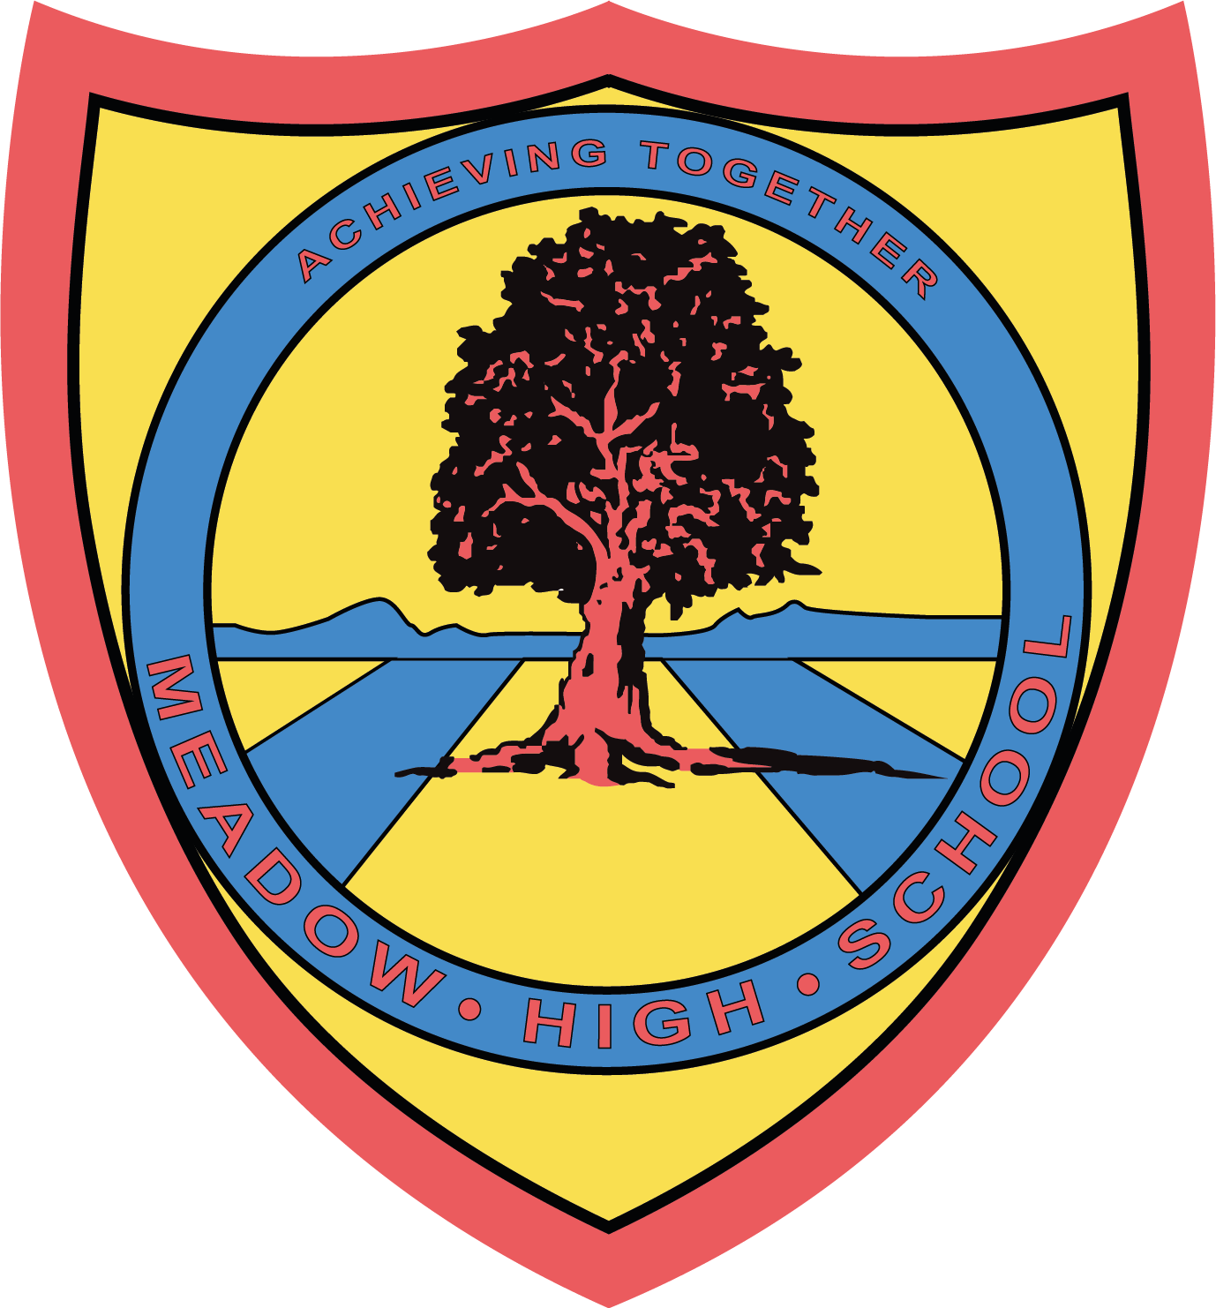

30th April 2024
Dear Parent/Carer,

To support Year 8 students with their learning of ‘Victorian Times’ the History topic, we have arranged a trip to the Gunnersbury Park Museum in Popes Lane W5, on Monday 13th May 2024.

We will be leaving school after registration at 9:30am and returning to school in time for transport home before 3pm. Therefore, you will need to provide your child with a healthy packed lunch and water. If your child is entitled to a free school meal then one can be provided for them. Please indicate below, along with sandwich choice. We will travel on the minibus, which will be driven by a MIDAS (qualified) trained driver and a First-Aider will also accompany us.

If you would also like to provide your child with some money to use in the museum shop, then please do so. No more than £5 please. This will need to be kept with your child on the day of the trip and it is their responsibility to look after their money.

Please complete the attached slip and return it as soon as possible. If you have any queries, please feel free to contact your child’s form tutor.

Yours sincerely,

Mrs Mansoor

Article 23:- 'A child with a disability has the right to live a full and decent life with dignity and independence, and to play an active part in the community.'

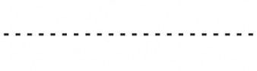
Reply-Slip: Gunnersbury Park Museum: Monday 13th May 2024 – please return to Mrs Mansoor

I acknowledge that my child ………………………………………………………………………………………………… will take part in this educational trip.
( ) I will be providing my child with a healthy packed lunch on that day.
( ) My child is entitled to a free lunch. Please provide one for them.
Sandwich choice: tuna mayo ( ) egg mayo ( ) cheese ( )

Signed …………………………………………………………… Date ………………………………………
(Parent/Carer)

