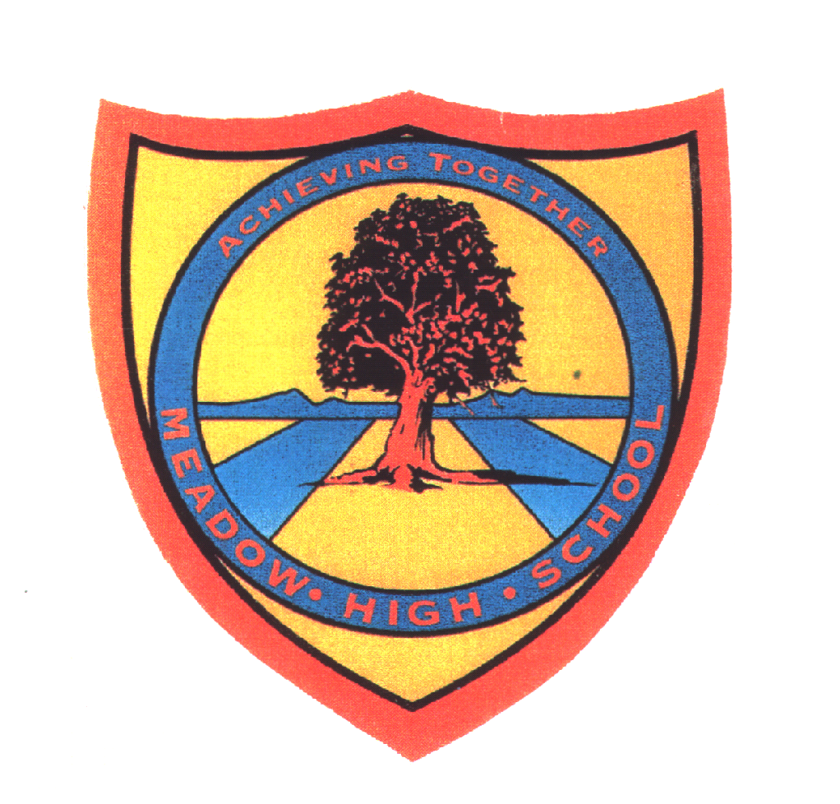
Meadow High School
Royal Lane, Hillingdon, Middlesex UB8 3QU

Telephone: (01895) 443310
Email: meadow@meadowhighschool.org
Website: www.meadowhighschool.org

Headteacher: Mrs Jenny Rigby
Deputy Headteacher: Ms Claire Caddell

June 2021

RE: 6th Form BBQ - 14th July

Dear Parents / Carers,

Traditionally at the end of the school year, pupils in the Sixth Form have a reward treat. We have decided to have a BBQ this year on Wednesday 14th July. The Crunchy Munchy student cooking team will be shopping and cooking for the 6th Form.

We are kindly asking parents for a voluntary contribution, so that the form tutors can cover the cost of the food. If possible we would like you to donate a minimum of £1.

Students will have lunch first and then have party food in the afternoon. Please could you send your child in with a light packed lunch, money for their school lunch or indicate their choice of free school lunch below.

If you have any questions regarding this please contact me or your child’s form tutor.

Yours Sincerely,

K Mayall

Kate Mayall
Sixth Form Tutor

---------------------------------------------------------------------------------------------------------------------------
Reply slip – 6th Form BBQ - please return to Mrs Mayall.

Pupils Name: ­­­­_____________________________ Tutor Group_________

( ) I enclose a voluntary contribution of: £________ (state the amount)

( ) My son/daughter is entitled to a free school meal, please provide one for him/her
Please specify the sandwich filling below

( ) Egg Mayonnaise
( ) Tuna Mayonnaise
( ) Cheese

Parent’s Name: ­­­­_________________________

Parent’s Signature: ­­­­_________________________

