Meadow High School
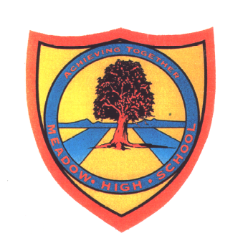
Royal Lane, Hillingdon, Middlesex UB8 3QU

Telephone: (01895) 443310
Email: meadow@meadowhighschool.org
Website: www.meadowhighschool.org

Headteacher: Mrs Jenny Rigby
Deputy Headteacher: Ms Claire Caddell

23rd May 2022

Dear Parents / Carers,
Year 12, 13 and 14 Football Tournament
Your child has signed up to play in a football tournament on Friday 27th May. It will be held at the school during the day. For this event, could you please make sure your child has suitable clothing; tracksuit bottoms/shorts and a sports T-shirt which should match the colour house that they are in.
There will be a little shop run by 6th form students with a cake sale and refreshments to purchase.
Just a reminder, after this event, at lunchtime The Queen's Jubilee celebration will take place. For this event, students should wear clothing that matches the jubilee colours.
The pupils will be outside for large periods of the day, please make sure your child has plenty of water and sun cream or maybe a hat with them.
Kind Regards,

Mr. C. Morgan
Head of PE

