Meadow High School
Royal Lane, Hillingdon, Middlesex UB8 3QU

Telephone: (01895) 443310
Email: meadow@meadowhighschool.org
Website: www.meadowhighschool.org

Headteacher: Mrs Jenny Rigby
Deputy Headteacher: Ms Claire Caddell
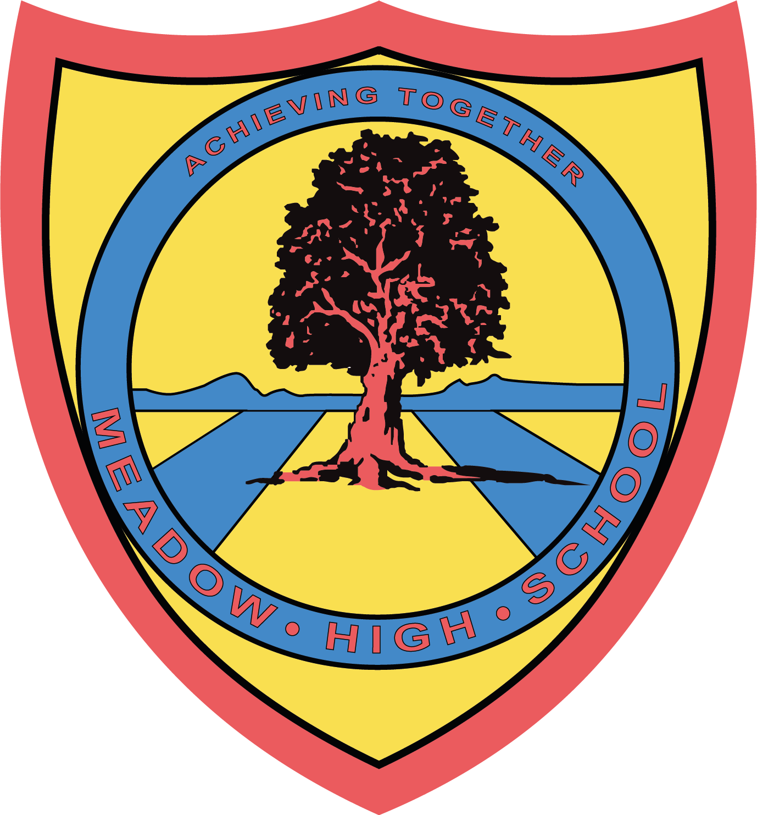

23rd January 2023

Dear Parents/ Carers,

U14’s - Middlesex FA Tournament

Your child has been selected to attend the U14’s Football Event on Wednesday 25th January. The event will be taking place between 09:50 – 12:40, so no extra travel arrangements need to be made. Pupils will also be back for normal lunch arrangements. On the day, your child should come into school in their PE kit with shin pads.

If you have any questions just let me know.

Kind regards,
Mr. Anstee
PE Teacher
@MeadowPE

Article 23:- 'A child with a disability has the right to live a full and decent life with dignity and independence, and to play an active part in the community.'



