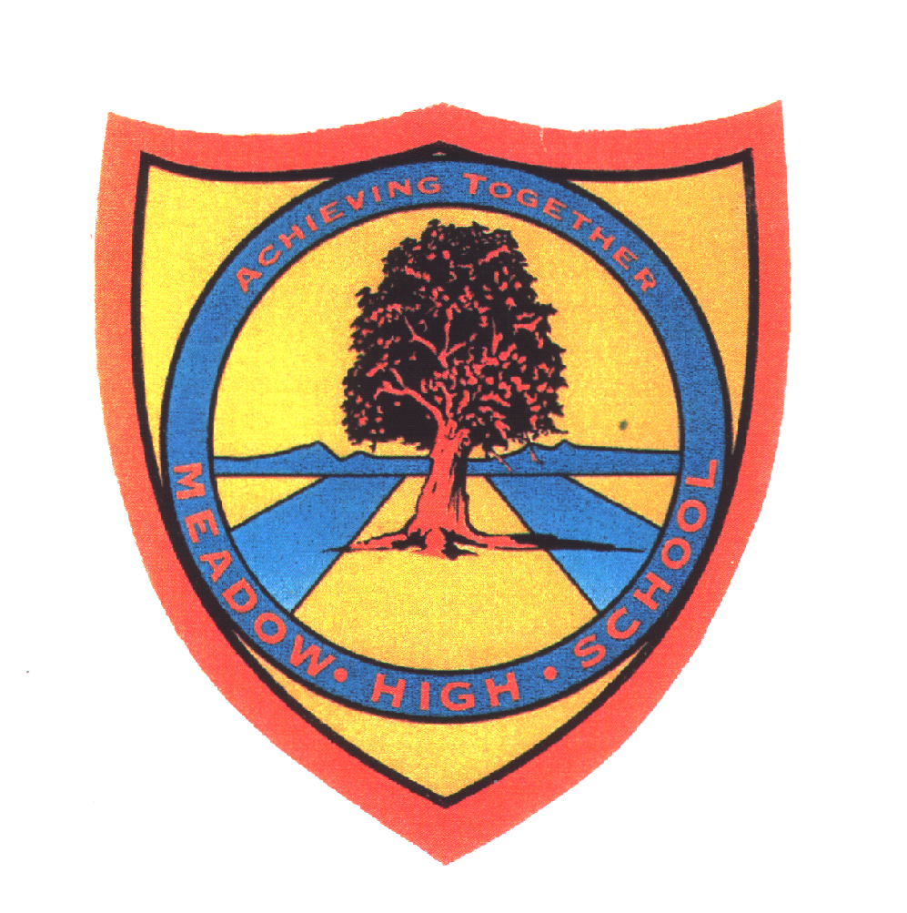 | Pathway 1 | Key Stage 3 Cycle 1 | Spring 2  Topic: Life Cycle & Growth
Learning Intention: Pupils will explore life cycles of varying animals and consider how animals change over time. This will then be applied to the human life cycle and RSE links made to support pupils' understanding of human development and growth, including puberty.
Key knowledge that should be learned during this SoW |  | All | Most | Some
Concept: |  | Pupils will learn about human and animals life cycle. They will work on their ability to sequence. Pupils will explore similarities and differences between different animals and develop their basic understanding of survival.
Knowledge: |  | To know animals and their babies.  To encounter a range of life cycles.  To know that humans produce babies that grow into children and then into adults. | To be able to recognise stages of a simple life cycle.  To be able to sequence a simple life cycle using pictures.  To consider the ways they have changed physically since they were born. | To be able to sequence a simple life cycle.  To be able to record stages in a life cycle.
Key Skills: |  | Labelling  Identifying | Sequencing | Recording
Language and/or communication skills: |  | Animals  Babies  Life | Life cycle  Sequence  survival | Sequence  Offspring
Curricular Links |  | Geography, PSHCE, RSE,

