Meadow High School
Royal Lane, Hillingdon, Middlesex UB8 3QU

Telephone: (01895) 443310
Email: meadow@meadowhighschool.org
Website: www.meadowhighschool.org

Headteacher: Mrs Jenny Rigby
Deputy Headteacher (Royal Lane): Miss Michelle Taylor
Deputy Headteacher (Northwood Road): Miss Amy Willis
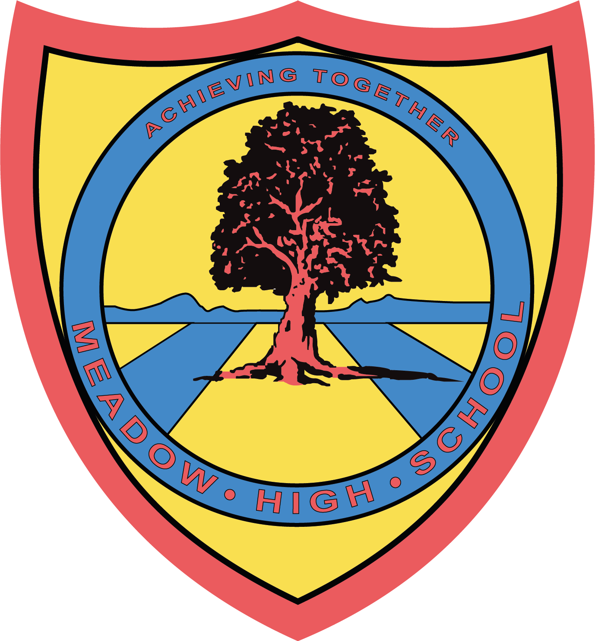

9 June 2025
Dear Parents / Carers,

Re: 6th Form BBQ - 27th June 2025

As the school year comes to an end for our leavers, we would like to give them a warm and memorable send-off.

To celebrate their time with us, we are organising a Sixth Form BBQ. All Sixth Form students are invited to join us for this event.

We kindly ask for a £2 contribution from students who would like to take part in the BBQ. Alternatively, students are welcome to bring a packed lunch or have a school meal as usual.
Please note that if your child is entitled to Free School Meals (FSM), the £2 contribution is not required.

Kind regards,

Mrs. A.J Fabisch Miss F Bonnar Mrs H O’Neill 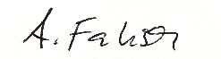
Head of 6th Form (F) Assistant Head PW1 Assistant Head PW1
afabisch@meadowhighschool.org

Article 23:- 'A child with a disability has the right to live a full and decent life with dignity and independence, and to play an active part in the community.'


---------------------------------------------------------------------------------------------------------------------------------
Leavers BBQ - Please return the below reply slip to your child’s form tutor by 13th June 2025.

Student’s name: ____________________________________________

I would like my child to take part in the BBQ and agree to contribute £2 towards it
by 20th June 2025 YES/ NO
I would like my child who is entitled to FSM to take part in the BBQ YES/ NO
I would like my child to have the school meal as usual instead YES/ NO
My child will bring a packed lunch on the day YES/ NO

Parent’s/ carer’s signature: ________________________________________

