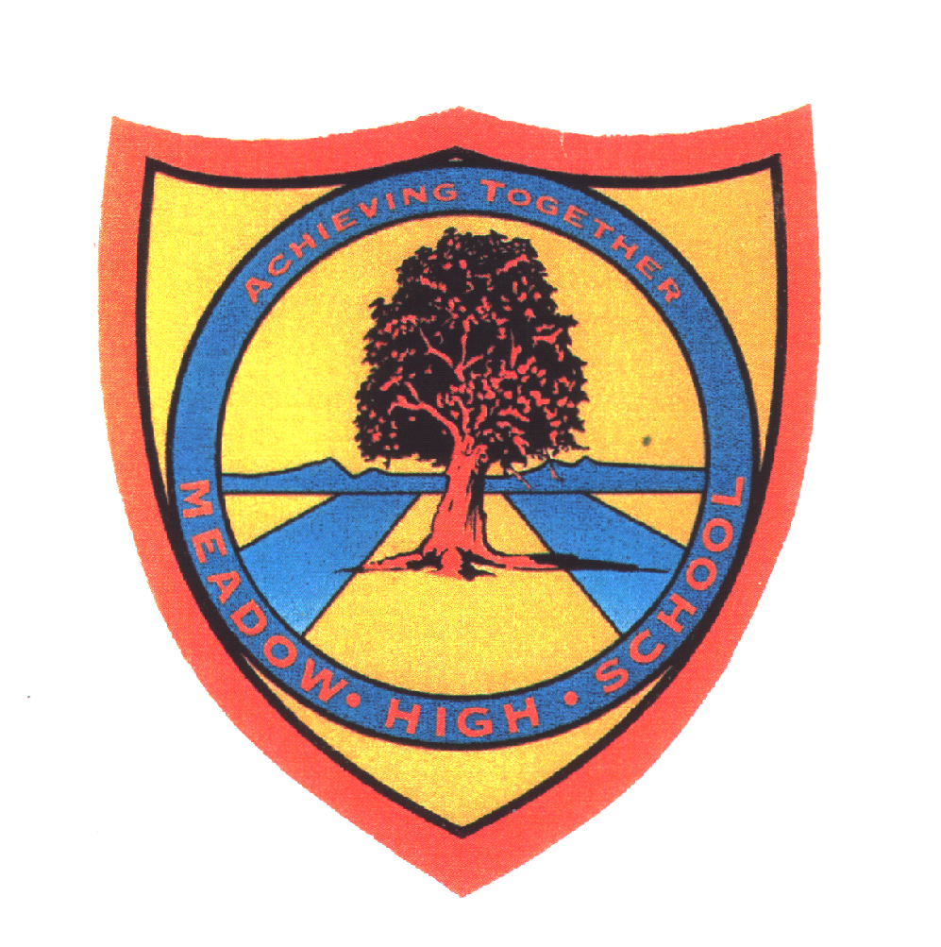 | Pathway 1 | KS4 Hybrid | Autumn 1  Topic: Health
Learning Intention: Pupils will learn the importance of and how to keep healthy. This will cover physical and mental health. Pupils will explore varying aspects of health and be able to identify some common hazard symbols. Pupils will also develop their observational and research skills.
Key knowledge that should be learned during this SoW |  | All | Most | Some
Concept: |  | That we are responsible for the health of ourselves and what this looks like for us as we get older and develop.
Knowledge: |  | Pupils are aware of basic hygiene practises. | Pupils know what they need to do to keep themselves clean and healthy. | Know what germs are and the importance hygiene plays in keeping healthy.
Key Skills: |  | Observational skills | Research skills | Observational and research skills with self-care practise.
Language and/or communication skills: |  | Healthy  Hygiene  Personal | Mental health  Physical health | Why  Reasoning  Consequences
Curricular Links |  | RSE, PSHCE,

