Meadow High School
Royal Lane, Hillingdon, Middlesex UB8 3QU

Telephone: (01895) 443310
Email: meadow@meadowhighschool.org
Website: www.meadowhighschool.org

Headteacher: Mrs Jenny Rigby
Deputy Headteacher PW2/3: Ms Claire Caddell
Deputy Headteacher PW1: Miss Amy Willis
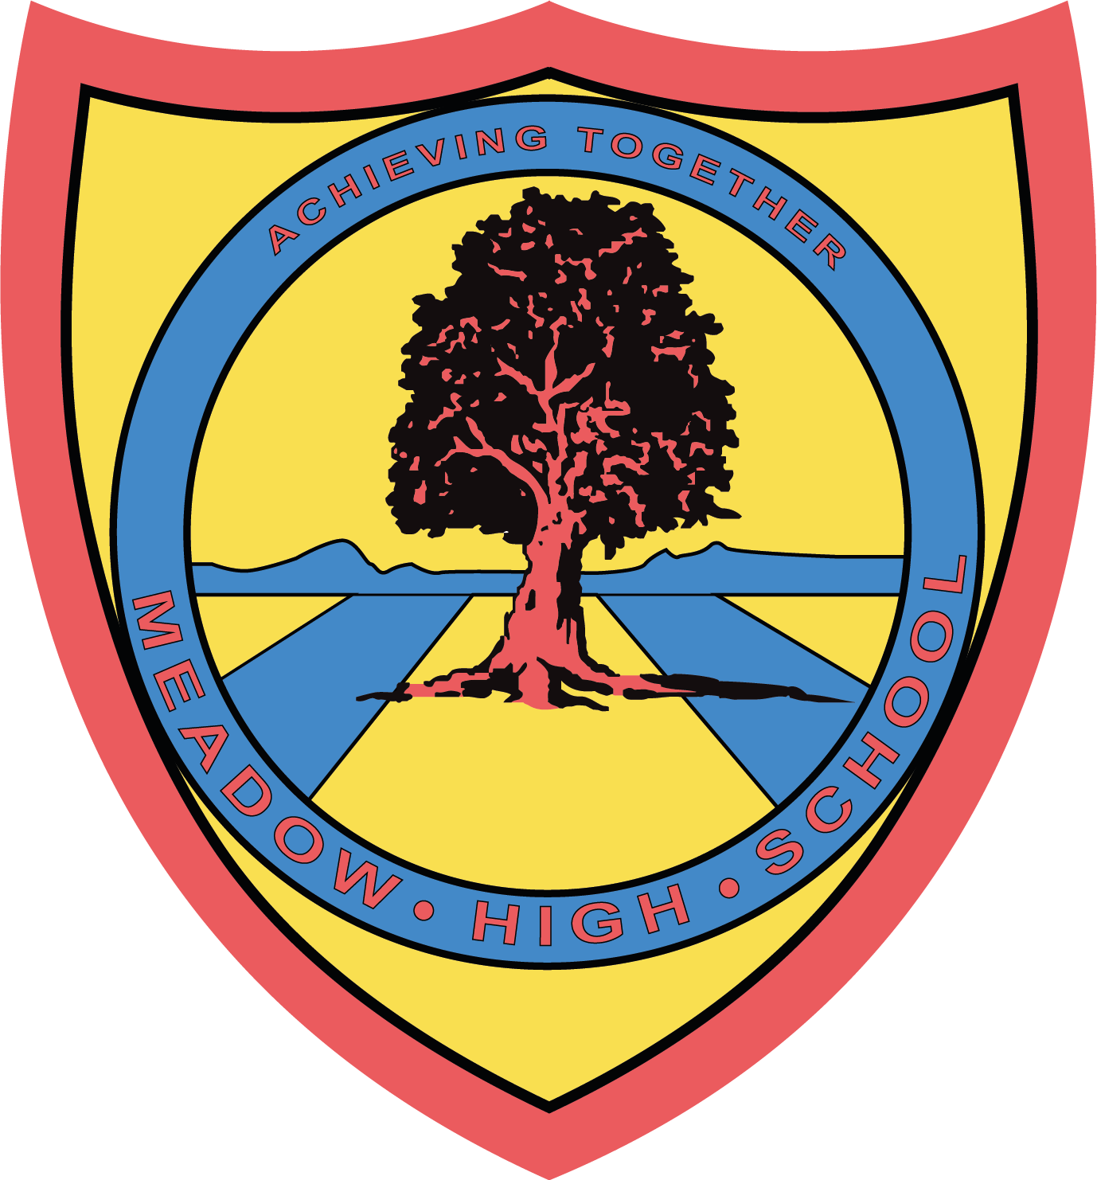

14th March 2024

Dear Parents/Carers,

I am pleased to inform you that your child will be participating in the Art GCSE workshop to support GCSE learning. The aim is to prepare pupils are for sitting a GCSE exam.

Pupils in their second year of GCSE will need to participate for 5 days and should come to the Art room at 9:15 on the following days:

Thursday 21st March
Friday 22nd March
Monday 25th March
Tuesday 26th March
Wednesday 27th March

Pupils in the first year GCSE will need to participate for 3 days and come to the Art room at 9:25am on the following dates:

Monday 25th March
Tuesday 26th March
Wednesday 27th March

Please be mindful not to increase pupils anxieties by mentioning the Exam, we will be referring to it as the workshop.

Please note, students will still attend English lessons during this time.

Please contact c.kepinska@meadowhighschool.org if you have any queries.

Regards,

C.Kepinska,
Arts Faculty Leader

Article 23:- 'A child with a disability has the right to live a full and decent life with dignity and independence, and to play an active part in the community.'


