Meadow High School
Royal Lane, Hillingdon, Middlesex UB8 3QU

Telephone: (01895) 443310
Email: meadow@meadowhighschool.org
Website: www.meadowhighschool.org

Headteacher: Mrs Jenny Rigby
Deputy Headteacher (Royal Lane): Miss Michelle Taylor
Deputy Headteacher (Northwood Road): Miss Amy Willis
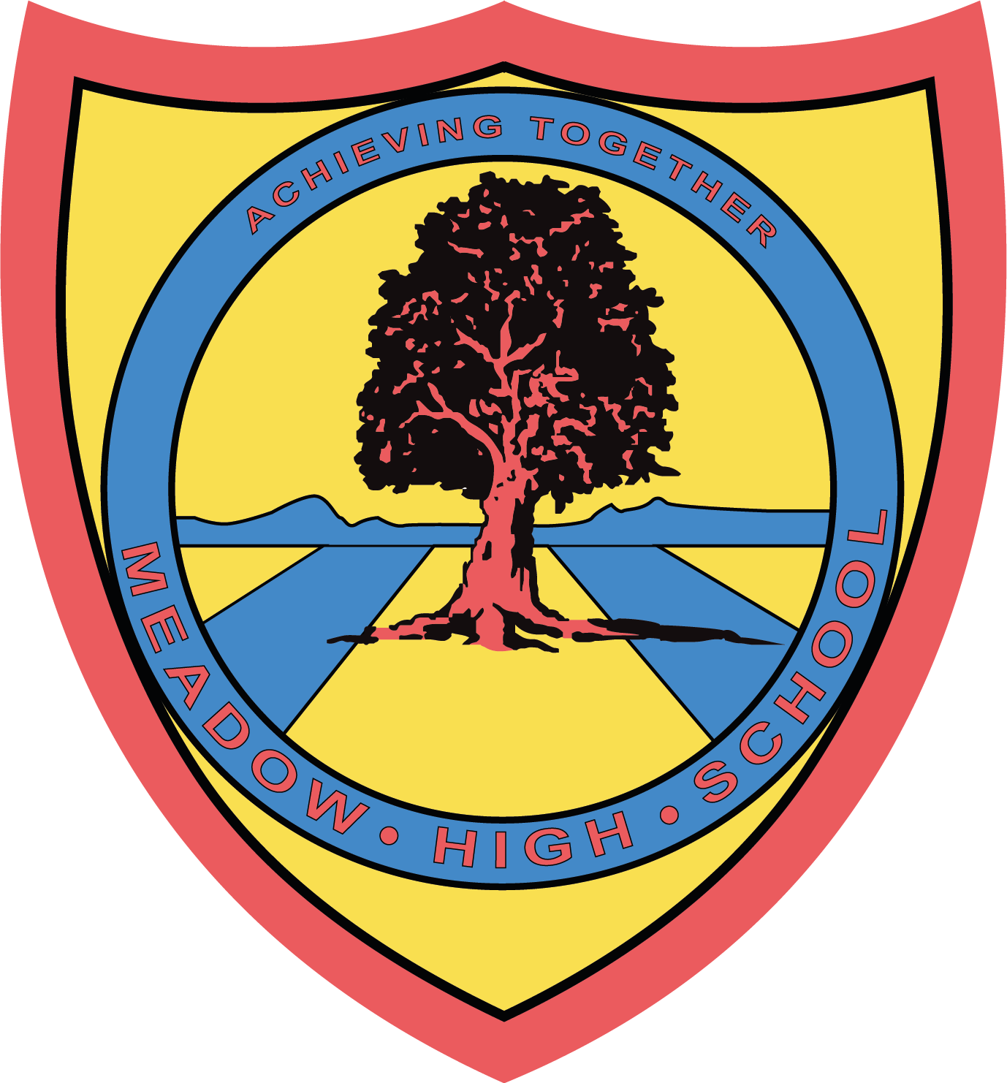

Friday 2nd May 2025

Dear Parent/Carer,

Trip to Compass Theatre – Friday 23 May 2025

To support your child with their learning of ‘Macbeth’ in English we have arranged a trip to the Compass Theatre in Ickenham on Friday, 23rd May 2025.

We will be leaving school after registration at 9:30am and returning to school in time for lunch at 12:45pm. We will travel on the minibus, which will be driven by a MIDAS (qualified) trained driver. A First-Aider will also accompany us.

The visit includes sitting in the auditorium as an audience, going up onto the stage, and showing the wings, lights and Stage Manager desk. Be shown inside the theatres' Lighting Box and Sound Desk, go into the Dressing Rooms to try on a costume or puppet to bring back on stage, go upstairs to the Costume Store to see all the other theatre costumes.

Please complete the attached slip and return it as soon as possible. If you have any queries, please feel free to contact myself or your child’s form tutor.

Yours sincerely,

Ms Kovacs
Year 9 Form Tutor
Article 23:- 'A child with a disability has the right to live a full and decent life with dignity and independence, and to play an active part in the community.'




Reply-Slip: Compass Theatre Trip. Friday 23rd May 2025 – please return to Mrs Kovacs

I acknowledge that my child ………………………………………………………………………………………………….. will take part in this educational trip.

Signed …………………………………………………………… Date ……………………………………………………………………
(Parent/Carer)

